Committee on IDEA
Senate of the Associated Students, 94th Session
Agenda for Thursday, October 8th, 2026 at 6:00 PM
Joe Crowley Student Union, 3rd floor, Room 324, 1664 North Virginia St., Reno, NV 89557
Zoom link:
https://unr.zoom.us/j/84856077565

- CALL MEETING TO ORDER
order shall be called by the secretaries.

- COMPLIANCE WITH NEVADA OPEN MEETING LAW
  - Was the agenda posted three full working days by 9 am, not including the meeting date?
    - https://nevadaasun.com/meetings/committee-on-idea-34/
  - Is the meeting taking place on the day of the week, month, day, year, at the time and location listed on the agenda?
  - Is the Zoom link working and available to the public?

If the answer to any of these questions is no, this meeting must be ENDED IMMEDIATELY unless NOML covers a legitimate correction.

- LAND ACKNOWLEDGEMENT
“We acknowledge that the University of Nevada, Reno is situated on the traditional homelands of the Numu (Northern Paiute), Wašiw (Washoe), Newe (Western Shoshone), Nuwu (Southern Paiute) peoples. These lands continue to be a gathering place for Indigenous Peoples and we recognize their deep connections to these places. We extend our appreciation for the opportunity to live and learn on their territory.”

- ROLL CALL
The Secretary must list roll call.
  - Chair Castro
  - Senator Benavente
  - Senator Espinoza
  - Senator Evans
  - Senator Price
  - Senator Radke
  - Senator Rivers
  - Senator Strabala
  - Senator Saporito

- PUBLIC COMMENT (INFORMATION ONLY)
Items heard under public comment may be for items either on or off the agenda. Action may not be taken on items raised under public comment. The Chair may elect to take public comment on actions on this agenda. The Chair may impose reasonable limits on the length of time members of the public may speak.

- ADOPTION OF MINUTES (FOR POSSIBLE ACTION)
- 9/17/26

- REPORTS (INFORMATION ONLY)
  - Chair Castro
  - Senator Benavente
  - Senator Espinoza
  - Senator Evans
  - Senator Price
  - Senator Radke
  - Senator Rivers
  - Senator Strabala
  - Senator Saporito
  - IDEA Director Benuto

- OLD BUSINESS (INFORMATION ONLY/FOR POSSIBLE ACTION/FOR POSSIBLE CORRECTIVE ACTION)
There is no old business to be discussed at this time.

- NEW BUSINESS (INFORMATION ONLY/FOR POSSIBLE ACTION)
- S.B. 94 - 28 An Act to Rename the Department and Committee of IDEA

- MISCELLANEOUS BUSINESS (FOR POSSIBLE ACTION)
  - Presentation from Progressive Leadership and Alliance of Nevada
  - Liaison changes and additions

- PUBLIC COMMENT (INFORMATION ONLY)
Items heard under public comment may be for items either on or off the agenda. Action may not be taken on items raised under public comment. The Chair may elect to take public comment on actions on this agenda. The Chair may impose reasonable limits on the length of time members of the public may speak.

- ADJOURNMENT

NOTES:
Agenda items may be considered out of order at the discretion of the Chair. The committee may combine two or more agenda items for consideration. The Committee may remove an item from the agenda or delay discussion of an item at any time. For issues or concerns contact Chair Castro. senatorCastro@asun.unr.edu

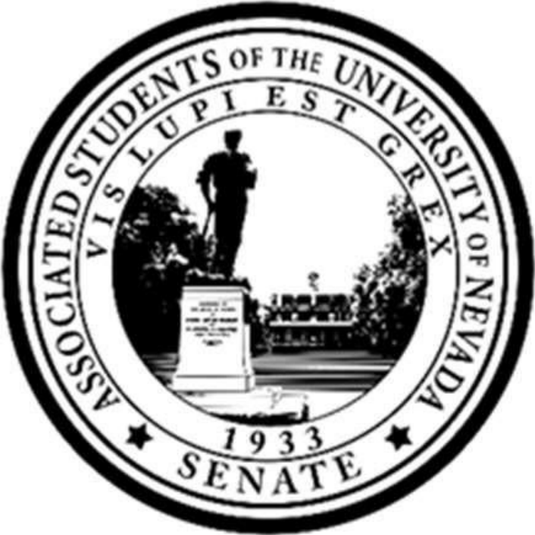

Written Minutes - Committee on IDEA
Senate of the Associated Students, 94th Session
Agenda for Thursday, September 17th, 2026 at 6:00 PM
Joe Crowley Student Union, 4th floor, Room 406, 1664 North Virginia St., Reno, NV 89557
Zoom link:
https://unr.zoom.us/j/84856077565

1. CALL MEETING TO ORDER
a. Chair Castro calls the meeting of the Committee on IDEA to order at 6:05 P.M.

2. COMPLIANCE WITH NEVADA OPEN MEETING LAW
a. Was the agenda posted three full working days by 9 am, not including the meeting date?
i. Yes.
b. Is the meeting taking place on the day of the week, month, day, year, at the time and location listed on the agenda?
i. Yes.
c. Is the Zoom link working and available to the public?
i. Yes.
3. LAND ACKNOWLEDGEMENT
a. We recognize that the University of Nevada, Reno, sits on the traditional homelands of the Numu (Northern Paiute), Wašiw (Washoe), Newe (Western Shoshone), Nuwu (Southern Paiute) peoples. These lands continue to be a gathering place for Indigenous peoples and we recognize the deep connections to these places. We extend our appreciation for the opportunity to live and learn on their territory.

4. ROLL CALL
a. Chair Castro- Present
b. Vice Chair Radke- Present
c. Senator Benavente- Present
d. Senator Bhardwaj- Absence Excused
e. Senator Espinoza- Present
f. Speaker Pro Tempore Evans- Present
g. Senator Price- Present
h. Senator Rivers- Present
i. Parliamentarian Strabala- Absence Excused
j. Senator Saporito- Present
i. A quorum is present.

5. PUBLIC COMMENT
a. There is no public comment at this time.

6. ADOPTION OF MINUTES
a. 6/03/26
i. Chair Castro seeks a motion to approve agenda item 6a through unanimous consent.
ii. So moved by Senator Benevente.
iii. Second by Speaker Pro Tempore Evans
iv. Seeing no dissent, the minutes are approved.
7. REPORTS (INFORMATION ONLY)
a. Chair Castro- reports that this is the same time and day the committee will be meeting. There are two pieces of legislation attached that are proposed that I would that to share with the committee. The first in an act to rename this committee from IDEA to DEIA to avoid confusion with the Individuals with Disabilities Act. The second is a proposed new liaison position for the Committee on ADA.
i. Senator Saporito asks to add the two proposed legislation to the written minutes.
ii. Secretary Fan answers yes.
b. Vice Chair Radke- No report at this time.
c. Senator Benavente- No report at this time.
d. Senator Bhardwaj- No report at this time.
e. Senator Espinoza- No report at this time.
f. Speaker Pro Tempore Evans- No report at this time.
g. Senator Price- I am sorry I am not there in person, I am feeling under the weather. I will be attending the first meeting of the Black Student Association tomorrow.
i. Speaker Issa asks, I am wanting to go to the presentation tomorrow but if I am not able to can you let them know they have an invitation to present to Senate.
h. Senator Rivers- No report at this time.
i. Parliamentarian Strabala- No report at this time.
j. Senator Saporito- I reached out to Shane and Callie at DRC and I expect to get a response back within the week.
k. IDEA Director Benuto- No report at this time.

8. OLD BUSINESS
a. There is no old business at this time.

9. NEW BUSINESS
a. Discussion Relating to efficiency in NSHE Committee on IDEA.
i. Vice Chair Radke comments that there have been a lot of racist incidents on campus that have gone unaddressed.
ii. Senator Saporito comments that we could get studies showing the comfortability the student body has and present it to the NSHE Committee on IDEA.
iii. Senator Price asks how easy it is for us to get agenda items to the NSHE Committee on IDEA.
iv. Chair Castro answers that she will petition Chair Downs, the chair of the NSHE Committee on IDEA to get agenda items in front of the committee and everyone is welcome to attend the upcoming meeting she has set up.
v. Senator Saporito asks whether or not the Board of NSHE is considering combining the Committee on IDEA with other committees.
vi. Chair Castro answers that they aren’t really wanting to merge all of it with other committees but certain parts to the Committee on Safety and the rest will go to the full board.

10. MISCELLANEOUS BUSINESS (FOR POSSIBLE ACTION)
a. Liaison changes and additions
i. Senator Espinoza motions to place herself in the liaison position to Pack Pathways through unanimous consent.
ii. Second by Speaker Pro Tempore Evans.
iii. Seeing no dissent, Senator Espinoza is now placed in that liaison position.

11. PUBLIC COMMENT
a. Speaker Issa comments, with regards to the topic of racism on campus, I have had a private conversation with university faculty regarding President Sandoval and his past association with the organization Coffin and Keys, given that group's history and racist past. I feel it is an issue and university faculty also have issues with his association. As a student leader it worries me and it should worry all of you too.

12. ADJOURNMENT
a. Chair Castro adjourns the Committee on IDEA at 6:20 P.M. in JCSU Room 405 and on Zoom.

[DISCUSSION DRAFT]
94th SESSION
2026-2027

S. B. 94 - 28
An Act to Rename the Department and Committee of IDEA
_________________________
In the Senate of the Associated Students
_______________________________
September 17th, 2026
Submitted to the Senate of the Associated Students by Senator Castro
______________________________
Whereas, The current acronym of IDEA utilized with ASUN stands for “Inclusivity, Diversity, Equity, and Accesibility”,
Whereas, The acronym of IDEA is currently used on a broader scale to refer to the Individuals with Disabilties Education Act, previously named the Education for All Handicapped Children Act (EHA), which was renamed to IDEA in 1990. ¹
Whereas, The usage of IDEA contributes to issues of confusion regarding the purpose and intent of both the Department of IDEA and the Committee of IDEA;
Whereas, Many members of the public have expressed their belief that ASUN’s usage of IDEA is in relation to the federal piece of legislation, the Individuals with Disabilities Education Act.
Whereas, the name “DEIA” stands for Diversity, Equity, Inclusion, and Accessibility; sharing all meanings with the name IDEA without it’s confusion. ²
Whereas, This change better compliments ASUN’s values towards transparency and accessibility, and does not symbolize a change in obligation or role.
Be it enacted, The Department of IDEA and Committee of IDEA shall be officially renamed to the Department of DEIA, and that this change shall be reflected wherever the name may appear in the Statutes of the Associated Students; and
Be it further enacted, the Director of Ethics and Compliance, the Committee on Government Operations, ASUN Professional Staff and the Secretaries of the Senate shall ensure that the changes made in this legislation are reflected in the Statutes of the Students, other governing documents, and the ASUN Website.
Be it further enacted, that a copy of this bill be sent to the following individuals:
● Director of the Center for Student Engagement, Dion Webb-Figueroa;
● Associate Director of Student Government, Luis Aguilar-Herrera;
● Director of the Department of IDEA, Jorge Benuto
● President of the Associated Students, Dillon Moss;
● Vice President of the Associated Students, Luke Calderon; and
● Speaker of the 94th Senate of the Associated Students, Jason Issa;
[DISCUSSION DRAFT]
94th SESSION
2026-2027

S. B. R. 94 - 27
A Binding Resolution to Add a Liaison to The Committee on ADA for the Committee on IDEA _______________________________
In the Senate of the Associated Students
_______________________________
September 17th, 2026
Submitted to the Senate of the Associated Students by Senator Castro
______________________________
Whereas, the committee of IDEA intrinsically involved issues of campus accessibility,
Whereas, within the University of Nevada Reno exists the campus American’s with Disabilities Act Committee, which regularly meets to discuss concerns relating to university adherence to The Americans with Disabilities Act of 1990. Concerns varying from campus walkability, signage, facilities, and more.
Whereas, this committee welcomes the presence of student liaisons and feedback;
Whereas, establishing an ongoing relationship between ASUN student leaders and the ADA Committee will allow for a more seamless discussion of student issues of accessibility on campus, and easier access to solutions for students.
Be it resolved, The committee on IDEA shall formally adopt a liaison position for the University ADA Committee.
Be it further resolved, that the chair of the Committee on IDEA fulfill this liaison role, alongside any other willing committee members.
Be it further resolved, that the chair facilitate a replacement in case of any inability to attend the committee’s meetings, and facilitate student involvement within said committee.
Be it further resolved, that a copy of this binding resolution be sent to the following individuals:
● Director of the Center for Student Engagement, Dion Webb-Figueroa;
● Associate Director of Student Government, Luis Aguilar-Herrera;
● Director of the Disability Resource Center, Shane Carter
● President of the Associated Students, Dillon Moss;
● Vice President of the Associated Students, Luke Calderon; and
● Speaker of the 94th Senate of the Associated Students, Jason Issa;

[DISCUSSION DRAFT]
94th SESSION
2026-2027

S. B. 94 - 28
An Act to Rename the Department and Committee of IDEA
_________________________
In the Senate of the Associated Students
_______________________________
September 17th, 2026
Submitted to the Senate of the Associated Students by Senator Castro
______________________________
Whereas, The current acronym of IDEA utilized with ASUN stands for “Inclusivity, Diversity, Equity, and Accesibility”,
Whereas, The acronym of IDEA is currently used on a broader scale to refer to the Individuals with Disabilties Education Act, previously named the Education for All Handicapped Children Act (EHA), which was renamed to IDEA in 1990.
Whereas, The usage of IDEA contributes to issues of confusion regarding the purpose and intent of both the Department of IDEA and the Committee of IDEA;
Whereas, Many members of the public have expressed their belief that ASUN’s usage of IDEA is in relation to the federal piece of legislation, the Individuals with Disabilities Education Act.
Whereas, the name “DEIA” stands for Diversity, Equity, Inclusion, and Accessibility; sharing all meanings with the name IDEA without it’s confusion.
Whereas, This change better compliments ASUN’s values towards transparency and accessibility, and does not symbolize a change in obligation or role.
Be it enacted, The Department of IDEA and Committee of IDEA shall be officially renamed to the Department of DEIA, and that this change shall be reflected wherever the name may appear in the Statutes of the Associated Students; and
Be it further enacted, the Director of Ethics and Compliance, the Committee on Government Operations, ASUN Professional Staff and the Secretaries of the Senate shall ensure that the changes made in this legislation are reflected in the Statutes of the Students, other governing documents, and the ASUN Website.
Be it further enacted, that a copy of this bill be sent to the following individuals:
● Director of the Center for Student Engagement, Dion Webb-Figueroa;
● Associate Director of Student Government, Luis Aguilar-Herrera;
● Director of the Department of IDEA, Jorge Benuto
● President of the Associated Students, Dillon Moss;
● Vice President of the Associated Students, Luke Calderon; and
● Speaker of the 94th Senate of the Associated Students, Jason Issa;

○

○

https://sites.ed.gov/idea/IDEA-History
https://www.aclu.org/news/racial-justice/dei-and-accessibility-explained

