Department of IDEA
Agenda for Thursday, March 19th, 2026 at 11:00AM
In Person- JSCU 332 Frankie Sue Del Papa Presidents Conference Room
Joe Crowley Student Union 3rd Floor
1664 N. Virginia Street
Reno, Nevada 89557
Virtual Zoom ID: 339 969 0437 Passcode: IDEA25
Zoom: LINK

- CALL MEETING TO ORDER

- COMPLIANCE WITH NEVADA OPEN MEETING LAW
  - Was the agenda posted three full working days by 9 am, not including the meeting date? [Bring up the ASUN website and show the public]
  - Is the meeting taking place on the day of the week, month, day, year, at the time and location listed on the agenda?
  - Is the Zoom link working and available to the public?
  - If the answer to any of these questions is no, this meeting must be ENDED IMMEDIATELY unless NOML covers a legitimate correction.

- LAND ACKNOWLEDGEMENT
We recognize that the University of Nevada, Reno, sits on the traditional homelands of the Numu (Northern Paiute), Wašiw (Washoe), Newe (Western Shoshone), Nuwu (Southern Paiute) peoples. These lands continue to be a gathering place for Indigenous peoples and we recognize the deep connections to these places. We extend our appreciation for the opportunity to live and learn on their territory.

- ROLL CALL
The Secretary must list roll call.
- Director, Zyna Navarte
- Commissioner for Marketing and Outreach, Jaden Ottaviano
- Commissioner of Social Justice and Reform, Manvi Mummalaneni

- PUBLIC COMMENT (INFORMATION ONLY)
Items heard under public comment may be for items either on or off the agenda. Action may not be taken on items raised under public comment. The Chair may elect to take public comment on actions on this agenda. The Chair may impose reasonable limits on the length of time members of the public may speak.

- ADOPTION OF MINUTES (FOR POSSIBLE ACTION)
There are no minutes to be approved at this time.

- AUDIO MINUTES MISSING FOR PREVIOUS MEETINGS OF THIS BODY THAT DO NOT MEET 30 DAY POSTING OF NEVADA OPEN MEETING LAW FOR CORRECTIVE ACTION
For Possible Corrective Action:
Month/Day/2025 — Uploaded Audio (For Possible Corrective Action)

- REPORTS (INFORMATION ONLY)
- Director, Zyna Navarte
- Commissioner for Marketing and Outreach, Jaden Ottaviano
- Commissioner of Social Justice and Reform, Manvi Mummalaneni

- OLD BUSINESS (INFORMATION ONLY/FOR POSSIBLE ACTION)

- NEW BUSINESS (INFORMATION ONLY/FOR POSSIBLE ACTION
  - UNR Hawaiian Event (Possible Action)
  - QSU Sponsorship (Possible Action)
  - Department of Sustainability Sponsorship (Possible Action)

- PUBLIC COMMENT (INFORMATION ONLY)
Items heard under public comment may be for items either on or off the agenda. Action may not be taken on items raised under public comment. The Chair may elect to take public comment on action items on this agenda. The Chair may impose reasonable limits on the length of time members of the public may speak.

- ADJOURNMENT
NOTES:
Agenda items may be considered out of order at the discretion of the Chair. The committee may combine two or more agenda items for consideration. The Committee may remove an item from the agenda or delay discussion of an item at any time.

ASUN DEPARTMENT OF IDEA
EVENT & BUDGET PROPOSAL FORM

CONTACT INFORMATION:
Organizer(s)/ Intern(s): Zyna Navarte
E-mail(s): diversitydirector@asun.unr.edu or Znavarte@unr.edu
Learning Outcomes:
- Participants will be able to recognize and celebrate LGBTQ+ identities and experiences through an inclusive social space that promotes acceptance, community, and belonging.
EVENT INFORMATION:
Event Name: | Queer Prom | Date: | 05/01/2026
Event Location: | The Discovery | Time: | n/a
Expected  Attendance: | 100+ | Cost Per  Student: | n/a

BUDGET INFORMATION: Please itemize your ENTIRE event budget below:
DESCRIPTION: | AMOUNT: | VENDOR:
- Event Space | $1,300 | The Discovery Museum
TOTAL EVENT BUDGET: | $1,300
TOTAL ASUN BUDGET: | $1,300
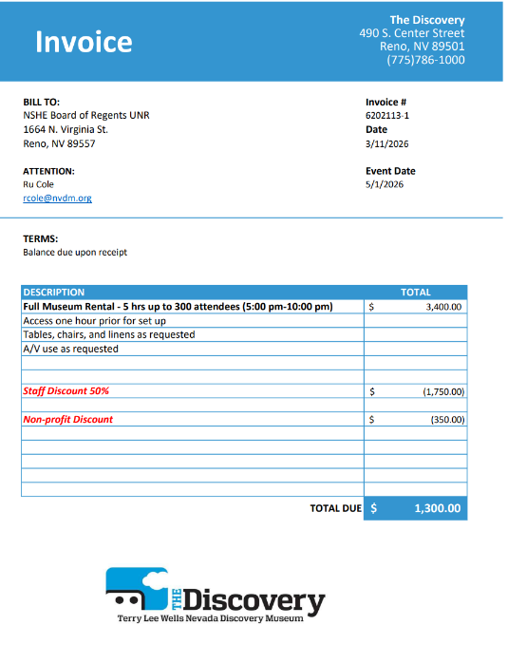

ASUN DEPARTMENT OF IDEA
EVENT & BUDGET PROPOSAL FORM

CONTACT INFORMATION:
Organizer(s)/ Intern(s): Zyna Navarte
E-mail(s): znavarte@unr.edu
Learning Outcomes:
- Participants will learn about Hawaiian culture and traditions, including the meaning of pā‘ina (gathering/celebration) and the cultural significance of aloha as a value of community and connection.
- Participants will engage with and appreciate Pacific Islander cultural expressions, such as traditional dance, music, and storytelling, to better understand the history and identity of Native Hawaiian communities.
- Participants will strengthen cross-cultural awareness and community belonging by interacting with diverse campus organizations and celebrating cultural traditions together
EVENT INFORMATION:
Event Name: | The Biggest Little Pā’ina: Aloha kāua | Date: April 4, 2026
Event Location: | Joe Crowley Student Union | Time: 4pm-6pm
Expected  Attendance: | 200+ | Cost Per  Student: 0 | n/a
BUDGET INFORMATION: Please itemize your ENTIRE event budget below:
DESCRIPTION: | Cost | Quantities | Total: | VENDOR:
- Balloon arch frame | $33.98 | 1 | $33.98 | Amazon
- Acrylic Flower Vase Square (4x4) | $48.99 | 2 | $48.99 | Amazon
- Aquarium Gravel (5lbs) | $15.49 | 1 | $15.49 | Amazon
- Artificial Bird of Paradise Plant | $19.99 | 3 | $59.97 | Amazon
- Sage Green Tablecloth | $8.98 | 1 | $8.98 | Amazon
- Artificial Ferns | $17.99 | 3 | $53.97 | Amazon
- Artificial Chrysanthemum Flowers | $14.99 | 4 | $59.96 | Amazon
- Floral Flower Foam Blocks | $9.99 | 3 | $26.97 | Amazon
- Red Eyelash Yarn | $6.64 | 6 | $39.84 | Amazon
- Pikake | $13.59 | 10 | $135.90 | Amazon
- Plumeria Clips | $5.99 | 14 | $83.86 | Amazon
- Puakenikeni | $55.00 | 2 | $110.00 | Amazon
- Black rectangle tablecloth | $8.48 | 66 | $192.45 | Amazon
TOTAL EVENT BUDGET: |  |  | $ 870.36
TOTAL ASUN BUDGET: |  |  | $ 870.36

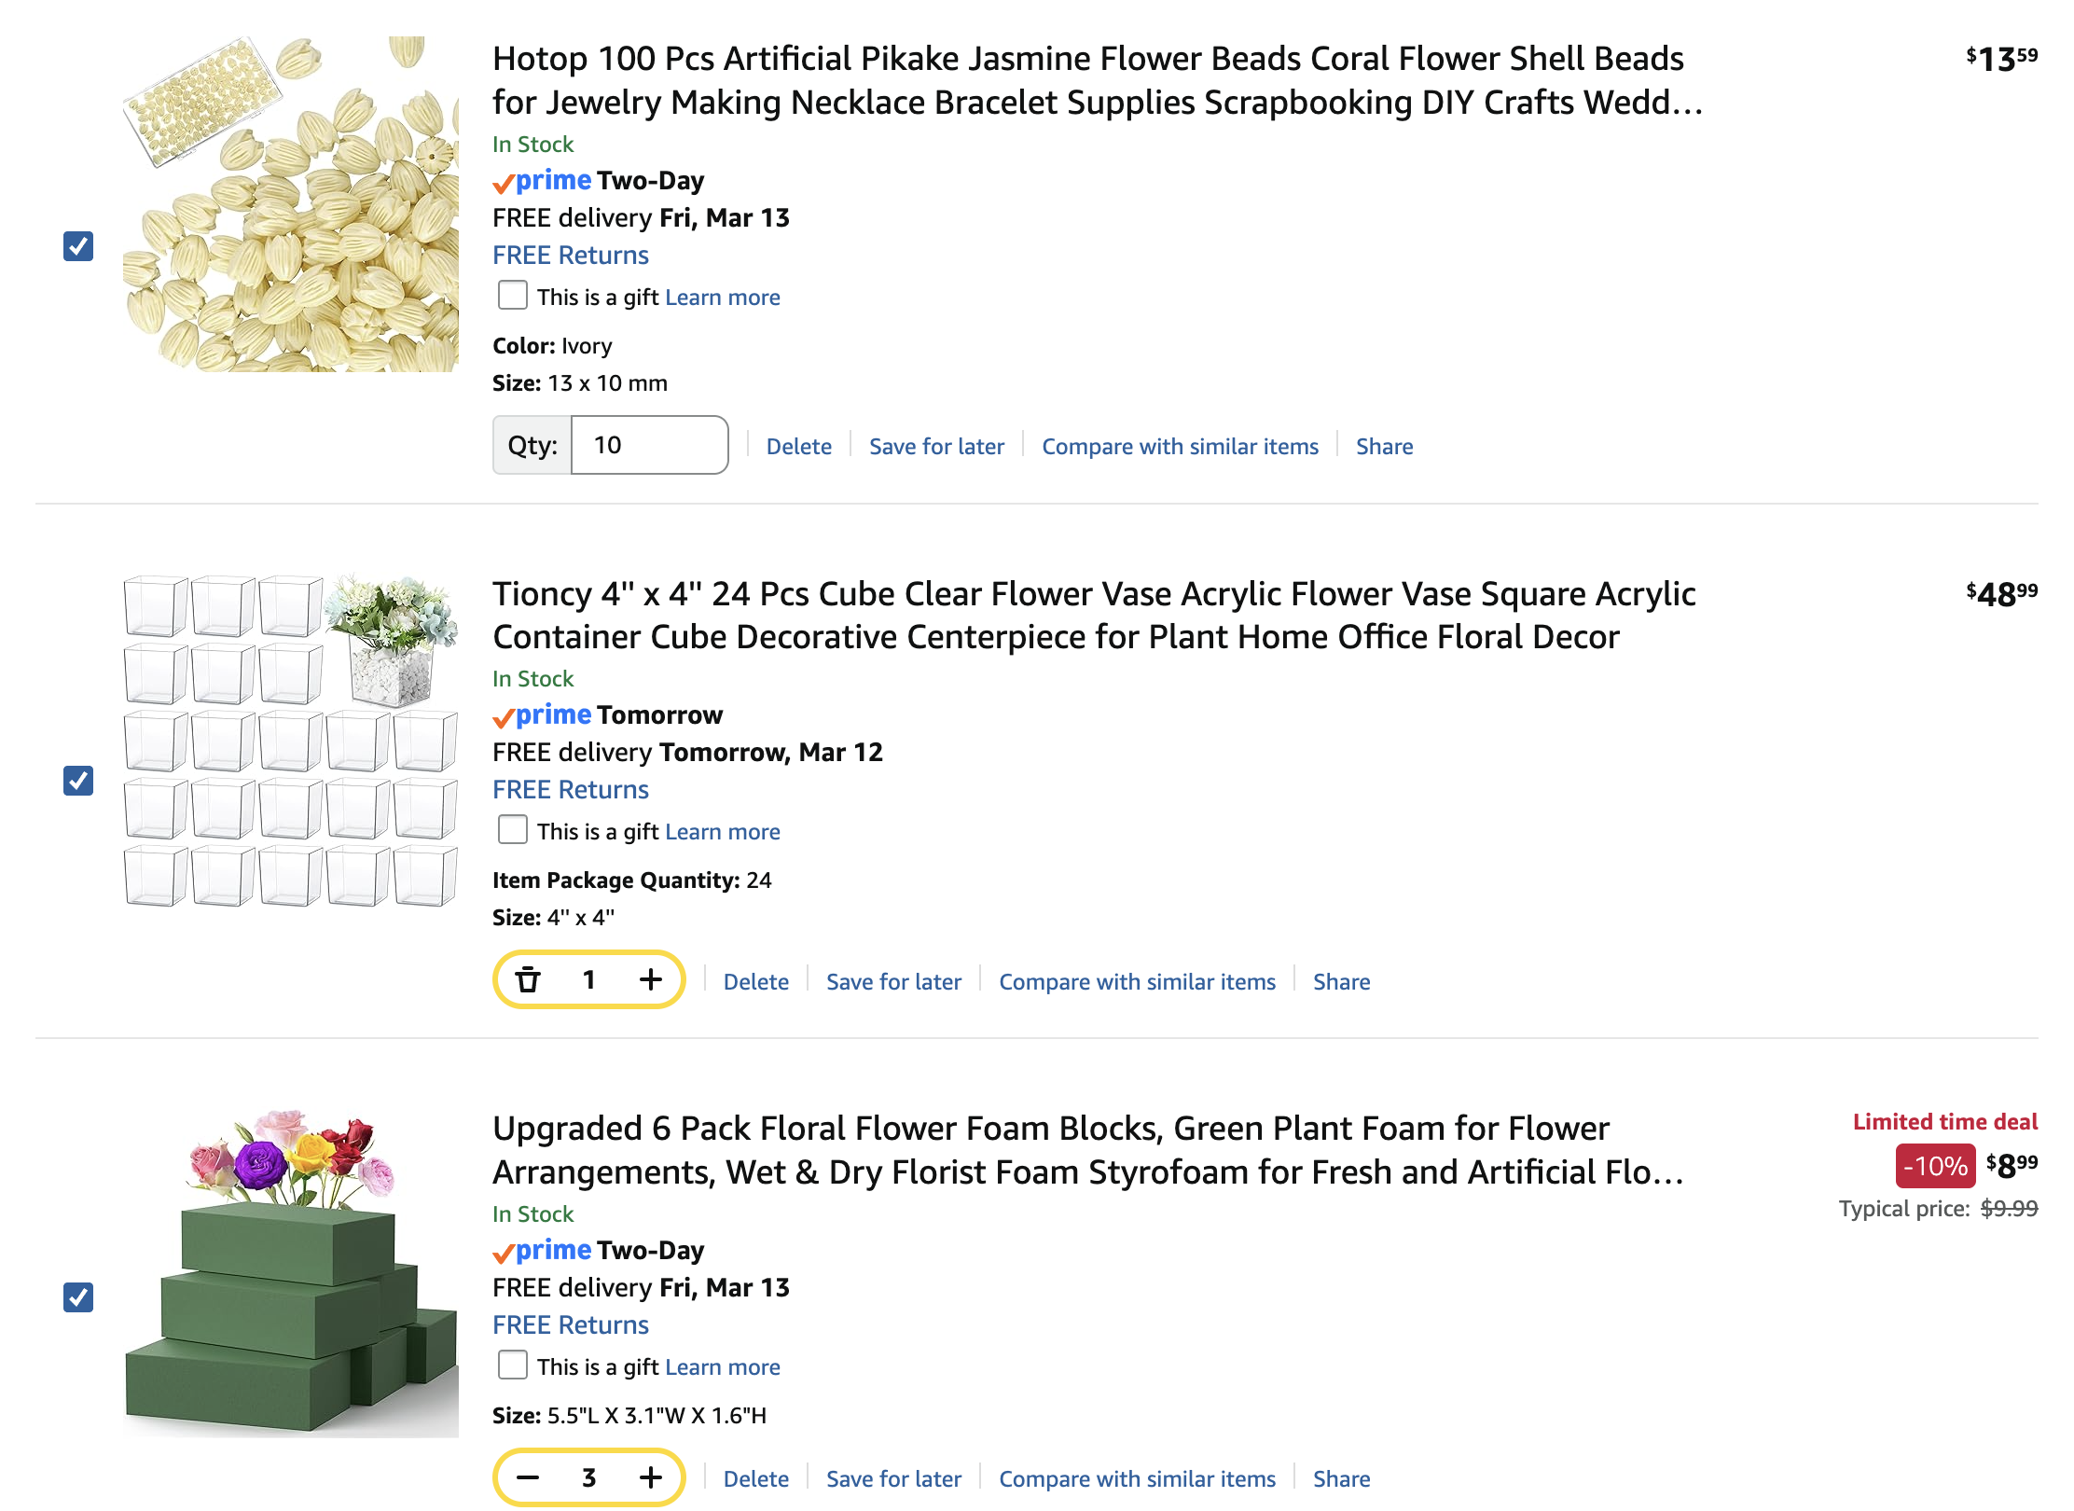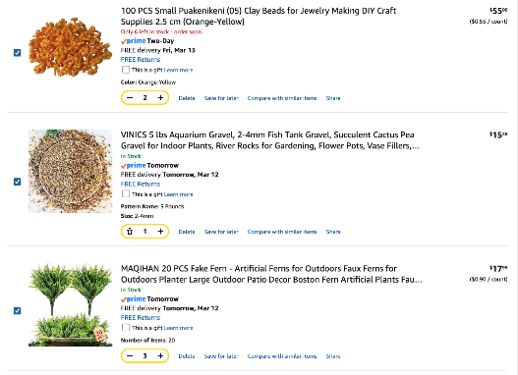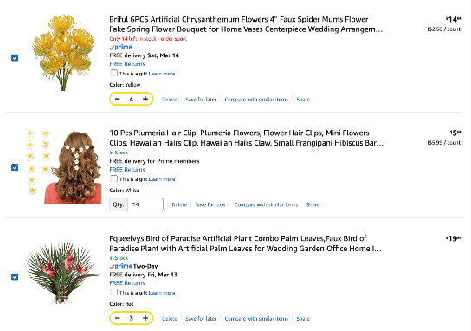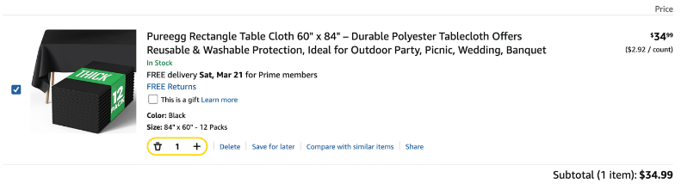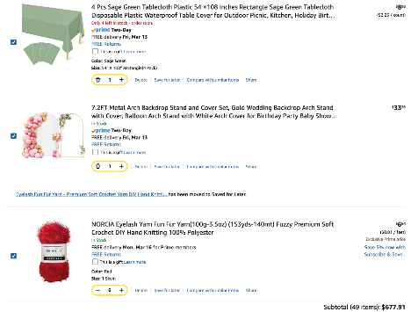
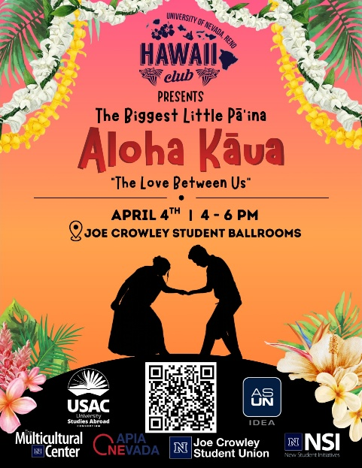

ASUN DEPARTMENT OF IDEA
EVENT & BUDGET PROPOSAL FORM

CONTACT INFORMATION:
Organizer(s)/ Intern(s): Zyna Navarte
E-mail(s): diversitydirector@asun.unr.edu or Znavarte@unr.edu
Learning Outcomes:
- Participants will be able to identify and access sustainable food and basic supplies that support student well-being, while learning about campus and community resources provided through the Department of Sustainability that help reduce food insecurity and promote environmentally responsible living.
EVENT INFORMATION:
Event Name: | n/a | Date: | n/a
Event Location: | JCSU or KC Breezeway | Time: | n/a
Expected  Attendance: | 100+ | Cost Per  Student: | n/a

BUDGET INFORMATION: Please itemize your ENTIRE event budget below:
DESCRIPTION: | AMOUNT: | VENDOR:
- Supplies for ongoing initiatives to Department of Sustainability sponsorship | $300 | Department of Sustainability
TOTAL EVENT BUDGET: | $300
TOTAL ASUN BUDGET: | $300

