Department of IDEA
Agenda for Thursday, February 26th, 2026 at 11:00 AM
In Person- JSCU 332 Frankie Sue Del Papa Presidents Conference Room
Joe Crowley Student Union 3rd Floor
1664 N. Virginia Street
Reno, Nevada 89557
Virtual Zoom ID: 339 969 0437 Passcode: IDEA25
Zoom: LINK

- CALL MEETING TO ORDER

- COMPLIANCE WITH NEVADA OPEN MEETING LAW
  - Was the agenda posted three full working days by 9 am, not including the meeting date? [Bring up the ASUN website and show the public]
  - Is the meeting taking place on the day of the week, month, day, year, at the time and location listed on the agenda?
  - Is the Zoom link working and available to the public?
  - If the answer to any of these questions is no, this meeting must be ENDED IMMEDIATELY unless NOML covers a legitimate correction.

- LAND ACKNOWLEDGEMENT
We recognize that the University of Nevada, Reno, sits on the traditional homelands of the Numu (Northern Paiute), Wašiw (Washoe), Newe (Western Shoshone), Nuwu (Southern Paiute) peoples. These lands continue to be a gathering place for Indigenous peoples and we recognize the deep connections to these places. We extend our appreciation for the opportunity to live and learn on their territory.

- ROLL CALL
The Secretary must list roll call.
- Director, Zyna Navarte
- Commissioner of Event Planning, Bea Campbell
- Commissioner for Marketing and Outreach, Jaden Ottaviano
- Commissioner of Social Justice and Reform, Manvi Mummalaneni

- PUBLIC COMMENT (INFORMATION ONLY)
Items heard under public comment may be for items either on or off the agenda. Action may not be taken on items raised under public comment. The Chair may elect to take public comment on actions on this agenda. The Chair may impose reasonable limits on the length of time members of the public may speak.

- ADOPTION OF MINUTES (FOR POSSIBLE ACTION)
There are no minutes to be approved at this time.

- AUDIO MINUTES MISSING FOR PREVIOUS MEETINGS OF THIS BODY THAT DO NOT MEET 30 DAY POSTING OF NEVADA OPEN MEETING LAW FOR CORRECTIVE ACTION
For Possible Corrective Action:
Month/Day/2025 — Uploaded Audio (For Possible Corrective Action)

- REPORTS (INFORMATION ONLY)
- Director, Zyna Navarte
- Commissioner of Project and Events, Bea Campbell
- Commissioner for Marketing and Outreach, Jaden Ottaviano
- Commissioner of Social Justice and Policy, Manvi Mummalaneni

- OLD BUSINESS (INFORMATION ONLY/FOR POSSIBLE ACTION)

- NEW BUSINESS (INFORMATION ONLY/FOR POSSIBLE ACTION
  - Black Culture Festival Food (Possible Action)
  - Women’s History Month (Possible Action)
  - Fusion: The Multiracial Celebration (Possible Action)

- PUBLIC COMMENT (INFORMATION ONLY)
Items heard under public comment may be for items either on or off the agenda. Action may not be taken on items raised under public comment. The Chair may elect to take public comment on action items on this agenda. The Chair may impose reasonable limits on the length of time members of the public may speak.

- ADJOURNMENT
NOTES:
Agenda items may be considered out of order at the discretion of the Chair. The committee may combine two or more agenda items for consideration. The Committee may remove an item from the agenda or delay discussion of an item at any time.

ASUN DEPARTMENT OF IDEA
EVENT & BUDGET PROPOSAL FORM

CONTACT INFORMATION:
Organizer(s)/ Intern(s): Jaden Ottaviano, Ruby Sparks
E-mail(s): commissionerottaviano@asun.unr.edu, rubysparks@unr.edu
Learning Outcomes:
- Participants will gain a deeper understanding of Black history and culture through interactive performances, educational resources, and community engagement
- Participants will recognize the impact of Black culture on social, artistic, and political movements and reflect on its continued importance today
- Participants will build intercultural awareness and allyship skills by engaging in inclusive dialogue that promotes equity and respect.
EVENT INFORMATION:
Event Name: | Black Culture Festival | Date: | 03/06/2026
Event Location: | JCSU Ballroom | Time: | 5:30PM TO 8:30PM
Expected  Attendance: | 100+ | Cost Per  Student: | n/a

BUDGET INFORMATION: Please itemize your ENTIRE event budget below:
DESCRIPTION: | AMOUNT: | VENDOR:
- 300-Finger Tailgate | $428.97 (2) | canes
- Milo's Strawberry Lemonade - 128 fl oz | $4.48 (7) | walmart
- Milo's Famous Sweet Iced Tea, 100% Natural, 128 fl oz | $3.94 (7) | walmart
- Milo's 100% Natural Famous Unsweet Iced Tea, 128 fl oz Jug | $3.94 (7) | walmart
- Marketside Bite Sized Turtle Chocolate Brownies, 13.3 oz, 12 Count (Shelf-Stable) | $5.97 (5) | walmart
- Marketside Bite Sized Ultimate Chocolate Brownies, 13.3 oz, 12 Count (Shelf-Stable) | $5.83 (5) | walmart
- Great Value Purified Drinking Water, 16.9 fl oz, 40 Count | $5.47 (5) | walmart
- Assorted Cookie Tray, 84 ct. | $19.93 (2) | Sams club
- Mac & Cheese Tray | $74.00 (4) | Chik-fil-a
- Cobb Salad | $249.75 | Chik-fil-a
- Ribs (33) | $1,122.00 | Famous Daves
- Cornbread full pan | $180.00 | Famous Daves
- M & M’s Southern Café: Beans, Rice, Collard Greens | $2,500 (estimate amount) | M & M’s Southern Cafe
- Photobooth | $50.00 | Nevada Student Initiative
TOTAL EVENT BUDGET: | $5,468.43
TOTAL ASUN BUDGET: | $5,468.43
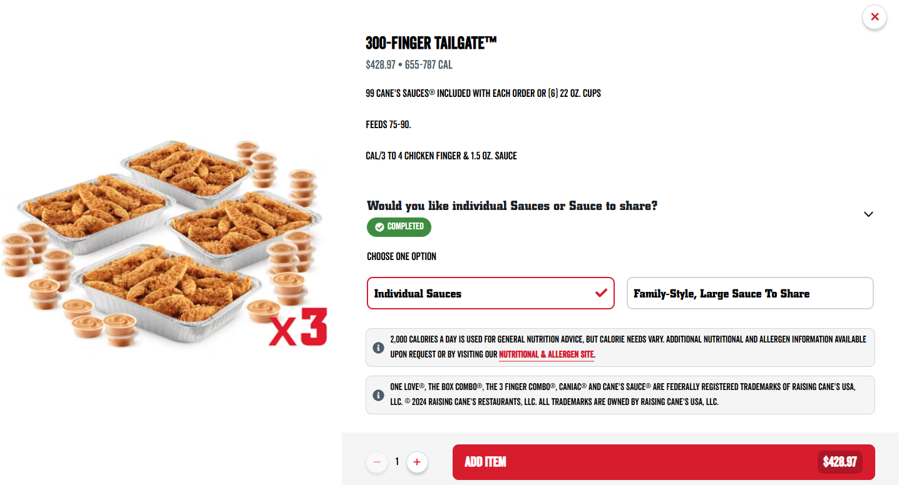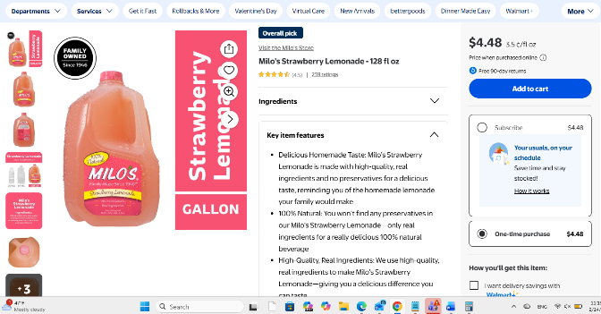
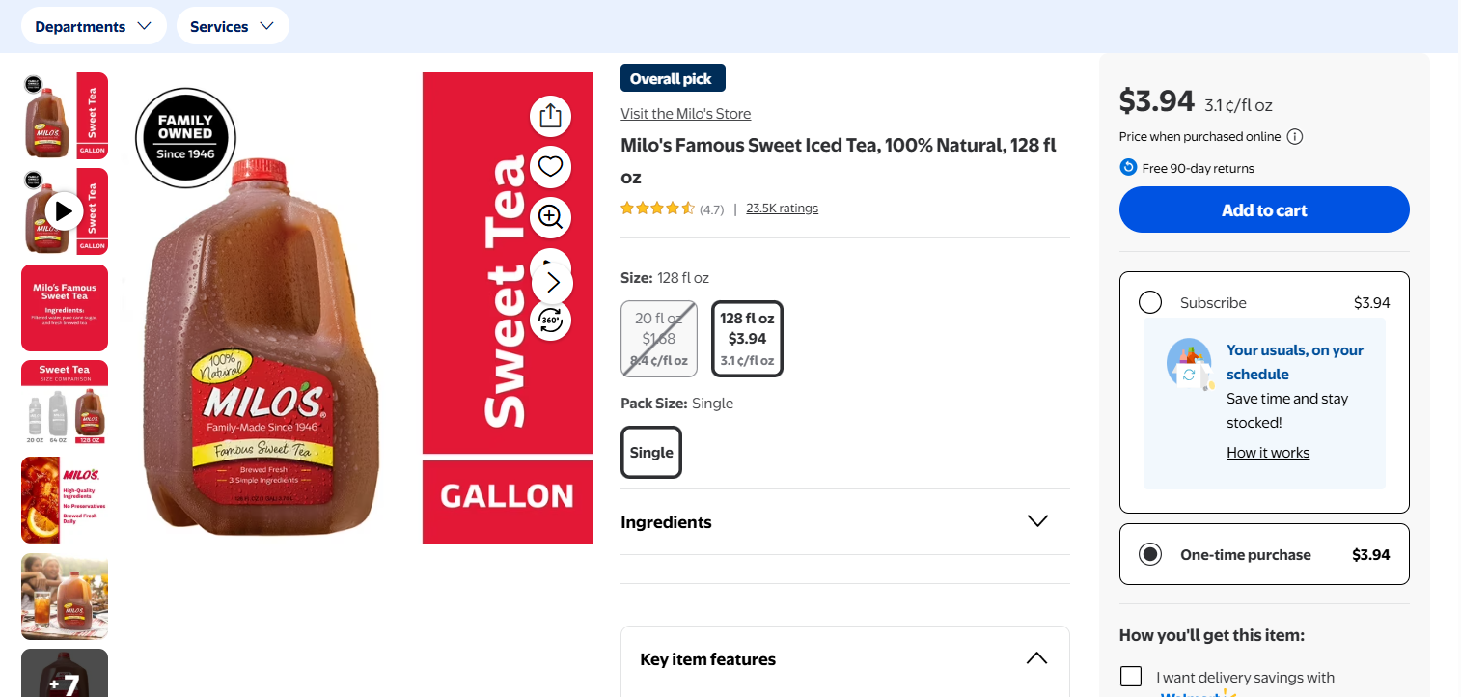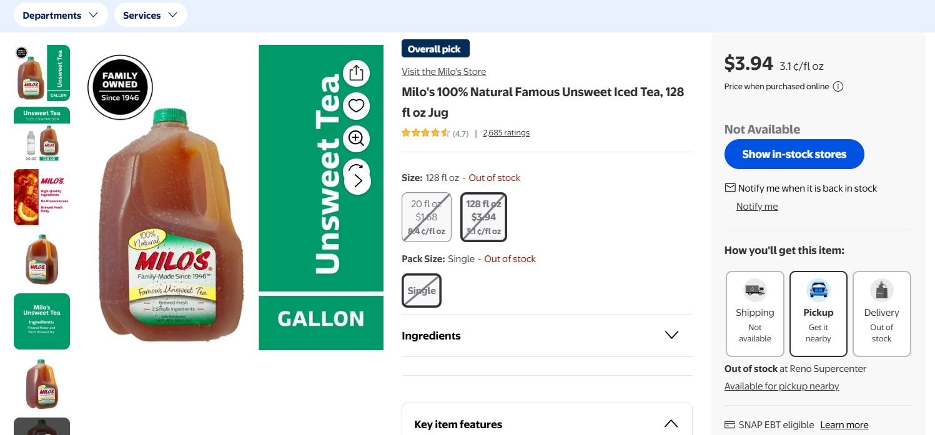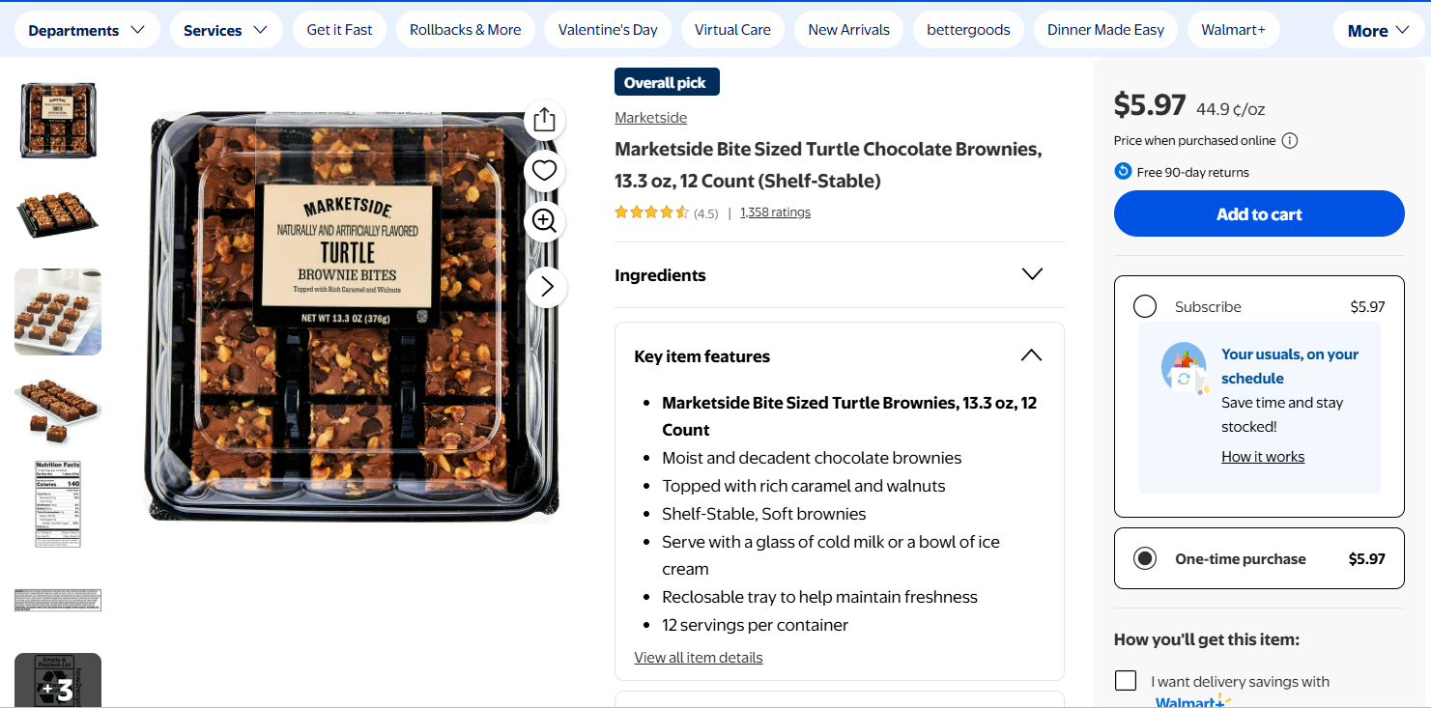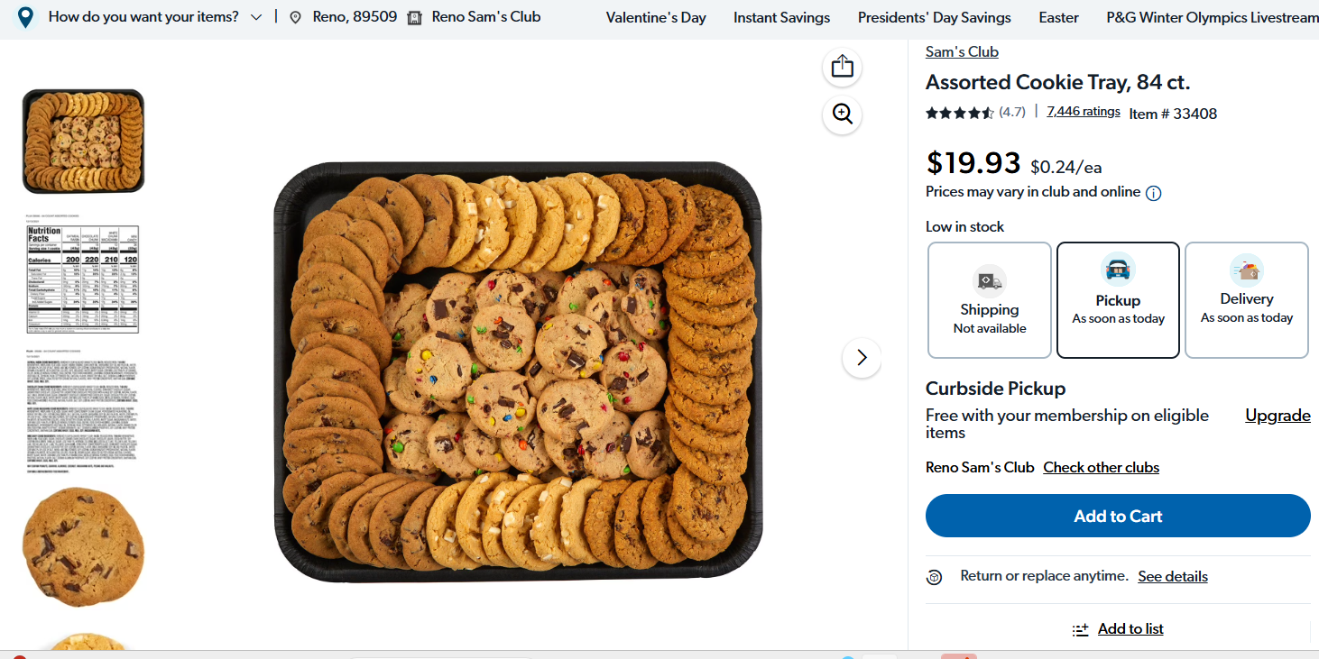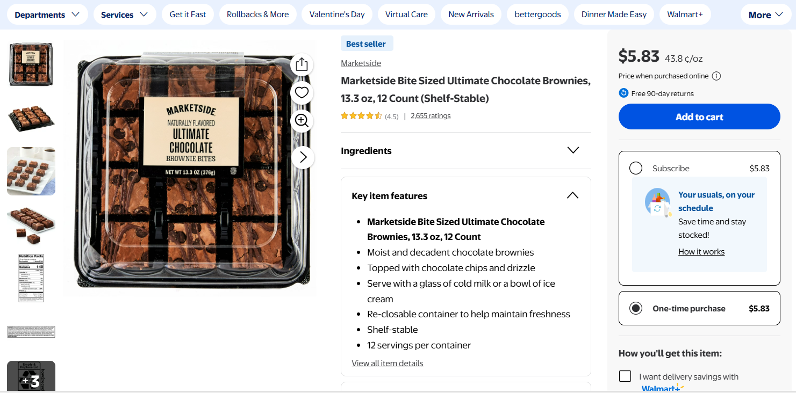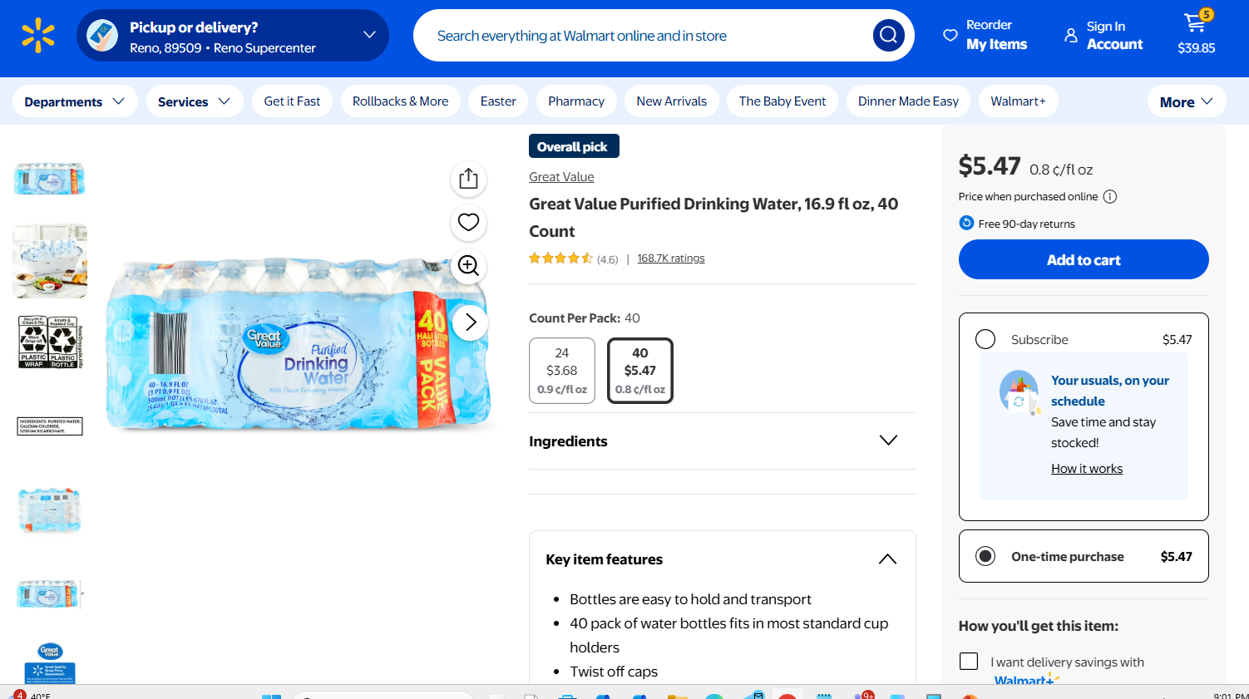
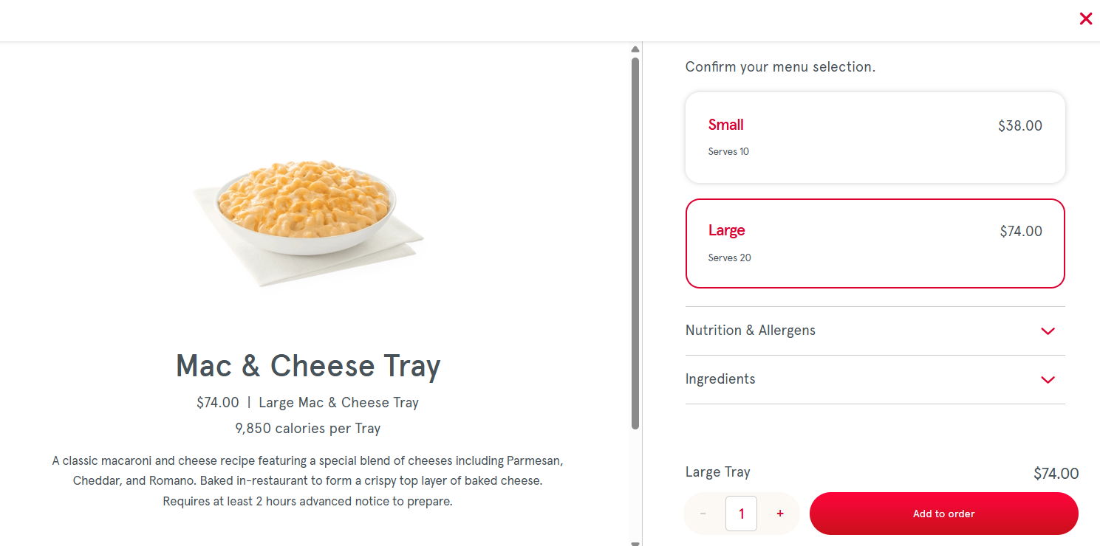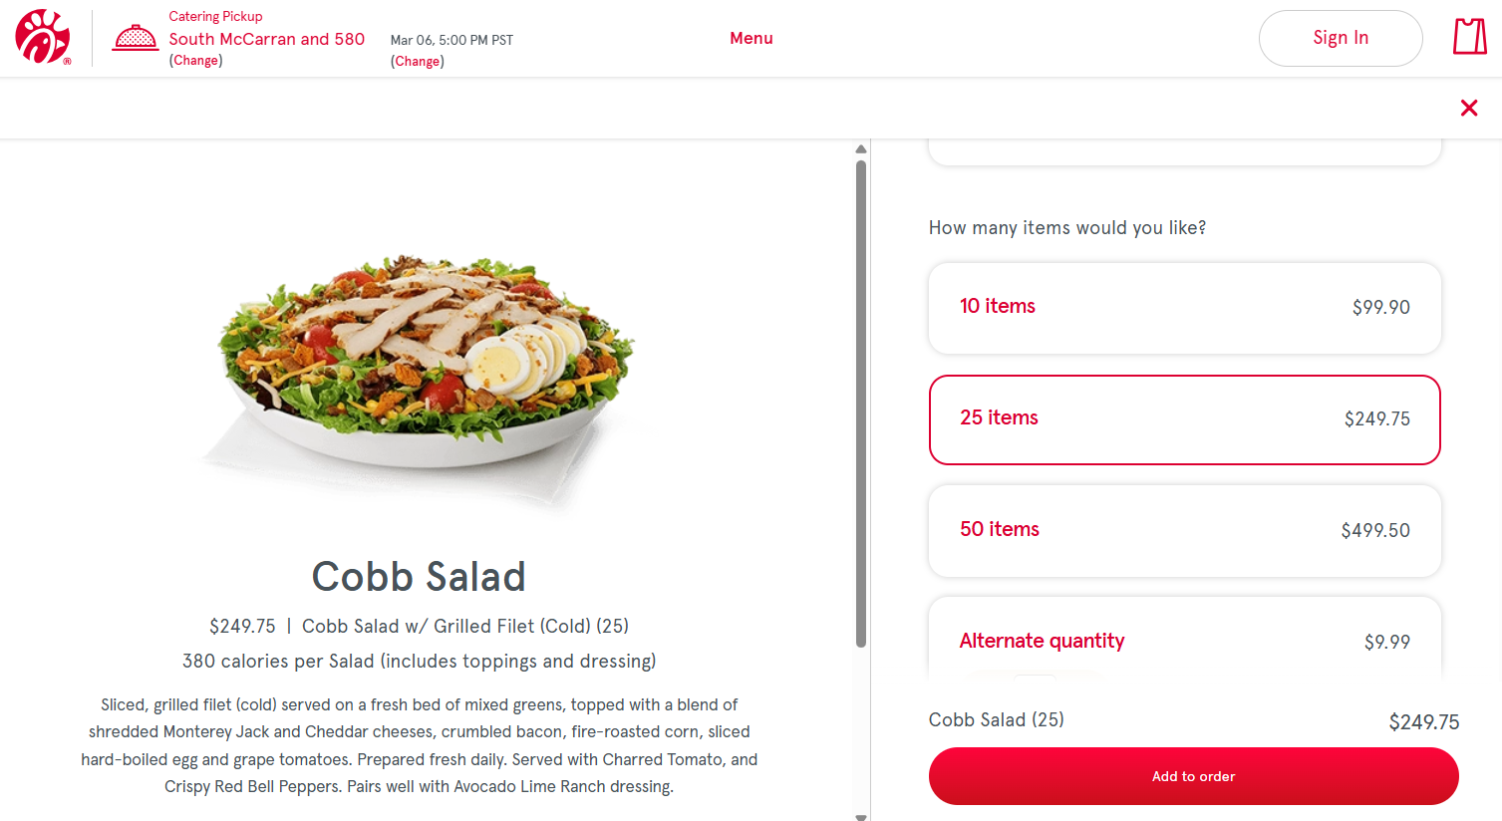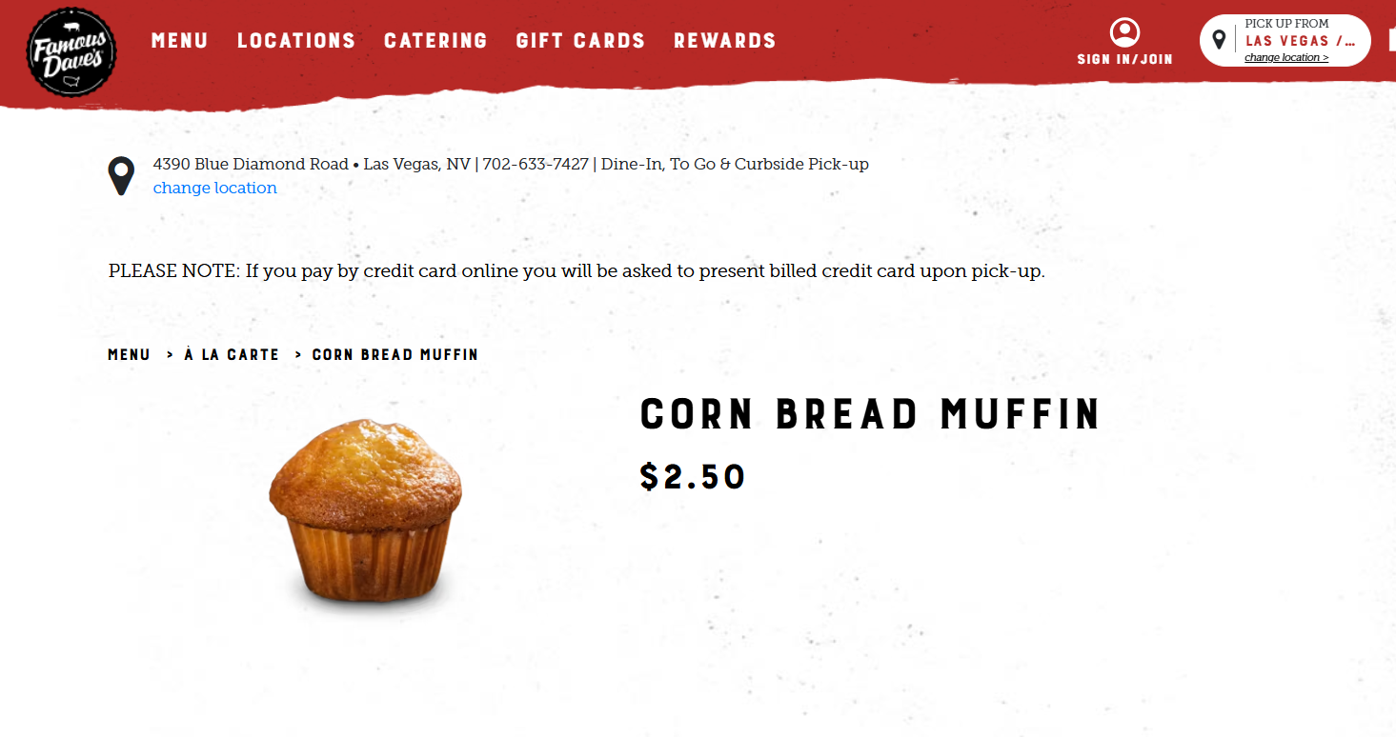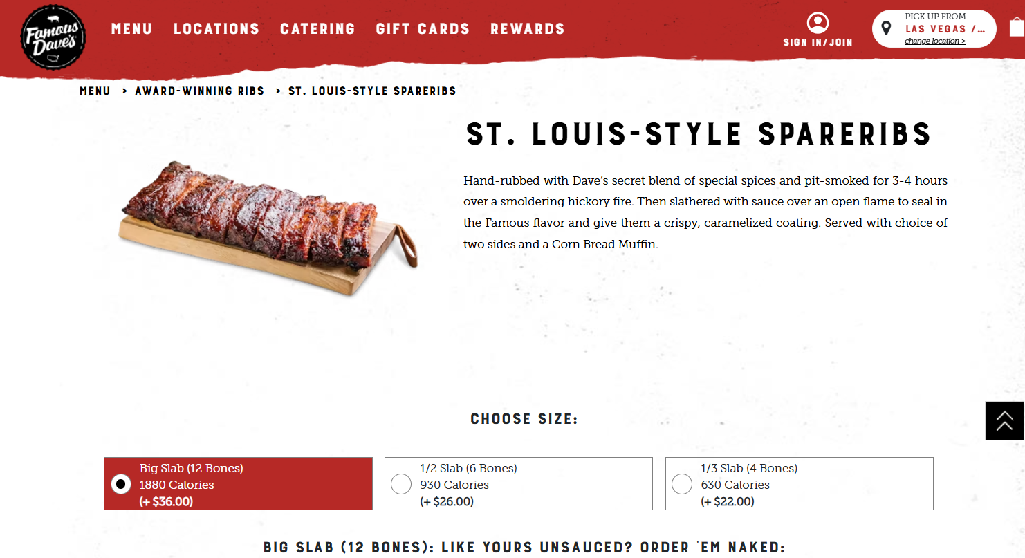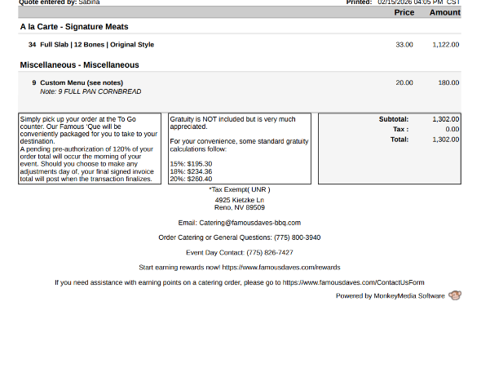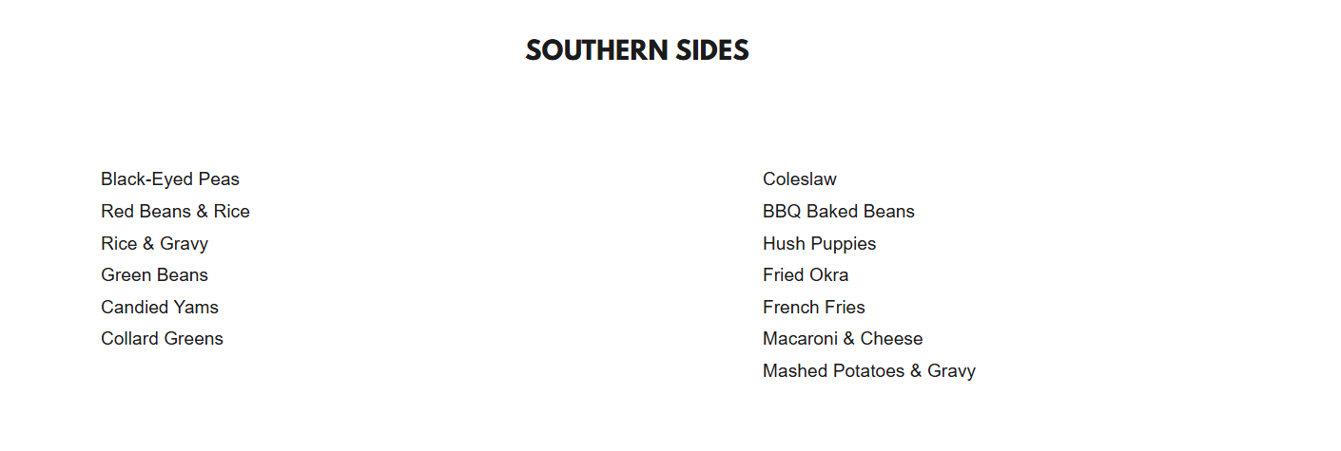

ASUN DEPARTMENT OF IDEA
EVENT & BUDGET PROPOSAL FORM

CONTACT INFORMATION:
Organizer(s)/ Intern(s): Manvi Mummalaneni & Brooklyn Menante
Email: commissionermummalaneni@asun.unr.edu
Learning Outcomes:
- Social justice packets that will explain what Women’s history month is about
- Planned Parenthood Club will also be informing students on their mission
EVENT INFORMATION:
Event Name: | Women’s History Month | Date: | 3/23/26
Event Location: | KC Breezeway | Time: | 10 am to 12 pm (set up at 9:30)
Expected  Attendance: | 100+ | Cost Per  Student: | n/a

BUDGET INFORMATION: Please itemize your ENTIRE event budget below:
DESCRIPTION: | AMOUNT: | VENDOR:
30 Sets Women's History Month Pins International Womens Day Buttons Pins with Motivational Cards Bags for Female Rights Awareness Inspirational Mother's Day Gifts | $37.98 (2 with $18.99 each) | Amazon
Zeyune Women's History Month Party Favors Bulk Feminist Button Badges Pins Freedom Equality Feminism Rights Silicone Bracelets Female Awareness Inspirational Supplies Decor for Gift | $19.99 | Amazon
Snickers, Twix & More Minis Chocolate Candy Bars Variety pack - 30.63 oz Bulk Bag | $29.92 (2 @14.96) | Walmart
hulanddfd Easter Bunny Basket, Pink Large Capacity Canvas Handbasket Cute Candy Bowl for Easter Party Decoration | $5.37 | Walmart
Rectangular 54" x 108" Purple Plastic Table Cover, by Way To Celebrate | $1.00 | Walmart
50PCS Social Justice Stickers for Water Bottle,Notebook,Guitar,Bumper,Scrapbook,Bike,Laptop,Luggage,Suitcase,Aesthetic Cartoon Waterproof Vinyl Sticker,Teens Adults Sticker,Trendy Graffiti Decals | $8.58 (2 $4.29 each) | Amazon
Vanilla 48 Count SancDam Ultra-Thin Oral Sex Dam Membrane, Men and Women Giving Each Other Oral Sex, Cunnilingus Prop SM Fellatio, Oral Dam Covering for Lesbian Or Couples Sex (Dental Dams) | $47.99 | Amazon
LifeStyles ULTRA LUBRICATED Condoms - Also available in quantities of 12, 25, 50 (100 condoms) | 18.97 | Amazon
TOTAL EVENT BUDGET: | $169.80
TOTAL ASUN BUDGET: | $169.80

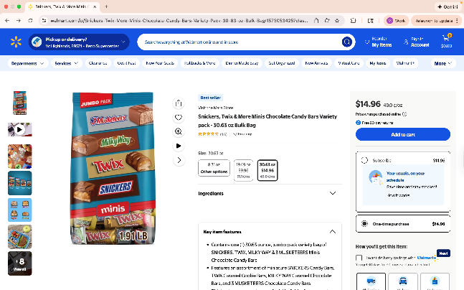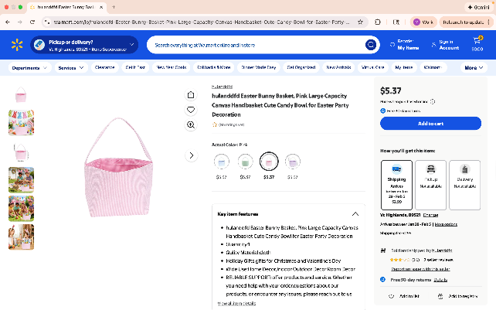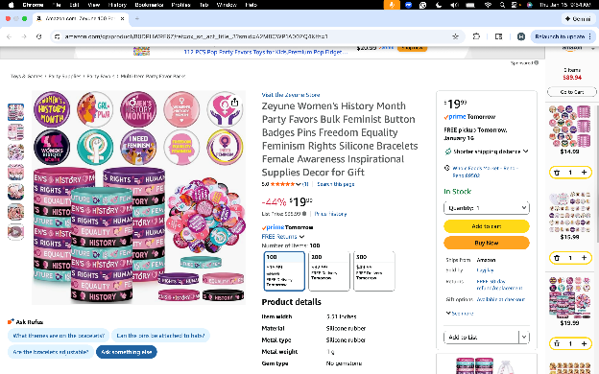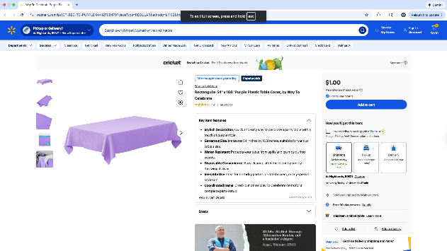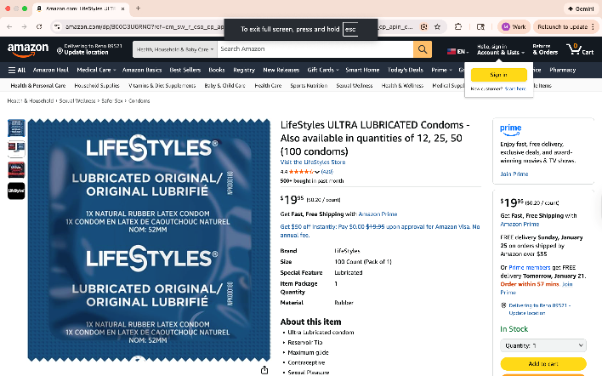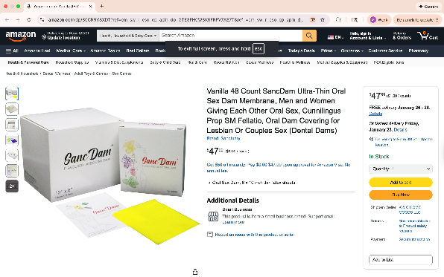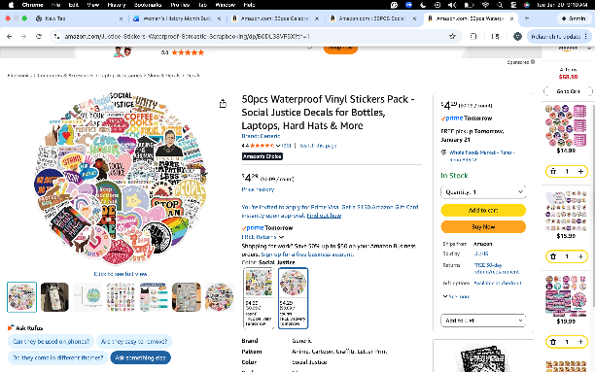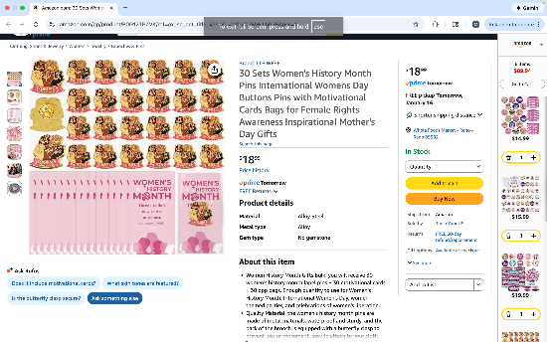

ASUN DEPARTMENT OF IDEA
EVENT & BUDGET PROPOSAL FORM

CONTACT INFORMATION:
Organizer(s)/ Intern(s): Zyna Navarte
E-mail(s): diversitydirector@asun.unr.edu or Znavarte@unr.edu
Learning Outcomes:
- Participants will be able to describe at least one unique experience or challenge faced by multiracial individuals and reflect on how intersecting identities shape personal and social experiences.
- Participants will demonstrate increased understanding of multiracial identity by identifying at least two ways to create more inclusive spaces for individuals with intersecting racial and cultural backgrounds.
EVENT INFORMATION:
Event Name: | Fusion: The Multiracial Celebration | Date: | March 16, 2026
Event Location: | JCSU Ballroom | Time: | 5pm – 8pm
Expected  Attendance: | 100-300+ | Cost Per  Student: | n/a

BUDGET INFORMATION: Please itemize your ENTIRE event budget below:
DESCRIPTION: | AMOUNT: | VENDOR:
- Blue Balloon Arch Kit, 152Pcs Explosion Star Various Blue and Silver Latex Balloon Garland kit Different Size Balloons for Anniversary Birthday Wedding Baby Shower Dark Party Decorations | $9.99 (2) | Amazon
- Blue and Silver Balloons Set, 60 PCS 12In Metallic Blue Silver Confetti Balloons and Navy Blue and Silver Latex Balloons Arch Kit for Wedding Graduation Anniversary Wedding Decorations | $8.99 (3) | Amazon
- Blue Foil Fringe Curtain- 4 Pack of 3.2x8.2ft Blue Streamers Backdrop Curtains for Party Decorations | $9.98 (5) | Amazon
- 10 Pack 10 Feet Foil Fringe Garland Metallic Tinsel Banner Wall Hanging Curtain Streamers Backdrop for Parade Floats Bachelorette Wedding Birthday Party Thanksgiving Christmas Decorations(Blue) | $23.99 (3) | Amazon
- Bulk Candy Individually - 10 Pounds - Big Bulk Candies - Party Favor Treats for Birthdays, Parades, Offices | $42.99 | Amazon
- AhfuLife Different Countries Toothpick Flag, 100 Pcs Mini Flags on Sticks for 2026 World Cup, International Toothpick Flags Cocktail Picks, Flag Cupcake Toppers for International Party Decorations | $6.99 (2) | Amazon
- Panelee 2 Pcs International Welcome Banners 13.8 x 43.3 Inch World Flags Banner Polyester Country Flags Decoration for Sports Events Club Birthday School Classroom Party Supplies Decoration(White) | $9.99 | Amazon
- Rope Untangling Puzzle Game, Educational Strategy Board Game for Kids & Adults, Family Travel Party Games with Multi-Level Challenges, Gifts for All Ages(Manual on Box) | $9.99 | Amazon
- Tic-Tac-Toe Game Book: Less TikTok, More Tic-Tac-Toe!: (For Kids and Adults) | $4.59 | Amazon
- Blue Balloons Metallic Blue Balloon, 60Pcs 12Inch Chrome Blue Balloons Kit Macaron Light Pearl Navy Blue Latex Ba | $6.98 (2) | Amazon
- Black History Month Decorations Photo Booth | $7.99 | Amazon
- Joyin Toy Photo Booth Props 66 Pieces | $9.99 | Amazon
- SpeedArmis Mini Tumble Tower, 54PCS Wooden | $9.99 | Amazon
- Gionlion 6000 Clay Beads Bracelet Making Kit | $8.99 | Amazon
- Mattel 4347154784 Uno Card Game 2 Pack, Red | $14.41 | Amazon
- Bicycle Jumbo Index Playing Cards | $5.24 | Amazon
- 350 Pcs Dark Blue Plastic Plates For Party | $26.89 (2) | Amazon
- Niuara Blue Plastic Table Cloth - 4 Pack 54" × 108" | $8.99 (5) | Amazon
TOTAL EVENT BUDGET: | $410.67
TOTAL ASUN BUDGET: | $410.67
