Department of IDEA
Agenda for Monday, February 09, 2026 at 7:00 PM
In Person- JSCU 332 Frankie Sue Del Papa Presidents Conference Room
Joe Crowley Student Union 3rd Floor
1664 N. Virginia Street
Reno, Nevada 89557
Virtual Zoom ID: 339 969 0437 Passcode: IDEA25
Zoom: LINK

- CALL MEETING TO ORDER

- COMPLIANCE WITH NEVADA OPEN MEETING LAW
  - Was the agenda posted three full working days by 9 am, not including the meeting date? [Bring up the ASUN website and show the public]
  - Is the meeting taking place on the day of the week, month, day, year, at the time and location listed on the agenda?
  - Is the Zoom link working and available to the public?
  - If the answer to any of these questions is no, this meeting must be ENDED IMMEDIATELY unless NOML covers a legitimate correction.

- LAND ACKNOWLEDGEMENT
We recognize that the University of Nevada, Reno, sits on the traditional homelands of the Numu (Northern Paiute), Wašiw (Washoe), Newe (Western Shoshone), Nuwu (Southern Paiute) peoples. These lands continue to be a gathering place for Indigenous peoples and we recognize the deep connections to these places. We extend our appreciation for the opportunity to live and learn on their territory.

- ROLL CALL
The Secretary must list roll call.
- Director, Zyna Navarte
- Commissioner of Event Planning, Bea Campbell
- Commissioner for Marketing and Outreach, Jaden Ottaviano
- Commissioner of Social Justice and Reform, Manvi Mummalaneni

- PUBLIC COMMENT (INFORMATION ONLY)
Items heard under public comment may be for items either on or off the agenda. Action may not be taken on items raised under public comment. The Chair may elect to take public comment on actions on this agenda. The Chair may impose reasonable limits on the length of time members of the public may speak.

- ADOPTION OF MINUTES (FOR POSSIBLE ACTION)
  - January 08, 2026 (Link) – Possible Action
  - January 26, 2026 (Link) – Possible Action

- AUDIO MINUTES MISSING FOR PREVIOUS MEETINGS OF THIS BODY THAT DO NOT MEET 30 DAY POSTING OF NEVADA OPEN MEETING LAW FOR CORRECTIVE ACTION

- REPORTS (INFORMATION ONLY)
- Director, Zyna Navarte
- Commissioner of Event Planning, Bea Campbell
- Commissioner for Marketing and Outreach, Jaden Ottaviano
- Commissioner of Social Justice and Reform, Manvi Mummalaneni

- OLD BUSINESS (INFORMATION ONLY/FOR POSSIBLE ACTION)
  - Share the Crown (Information)

- NEW BUSINESS (INFORMATION ONLY/FOR POSSIBLE ACTION
  - Diversity Calendar and Budget (Information)
  - Love in the Pack (Possible Action)
  - Black Culture Festival Items (Possible Action)
  - Flyers and Poster Printing (Possible Action)

- PUBLIC COMMENT (INFORMATION ONLY)
Items heard under public comment may be for items either on or off the agenda. Action may not be taken on items raised under public comment. The Chair may elect to take public comment on action items on this agenda. The Chair may impose reasonable limits on the length of time members of the public may speak.

- ADJOURNMENT
NOTES:
Agenda items may be considered out of order at the discretion of the Chair. The committee may combine two or more agenda items for consideration. The Committee may remove an item from the agenda or delay discussion of an item at any time.

ASUN DEPARTMENT OF IDEA
EVENT & BUDGET PROPOSAL FORM

CONTACT INFORMATION:
Organizer(s)/Intern(s): Zyna Navarte and Mia Salas (Intern)
E-mail(s): Znavarte@unr.edu
Learning Outcomes:
- We will have stickers that will showcase diverse identities on campus to promote representation.
- We will have activities to stimulate student engagement and inclusivity.
- We will offer informational slips and pamphlets about resources offered by IDEA and UNR.

EVENT INFORMATION:
Event Name: | Love in the Pack | Date: | Friday, February 13th, 2026
Event Location: | KC Breezeway | Time: | 10am – 12pm
Expected  Attendance: | 100 | Cost Per  Student:

BUDGET INFORMATION: Please itemize your ENTIRE event budget below:
DESCRIPTION: | AMOUNT: | VENDOR:
1. (3) PEANUTS® Snoopy Hearts Valentine's Sticker Pack - Set of 48, Largest 2¼" x 2½" | $17.97 | Walmart
2. Freshness Guaranteed Frosted Sugar Cookies, Pink, Shelf-Stable, Whole, 13.5 oz, 10 Count | 19.85 | Walmart
3. M&M's, Snickers, Twix & Milky Way Chocolate Christmas Candy Variety Pack - 120 Ct | 19.88 | Walmart
- Mainstays Decorative Oval Split Willow Basket with Cutout Handles, 16.14” L x 11.42” W x 7.08” H | 15.72 | walmart
- HERSHEY'S KISSES Solid Milk Chocolate, Valentine's Candy Gift Box, 1.45 oz | 25.99 (2) | walmart
- Assorted Daisy Flower Bunch Small | 4.97 (5) | walmart
- Mini Carnation Flower Bunch Small | 4.97 (4) | walmart
TOTAL EVENT BUDGET: | $224.13
TOTAL ASUN BUDGET | $224.13
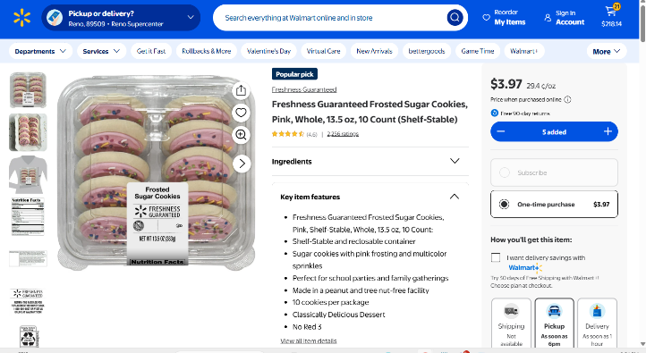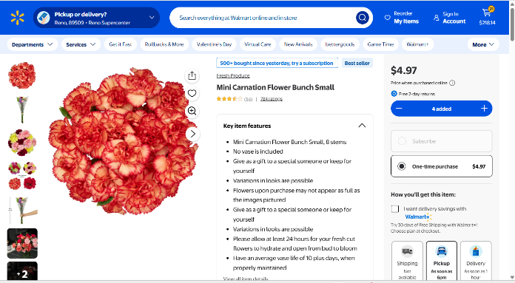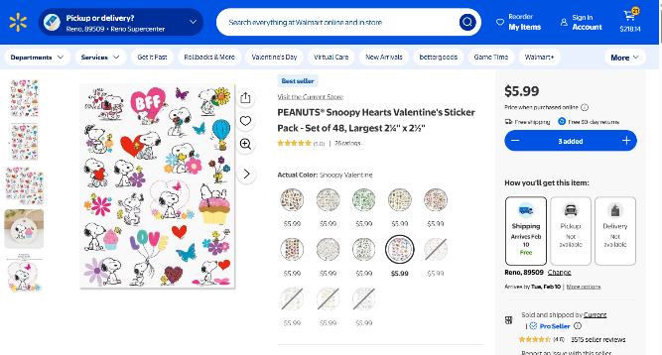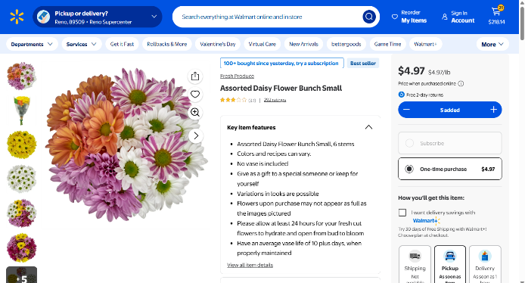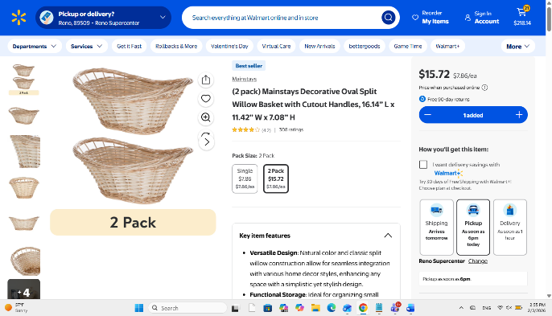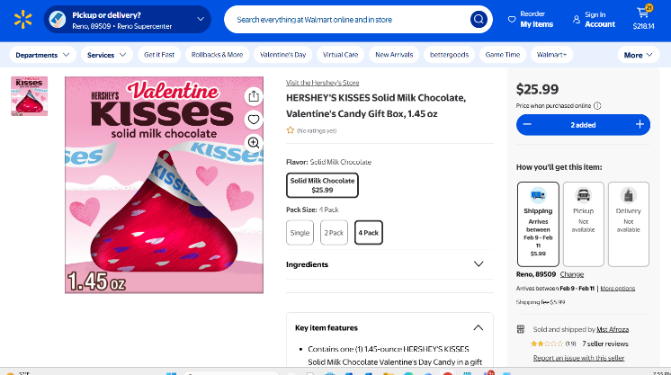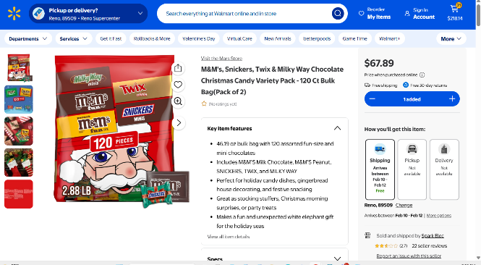

ASUN DEPARTMENT OF IDEA
EVENT & BUDGET PROPOSAL FORM

CONTACT INFORMATION:
Organizer(s)/ Intern(s): Jaden Ottaviano, Ruby Sparks
E-mail(s): commissionerottaviano@asun.unr.edu, rubysparks@unr.edu
Learning Outcomes:
- Participants will gain a deeper understanding of Black history and culture through interactive performances, educational resources, and community engagement
- Participants will recognize the impact of Black culture on social, artistic, and political movements and reflect on its continued importance today
- Participants will build intercultural awareness and allyship skills by engaging in inclusive dialogue that promotes equity and respect.
EVENT INFORMATION:
Event Name: | Black Cultural Festival | Date: | March 06, 2026
Event Location: | JCSU Ballrooms | Time: | 5:30pm -8:30pm
Expected  Attendance: | 100+ | Cost Per  Student: | n/a

BUDGET INFORMATION: Please itemize your ENTIRE event budget below:
DESCRIPTION: | AMOUNT: | VENDOR:
- Balloon Arch | $18.98 (2) | Amazon
- Balloon Arch | $19.98 (2) | Amazon
- Photo Backdrop (9ft x 6ft) | $47.80 (2) | Amazon
- 4 pck Rectangle Tablecloths - Black and Gold | $59.88 (6) | Amazon
- 12 pck Round Tableclothes – Black and Gold | $45.98 (2) | Amazon
- 50 pcs Black and Gold Balloons | $67.90 (20) | Amazon
- 150 pcs Black Cutlery | $143.91 (9) | Amazon
- 100 pcs Green Plates | $179.96 (4) | Amazon
- 100 pcs Black and Gold Cups | $99.96 (4) | Amazon
- 400 pck Napkins | $29.99 (1) | Amazon
- Electric Balloon Pump | $13.98 (1) | Amazon

TOTAL EVENT BUDGET: | $728.32
TOTAL ASUN BUDGET: | $728.32

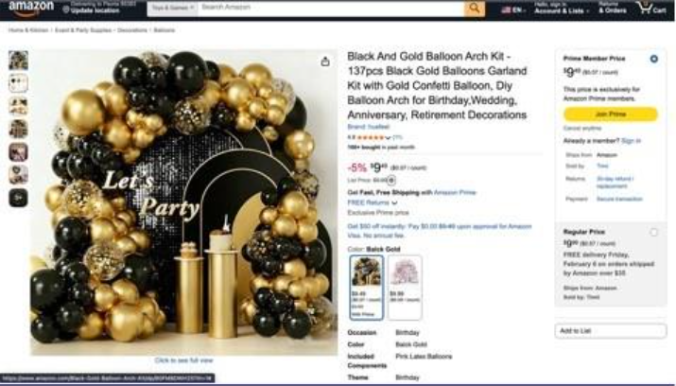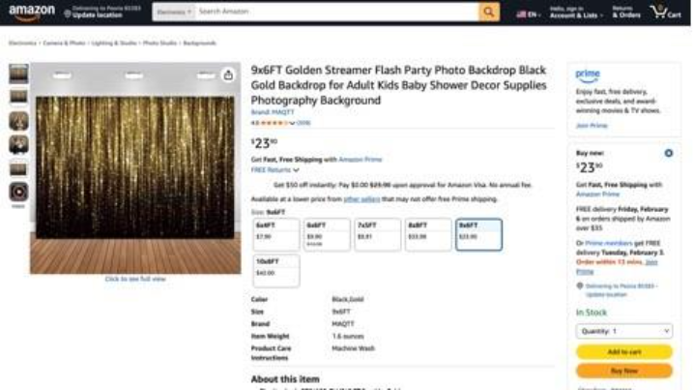
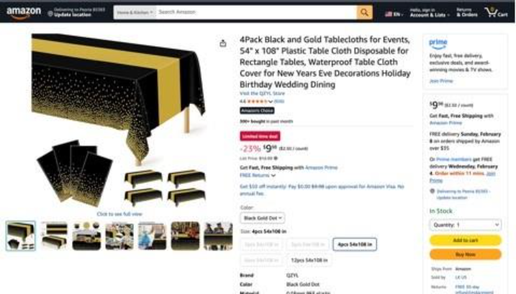
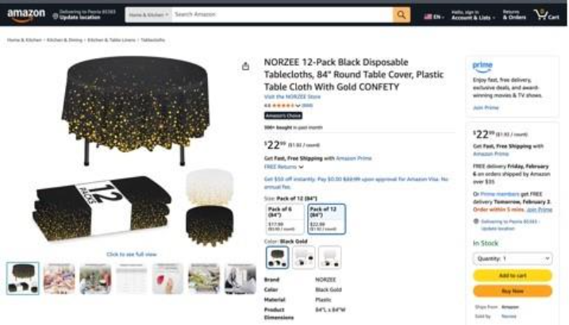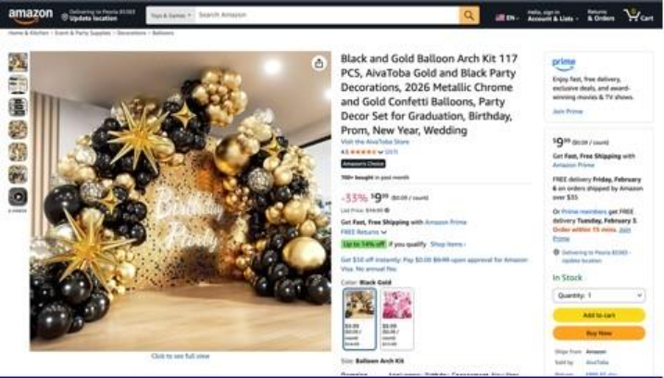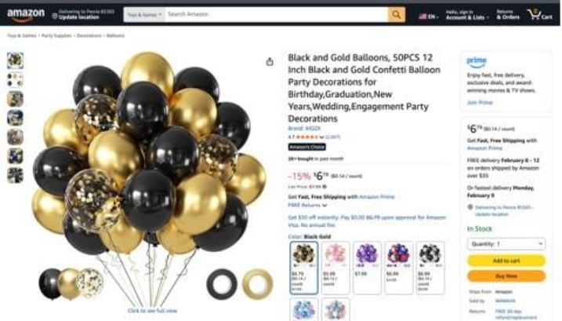
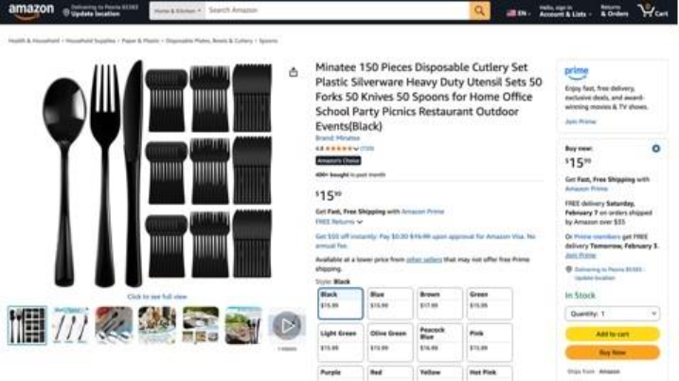
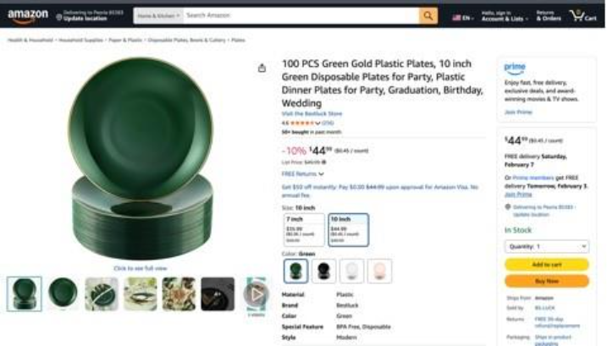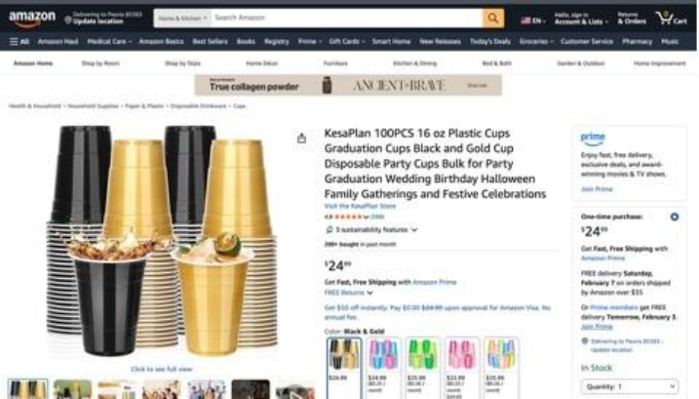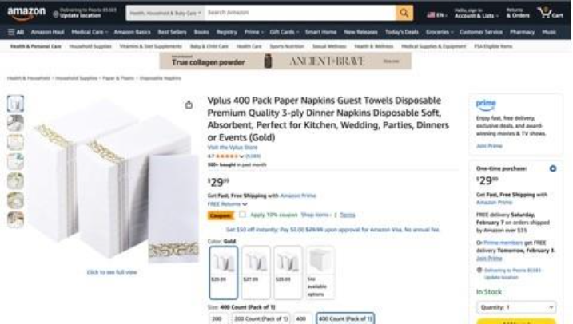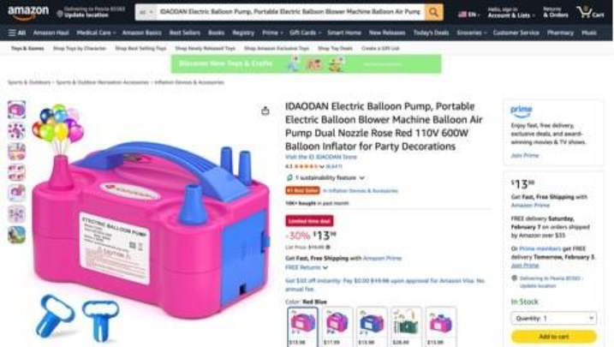

ASUN DEPARTMENT OF IDEA
EVENT & BUDGET PROPOSAL FORM

CONTACT INFORMATION:
Organizer(s)/Intern(s): Zyna Navarte
E-mail(s): Znavarte@unr.edu
Learning Outcomes:
1. Participants will gain awareness of campus resources through the Department of IDEA’s distribution of informational flyers and social justice packets at campus events.

EVENT INFORMATION:
Event Name: | Flyers Distributions and Printing | Date: | n/a
Event Location: | N/A | Time: | n/a
Expected  Attendance: | 100 | Cost Per  Student: | N/A

BUDGET INFORMATION: Please itemize your ENTIRE event budget below:
DESCRIPTION: | AMOUNT: | VENDOR:
1. Flyers & Social Justice Packets for February Month | $120 | LRC

TOTAL EVENT BUDGET: | $120
TOTAL ASUN BUDGET: | $120

DRAFT 