Department of IDEA
Agenda for Thursday, February 26th, 2026 at 11:00 AM
In Person- JSCU 332 Frankie Sue Del Papa Presidents Conference Room
Joe Crowley Student Union 3rd Floor
1664 N. Virginia Street
Reno, Nevada 89557
Virtual Zoom ID: 339 969 0437 Passcode: IDEA25
Zoom: LINK

- CALL MEETING TO ORDER
  - Director Zyna Navarte called the meeting to order at 11:10 AM.
- COMPLIANCE WITH NEVADA OPEN MEETING LAW
  - Was the agenda posted three full working days by 9 am, not including the meeting date? [Bring up the ASUN website and show the public]
  - Is the meeting taking place on the day of the week, month, day, year, at the time and location listed on the agenda?
  - Is the Zoom link working and available to the public?
  - If the answer to any of these questions is no, this meeting must be ENDED IMMEDIATELY unless NOML covers a legitimate correction.

- LAND ACKNOWLEDGEMENT
We recognize that the University of Nevada, Reno, sits on the traditional homelands of the Numu (Northern Paiute), Wašiw (Washoe), Newe (Western Shoshone), Nuwu (Southern Paiute) peoples. These lands continue to be a gathering place for Indigenous peoples and we recognize the deep connections to these places. We extend our appreciation for the opportunity to live and learn on their territory.

- ROLL CALL
The Secretary must list roll call.
- Director, Zyna Navarte - Present
- Commissioner of Event Planning, Bea Campbell – Present
- Commissioner for Marketing and Outreach, Jaden Ottaviano – Present
- Commissioner of Social Justice and Reform, Manvi Mummalaneni – Absent Excused

- PUBLIC COMMENT (INFORMATION ONLY)
There was no public comment at this time.

- ADOPTION OF MINUTES (FOR POSSIBLE ACTION)
There are no minutes to be approved at this time.

- AUDIO MINUTES MISSING FOR PREVIOUS MEETINGS OF THIS BODY THAT DO NOT MEET 30 DAY POSTING OF NEVADA OPEN MEETING LAW FOR CORRECTIVE ACTION
For Possible Corrective Action:
Month/Day/2025 — Uploaded Audio (For Possible Corrective Action)

- REPORTS (INFORMATION ONLY)
- Director, Zyna Navarte: Attended President’s Cabinet Meeting. Sustainability Department initiatives will be launching in April; collaboration anticipated. Finalizing Black Cultural Festival planning. Beginning drafting and planning for Fusion (Multiracial Celebration), occurring in three weeks. Conducting outreach to organizations including QSU, Hawaiian Club, and others for Black Cultural Festival and April collaborations. No questions were raised.
- Commissioner of Project and Events, Bea Campbell: Thanked ASUN officers and interns for assisting with the Share the Crown event. Achieved approximately 880+ participants. Secured media coverage from News 2. Donated approximately 100 hair kits and additional resources to Black Wall Street Reno. Sent invitations to executive branch directors for Black Cultural Festival participation. Submitted relocation form for Fusion. Hosted department presentations from Director Sosa and Assistant Director Cook. Director Mendoza scheduled to present next week. No questions were raised.
- Commissioner for Marketing and Outreach, Jaden Ottaviano: Continued Black Cultural Festival planning and budget coordination. Confirmed food purchases within budget. Conducted outreach to organizations for attendance and tabling. Updated marketing materials for Fusion. No questions were raised.
- Commissioner of Social Justice and Policy, Manvi Mummalaneni: Printed and folded 400 Social Justice pamphlets. 100 sheets of Know Your Rights cards (6 per sheet) pending cutting. Materials will be distributed to Senator Castro for allocation between events and senators. Reserved KC Breezeway for Women’s History Month tabling. Began drafting Social Justice packets for Women’s History Month. Director Navarte reminded commissioners to finalize pamphlet folding and card cutting prior to the Black Cultural Festival.

- OLD BUSINESS (INFORMATION ONLY/FOR POSSIBLE ACTION)
  - No old business at this time

- NEW BUSINESS (INFORMATION ONLY/FOR POSSIBLE ACTION
  - Black Culture Festival Food (Possible Action): Food selections finalized. Motion: Approve Black Cultural Festival food budget. Motion by Commissioner Ottaviano Second by Commissioner Campbell. Vote: Passed unanimously
  - Women’s History Month (Possible Action) Setup begins at 9:30 AM. Led by Commissioner Momalaneni. Collaboration under consideration with Planned Parenthood Club. Items purchased: pins, stickers, snacks, tablecloths, condoms, and Social Justice packets.Learning Outcomes: Advocate for Women’s History Month. Distribute Social Justice resources. Provide safety and advocacy information. Motion: Approve Women’s History Month tabling budget. Motion by Commissioner Campbell Second by Commissioner Ottaviano. Vote: Passed unanimously
  - Fusion: The Multiracial Celebration (Possible Action): Celebrate multiracial identity. Foster belonging and representation on campus. Event Details: 6–8 food tables in KC Breezeway. Rotunda reserved for performances, speakers, and seating. Expected attendance: 100–300 students. Purchases: balloon arch, curtains, candies, flag toothpicks, banners, UNO cards, bracelet-making supplies, tic-tac-toe materials, tablecloths. Motion: Approve Fusion budget. Motion by Commissioner Ottaviano Second by Commissioner Campbell Vote: Passed unanimously

- PUBLIC COMMENT (INFORMATION ONLY)
  - None

- ADJOURNMENT
NOTES:
Director Navarte adjourned the meeting at 11:23 AM on Thursday, February 26, 2026, in JCSU Room 332.

ASUN DEPARTMENT OF IDEA
EVENT & BUDGET PROPOSAL FORM

CONTACT INFORMATION:
Organizer(s)/ Intern(s): Jaden Ottaviano, Ruby Sparks
E-mail(s): commissionerottaviano@asun.unr.edu, rubysparks@unr.edu
Learning Outcomes:
- Participants will gain a deeper understanding of Black history and culture through interactive performances, educational resources, and community engagement
- Participants will recognize the impact of Black culture on social, artistic, and political movements and reflect on its continued importance today
- Participants will build intercultural awareness and allyship skills by engaging in inclusive dialogue that promotes equity and respect.
EVENT INFORMATION:
Event Name: | Black Culture Festival | Date: | 03/06/2026
Event Location: | JCSU Ballroom | Time: | 5:30PM TO 8:30PM
Expected  Attendance: | 100+ | Cost Per  Student: | n/a

BUDGET INFORMATION: Please itemize your ENTIRE event budget below:
DESCRIPTION: | AMOUNT: | VENDOR:
- 300-Finger Tailgate | $428.97 (2) | canes
- Milo's Strawberry Lemonade - 128 fl oz | $4.48 (7) | walmart
- Milo's Famous Sweet Iced Tea, 100% Natural, 128 fl oz | $3.94 (7) | walmart
- Milo's 100% Natural Famous Unsweet Iced Tea, 128 fl oz Jug | $3.94 (7) | walmart
- Marketside Bite Sized Turtle Chocolate Brownies, 13.3 oz, 12 Count (Shelf-Stable) | $5.97 (5) | walmart
- Marketside Bite Sized Ultimate Chocolate Brownies, 13.3 oz, 12 Count (Shelf-Stable) | $5.83 (5) | walmart
- Great Value Purified Drinking Water, 16.9 fl oz, 40 Count | $5.47 (5) | walmart
- Assorted Cookie Tray, 84 ct. | $19.93 (2) | Sams club
- Mac & Cheese Tray | $74.00 (4) | Chik-fil-a
- Cobb Salad | $249.75 | Chik-fil-a
- Ribs (33) | $1,122.00 | Famous Daves
- Cornbread full pan | $180.00 | Famous Daves
- M & M’s Southern Café: Beans, Rice, Collard Greens | $2,500 (estimate amount) | M & M’s Southern Cafe
- Photobooth | $50.00 | Nevada Student Initiative
TOTAL EVENT BUDGET: | $5,468.43
TOTAL ASUN BUDGET: | $5,468.43
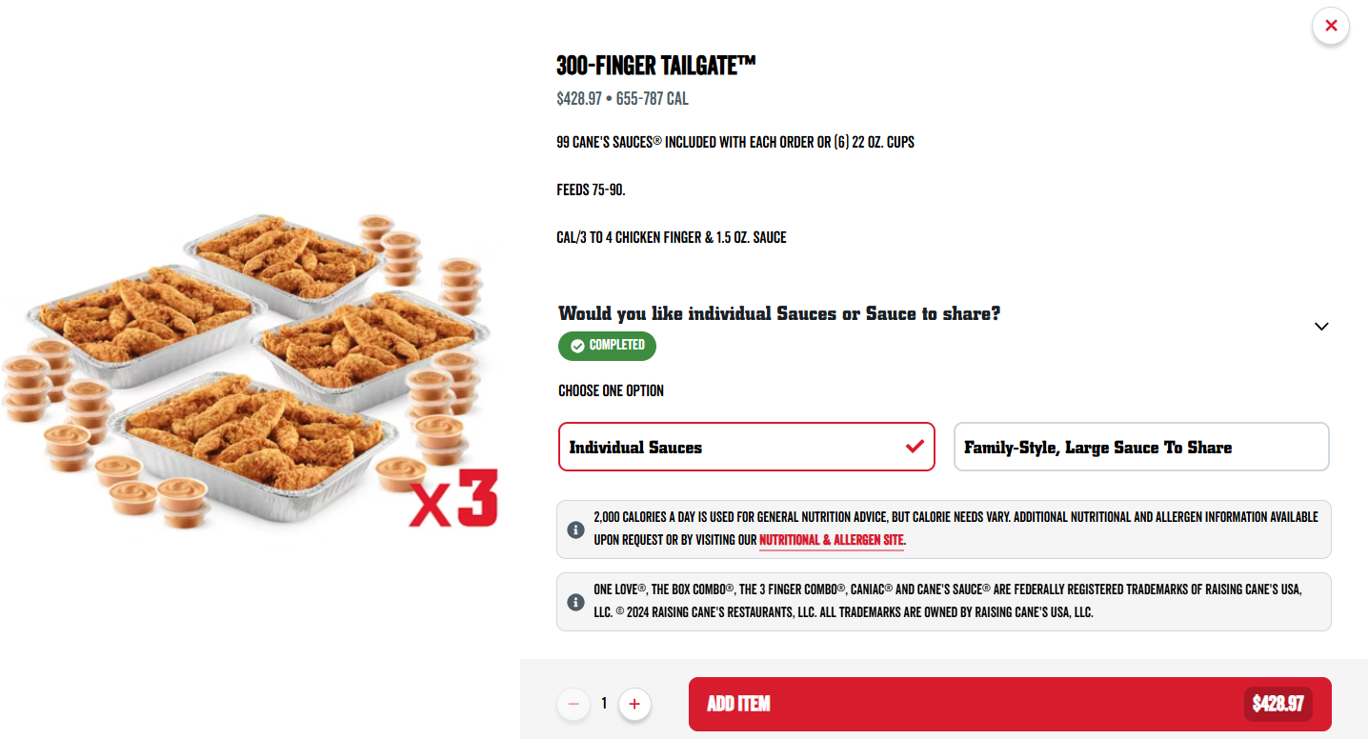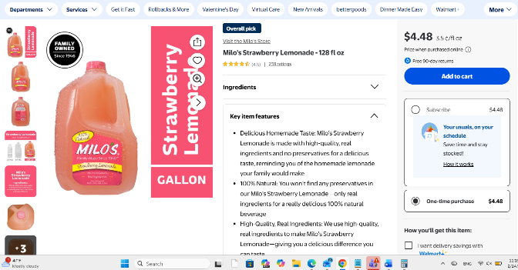
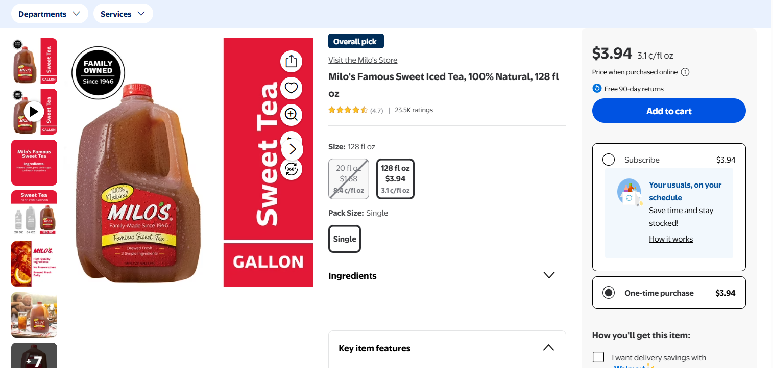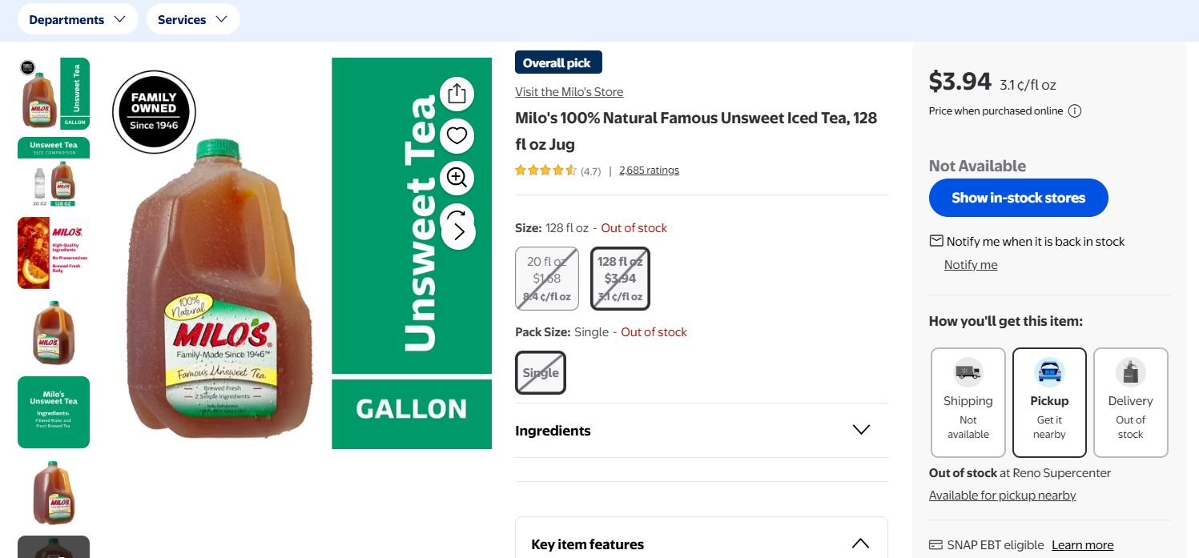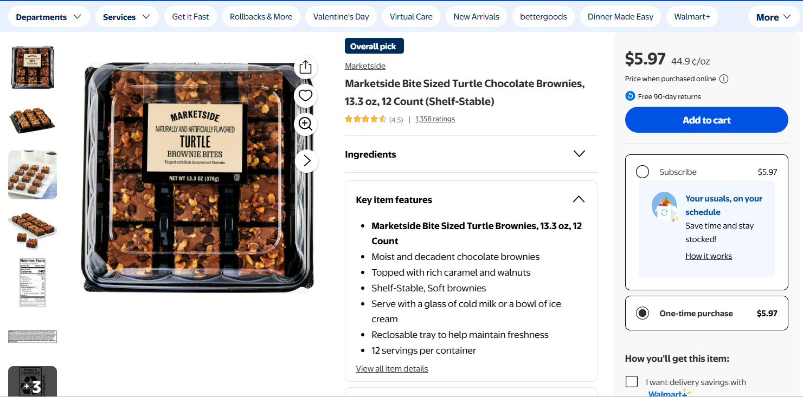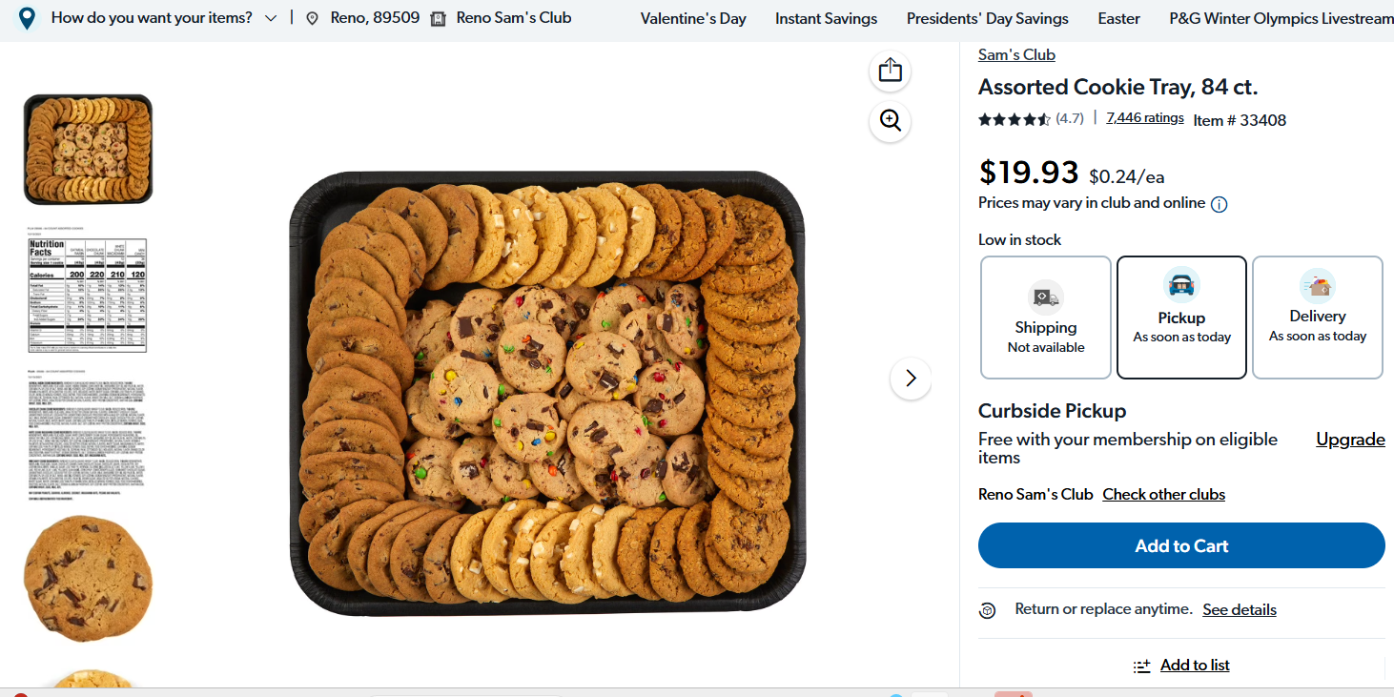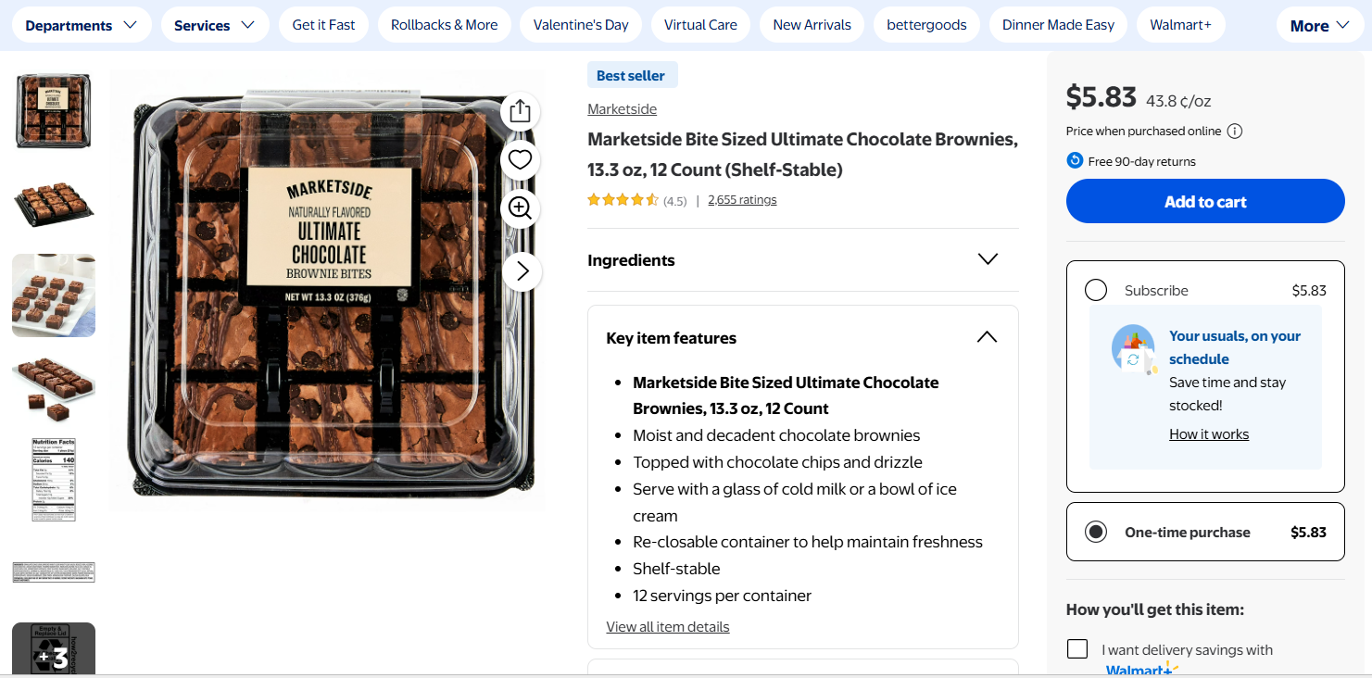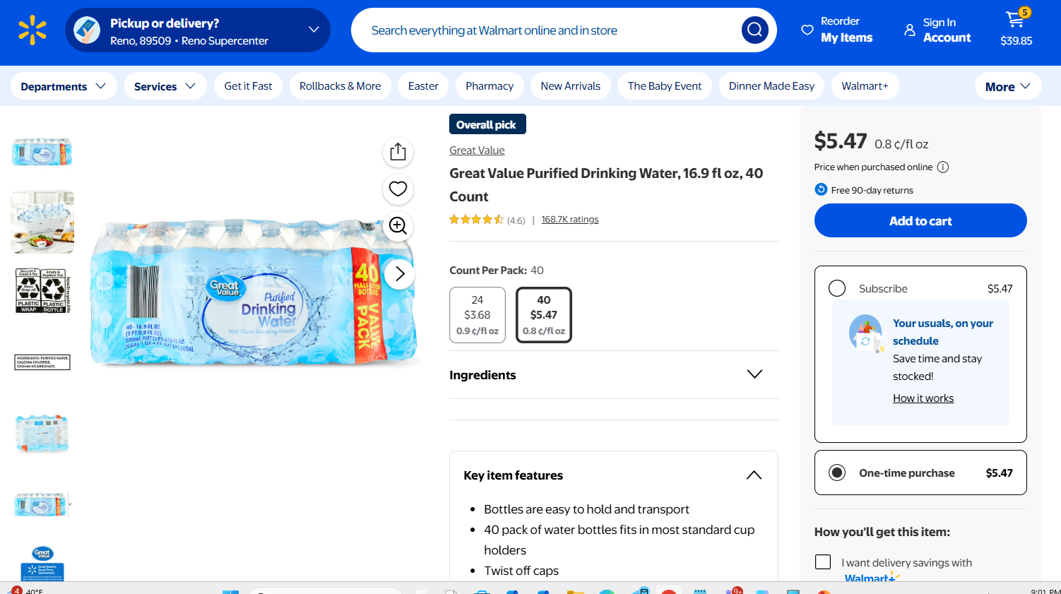
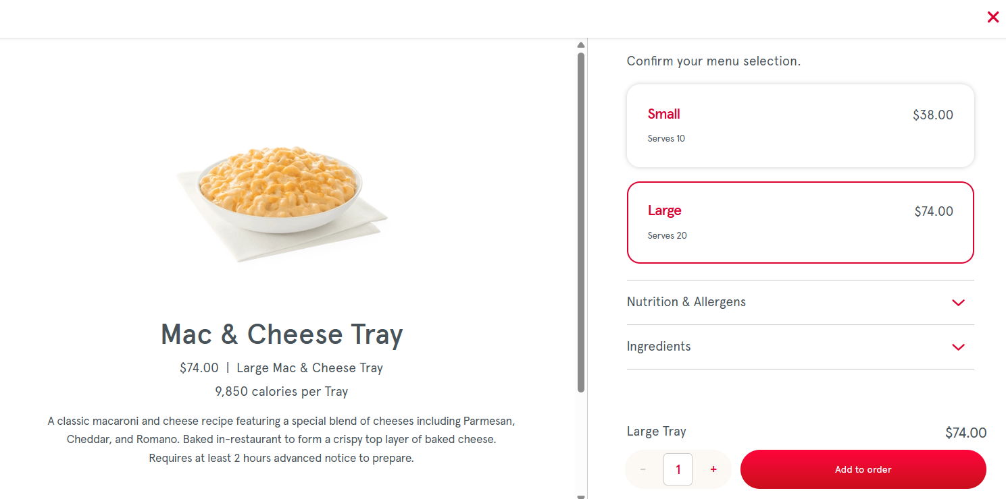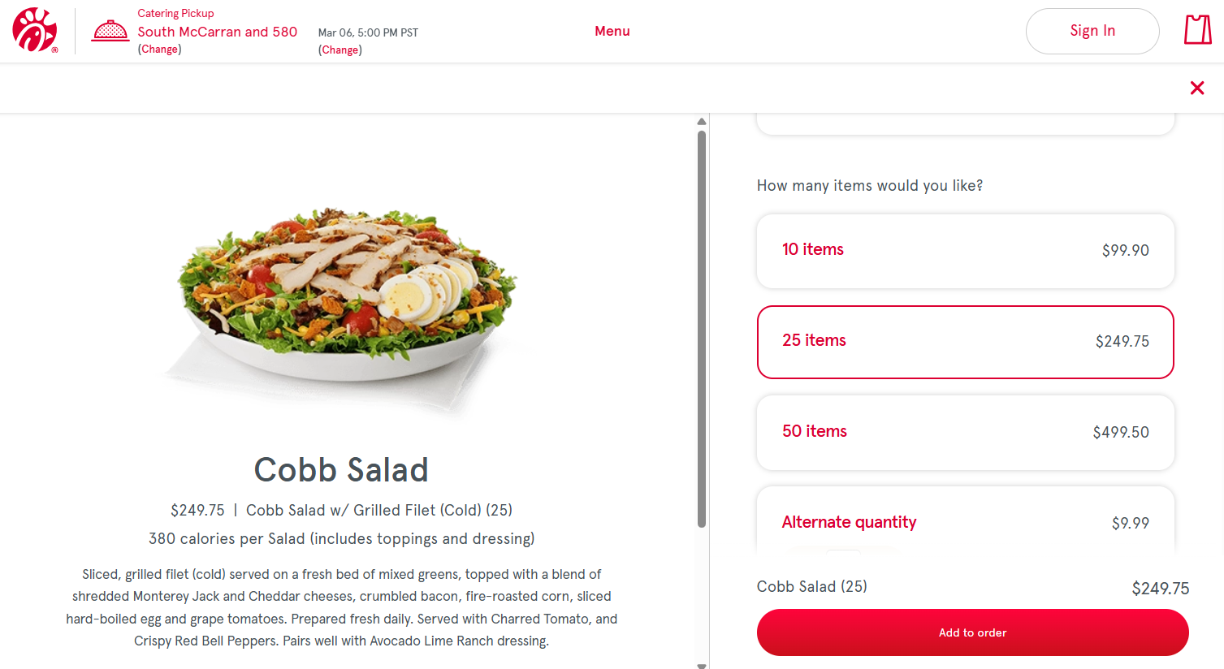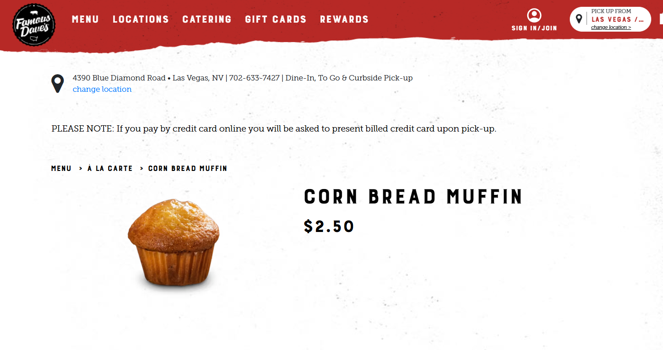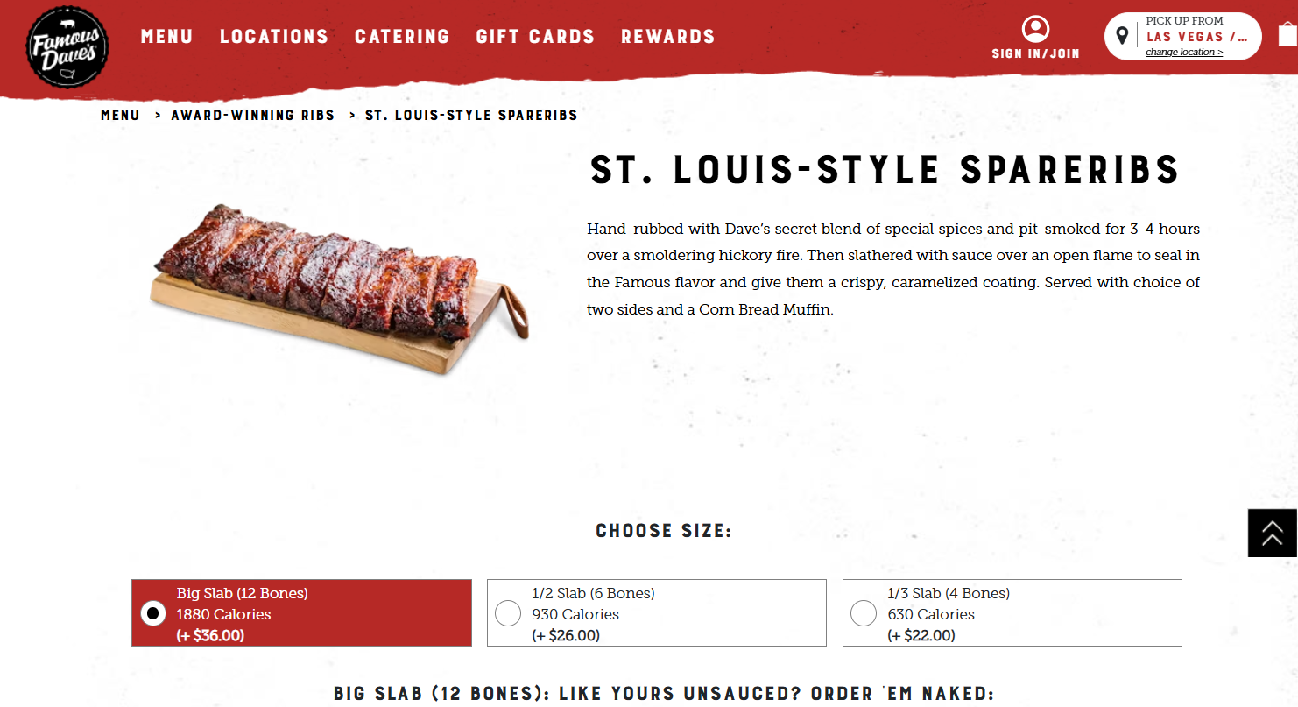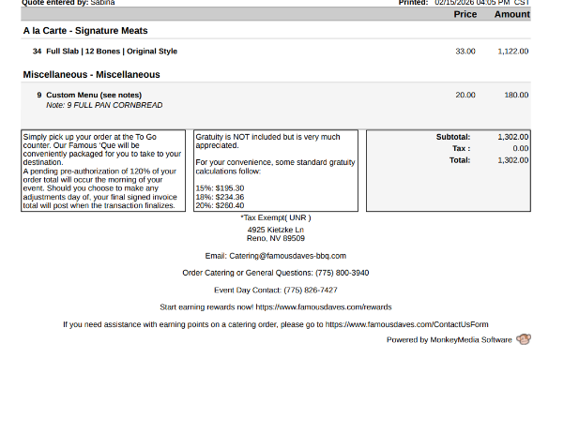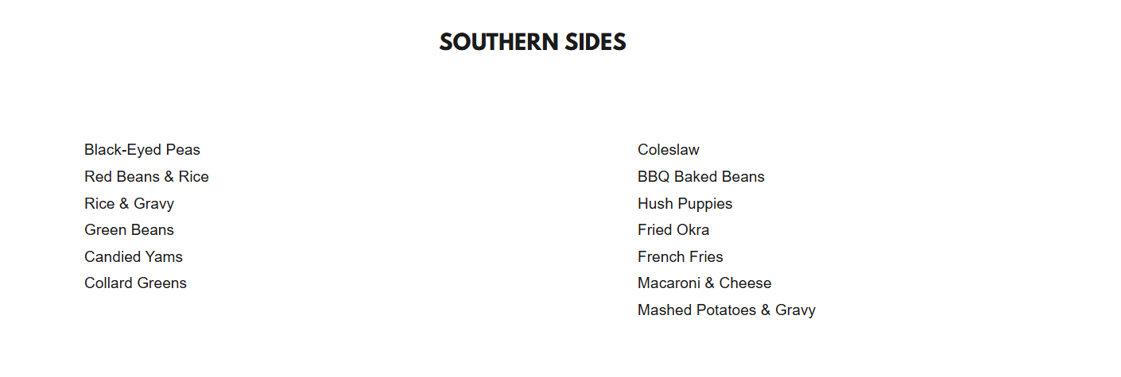

ASUN DEPARTMENT OF IDEA
EVENT & BUDGET PROPOSAL FORM

CONTACT INFORMATION:
Organizer(s)/ Intern(s): Manvi Mummalaneni & Brooklyn Menante
Email: commissionermummalaneni@asun.unr.edu
Learning Outcomes:
- Social justice packets that will explain what Women’s history month is about
- Planned Parenthood Club will also be informing students on their mission
EVENT INFORMATION:
Event Name: | Women’s History Month | Date: | 3/23/26
Event Location: | KC Breezeway | Time: | 10 am to 12 pm (set up at 9:30)
Expected  Attendance: | 100+ | Cost Per  Student: | n/a

BUDGET INFORMATION: Please itemize your ENTIRE event budget below:
DESCRIPTION: | AMOUNT: | VENDOR:
30 Sets Women's History Month Pins International Womens Day Buttons Pins with Motivational Cards Bags for Female Rights Awareness Inspirational Mother's Day Gifts | $37.98 (2 with $18.99 each) | Amazon
Zeyune Women's History Month Party Favors Bulk Feminist Button Badges Pins Freedom Equality Feminism Rights Silicone Bracelets Female Awareness Inspirational Supplies Decor for Gift | $19.99 | Amazon
Snickers, Twix & More Minis Chocolate Candy Bars Variety pack - 30.63 oz Bulk Bag | $29.92 (2 @14.96) | Walmart
hulanddfd Easter Bunny Basket, Pink Large Capacity Canvas Handbasket Cute Candy Bowl for Easter Party Decoration | $5.37 | Walmart
Rectangular 54" x 108" Purple Plastic Table Cover, by Way To Celebrate | $1.00 | Walmart
50PCS Social Justice Stickers for Water Bottle,Notebook,Guitar,Bumper,Scrapbook,Bike,Laptop,Luggage,Suitcase,Aesthetic Cartoon Waterproof Vinyl Sticker,Teens Adults Sticker,Trendy Graffiti Decals | $8.58 (2 $4.29 each) | Amazon
Vanilla 48 Count SancDam Ultra-Thin Oral Sex Dam Membrane, Men and Women Giving Each Other Oral Sex, Cunnilingus Prop SM Fellatio, Oral Dam Covering for Lesbian Or Couples Sex (Dental Dams) | $47.99 | Amazon
LifeStyles ULTRA LUBRICATED Condoms - Also available in quantities of 12, 25, 50 (100 condoms) | 18.97 | Amazon
TOTAL EVENT BUDGET: | $169.80
TOTAL ASUN BUDGET: | $169.80

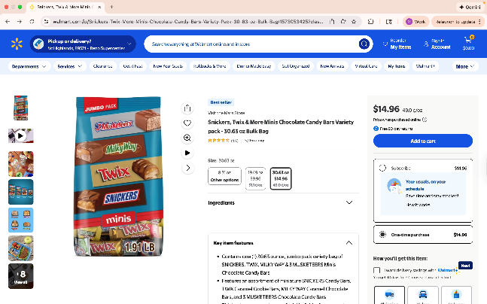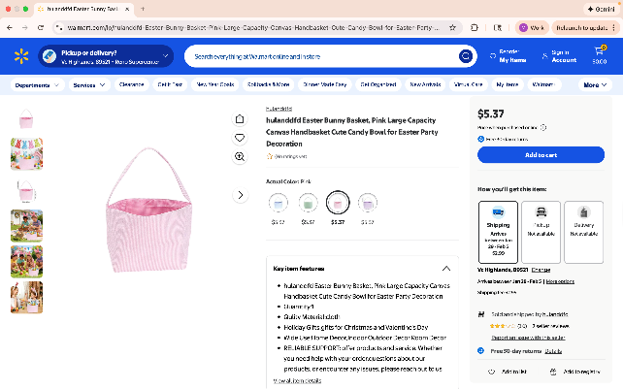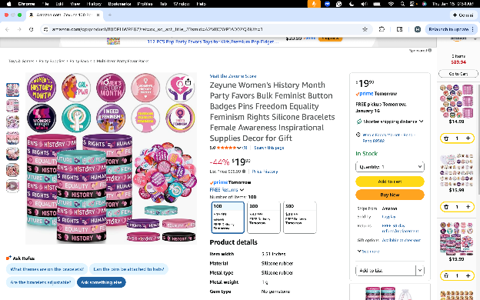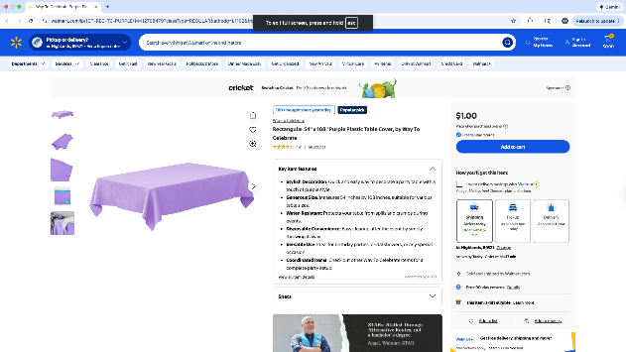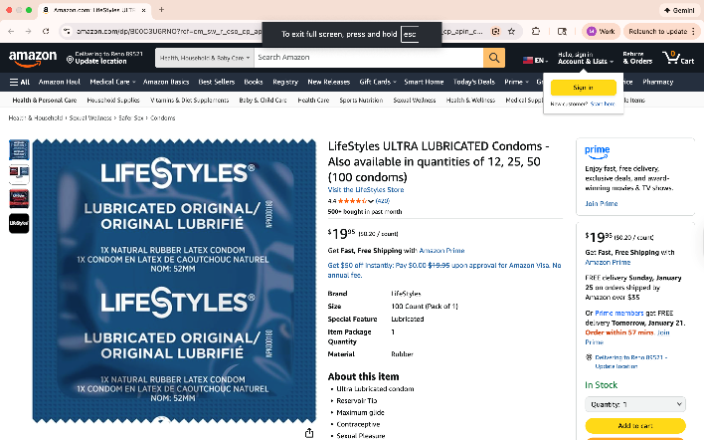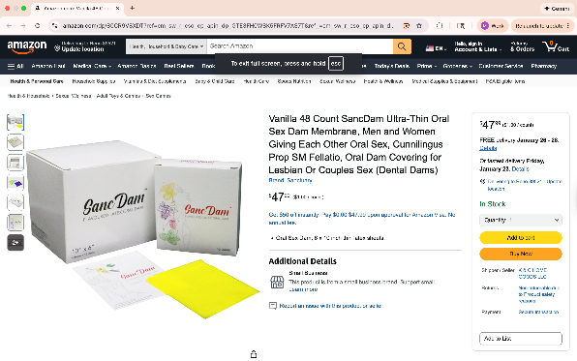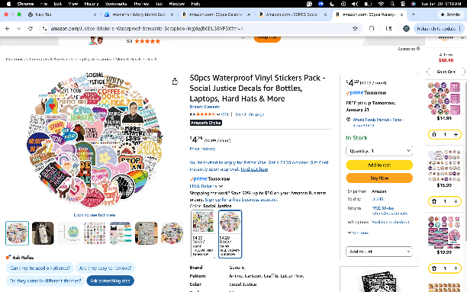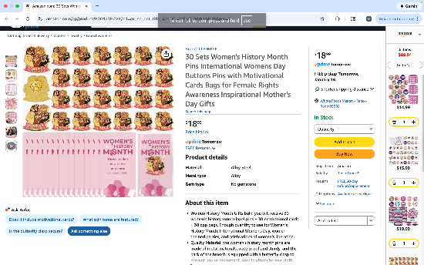

ASUN DEPARTMENT OF IDEA
EVENT & BUDGET PROPOSAL FORM

CONTACT INFORMATION:
Organizer(s)/ Intern(s): Zyna Navarte
E-mail(s): diversitydirector@asun.unr.edu or Znavarte@unr.edu
Learning Outcomes:
- Participants will be able to describe at least one unique experience or challenge faced by multiracial individuals and reflect on how intersecting identities shape personal and social experiences.
- Participants will demonstrate increased understanding of multiracial identity by identifying at least two ways to create more inclusive spaces for individuals with intersecting racial and cultural backgrounds.
EVENT INFORMATION:
Event Name: | Fusion: The Multiracial Celebration | Date: | March 16, 2026
Event Location: | JCSU Ballroom | Time: | 5pm – 8pm
Expected  Attendance: | 100-300+ | Cost Per  Student: | n/a

BUDGET INFORMATION: Please itemize your ENTIRE event budget below:
DESCRIPTION: | AMOUNT: | VENDOR:
- Blue Balloon Arch Kit, 152Pcs Explosion Star Various Blue and Silver Latex Balloon Garland kit Different Size Balloons for Anniversary Birthday Wedding Baby Shower Dark Party Decorations | $9.99 (2) | Amazon
- Blue and Silver Balloons Set, 60 PCS 12In Metallic Blue Silver Confetti Balloons and Navy Blue and Silver Latex Balloons Arch Kit for Wedding Graduation Anniversary Wedding Decorations | $8.99 (3) | Amazon
- Blue Foil Fringe Curtain- 4 Pack of 3.2x8.2ft Blue Streamers Backdrop Curtains for Party Decorations | $9.98 (5) | Amazon
- 10 Pack 10 Feet Foil Fringe Garland Metallic Tinsel Banner Wall Hanging Curtain Streamers Backdrop for Parade Floats Bachelorette Wedding Birthday Party Thanksgiving Christmas Decorations(Blue) | $23.99 (3) | Amazon
- Bulk Candy Individually - 10 Pounds - Big Bulk Candies - Party Favor Treats for Birthdays, Parades, Offices | $42.99 | Amazon
- AhfuLife Different Countries Toothpick Flag, 100 Pcs Mini Flags on Sticks for 2026 World Cup, International Toothpick Flags Cocktail Picks, Flag Cupcake Toppers for International Party Decorations | $6.99 (2) | Amazon
- Panelee 2 Pcs International Welcome Banners 13.8 x 43.3 Inch World Flags Banner Polyester Country Flags Decoration for Sports Events Club Birthday School Classroom Party Supplies Decoration(White) | $9.99 | Amazon
- Rope Untangling Puzzle Game, Educational Strategy Board Game for Kids & Adults, Family Travel Party Games with Multi-Level Challenges, Gifts for All Ages(Manual on Box) | $9.99 | Amazon
- Tic-Tac-Toe Game Book: Less TikTok, More Tic-Tac-Toe!: (For Kids and Adults) | $4.59 | Amazon
- Blue Balloons Metallic Blue Balloon, 60Pcs 12Inch Chrome Blue Balloons Kit Macaron Light Pearl Navy Blue Latex Ba | $6.98 (2) | Amazon
- Black History Month Decorations Photo Booth | $7.99 | Amazon
- Joyin Toy Photo Booth Props 66 Pieces | $9.99 | Amazon
- SpeedArmis Mini Tumble Tower, 54PCS Wooden | $9.99 | Amazon
- Gionlion 6000 Clay Beads Bracelet Making Kit | $8.99 | Amazon
- Mattel 4347154784 Uno Card Game 2 Pack, Red | $14.41 | Amazon
- Bicycle Jumbo Index Playing Cards | $5.24 | Amazon
- 350 Pcs Dark Blue Plastic Plates For Party | $26.89 (2) | Amazon
- Niuara Blue Plastic Table Cloth - 4 Pack 54" × 108" | $8.99 (5) | Amazon
TOTAL EVENT BUDGET: | $410.67
TOTAL ASUN BUDGET: | $410.67
