Ww12Docusign Envelope ID: 63D2362C-E4D9-4E02-B3A4-B5501231AE5B

Senate of the Associated Students of the University of Nevada
93rd Session, 2025-2026

A RESOLUTION ELECTING THE SPEAKER OF THE SENATE
Resolution Number: 01
Authored By: 2025-2026 Student Government Assembly
Sponsored By: 2025-2026 Student Government Assembly

Be it resolved by the Senate of the Associated Students that Leaf Acklin was elected and will serve as the Speaker of the 93rd Session of the Senate of the Associated Students.

Adopted in Senate on April 16, 2025
Attest:
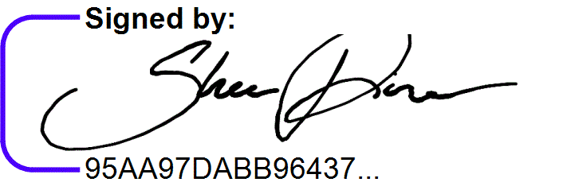
__________________________________________
Shea Finau, Senate Secretary

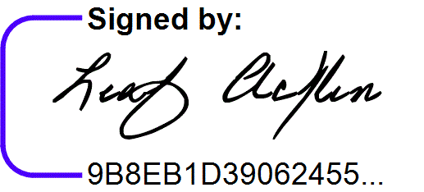
__________________________________________ Leaf Acklin, Speaker of the Senate

