Department of IDEA
Agenda for Monday, January 26, 2026 at 7:00 PM
In Person- JSCU 332 Frankie Sue Del Papa Presidents Conference Room
Joe Crowley Student Union 4th Floor
1664 N. Virginia Street
Reno, Nevada 89557
Virtual Zoom ID: 339 969 0437 Passcode: IDEA25
Zoom: LINK

- CALL MEETING TO ORDER

- COMPLIANCE WITH NEVADA OPEN MEETING LAW
  - Was the agenda posted three full working days by 9 am, not including the meeting date? [Bring up the ASUN website and show the public]
  - Is the meeting taking place on the day of the week, month, day, year, at the time and location listed on the agenda?
  - Is the Zoom link working and available to the public?
  - If the answer to any of these questions is no, this meeting must be ENDED IMMEDIATELY unless NOML covers a legitimate correction.

- LAND ACKNOWLEDGEMENT
We recognize that the University of Nevada, Reno, sits on the traditional homelands of the Numu (Northern Paiute), Wašiw (Washoe), Newe (Western Shoshone), Nuwu (Southern Paiute) peoples. These lands continue to be a gathering place for Indigenous peoples and we recognize the deep connections to these places. We extend our appreciation for the opportunity to live and learn on their territory.

- ROLL CALL
The Secretary must list roll call.
- Director, Zyna Navarte
- Commissioner of Event Planning, Bea Campbell
- Commissioner for Marketing and Outreach, Jaden Ottaviano
- Commissioner of Social Justice and Reform, Manvi Mummalaneni

- PUBLIC COMMENT (INFORMATION ONLY)
Items heard under public comment may be for items either on or off the agenda. Action may not be taken on items raised under public comment. The Chair may elect to take public comment on actions on this agenda. The Chair may impose reasonable limits on the length of time members of the public may speak.

- ADOPTION OF MINUTES (FOR POSSIBLE ACTION)
There are no minutes to be approved at this time.

- AUDIO MINUTES MISSING FOR PREVIOUS MEETINGS OF THIS BODY THAT DO NOT MEET 30 DAY POSTING OF NEVADA OPEN MEETING LAW FOR CORRECTIVE ACTION
There are no Possible Corrective Action at this time.

- REPORTS (INFORMATION ONLY)
- Director, Zyna Navarte
- Commissioner of Event Planning, Bea Campbell
- Commissioner for Marketing and Outreach, Jaden Ottaviano
- Commissioner of Social Justice and Reform, Manvi Mummalaneni

- OLD BUSINESS (INFORMATION ONLY/FOR POSSIBLE ACTION)

- NEW BUSINESS (INFORMATION ONLY/FOR POSSIBLE ACTION
  - Scheduling of Next Meeting (Possible Action)
  - Department Professionalism and Inclusion (Possible Action)
  - Black Culture Event Space (Possible Action)
  - Lunar New Year Sponsorship and Tabling (Possible Action)
  - Share the Crown Items (Possible Action)

- PUBLIC COMMENT (INFORMATION ONLY)
Items heard under public comment may be for items either on or off the agenda. Action may not be taken on items raised under public comment. The Chair may elect to take public comment on action items on this agenda. The Chair may impose reasonable limits on the length of time members of the public may speak.

- ADJOURNMENT
NOTES:
Agenda items may be considered out of order at the discretion of the Chair. The committee may combine two or more agenda items for consideration. The Committee may remove an item from the agenda or delay discussion of an item at any time.

ASUN DEPARTMENT OF IDEA
EVENT & BUDGET PROPOSAL FORM

CONTACT INFORMATION:
Organizer(s)/ Intern(s): Zyna Navarte
E-mail(s): diversitydirector@asun.unr.edu or Znavarte@unr.edu
Learning Outcomes:
- Strengthened Department Identity and Professionalism: Purchasing name plaques helps establish a clear and consistent departmental presence, reinforcing professionalism, recognition of roles, and a sense of belonging among officers, interns, and collaborators.
- Improved Engagement and Morale: Providing snacks during meetings and events supports attendee comfort and focus, creating a more welcoming environment that encourages participation, collaboration, and sustained engagement.
- Enhanced Accessibility and Inclusivity: Offering light refreshments and clearly labeled name plaques helps reduce barriers to participation by supporting basic needs and ensuring individuals feel recognized, respected, and included within department spaces.
EVENT INFORMATION:
Event Name: | N/a | Date: | January 30, 2026
Event Location: | N/A | Time: | n/a
Expected  Attendance: | 8 | Cost Per  Student: | $19.54

BUDGET INFORMATION: Please itemize your ENTIRE event budget below:
DESCRIPTION: | AMOUNT: | VENDOR:
- Frito-Lay Ultimate Classic Snacks Package, Variety Assortment of Chips, Cookies, Crackers, & Nuts, (Pack of 40) | $26.91 | Amazon
- Nabisco Classic Mix Variety Pack, OREO Mini, CHIPS AHOY! Mini, Nutter Butter Bites, RITZ Bits Cheese, 20 Snack Packs | $9.86 | Amazon
- Lasercrafting Personalized Office Name Plate/Name Tag With Wall or Desk Holder - 2x8 2x10 2x12 - CUSTOMIZE. Choose from a variety of colors and fonts to match your style. Great Christmas gift idea. | $14.94 (9) | Amazon
TOTAL EVENT BUDGET: | $171.23
TOTAL ASUN BUDGET: | $171.23

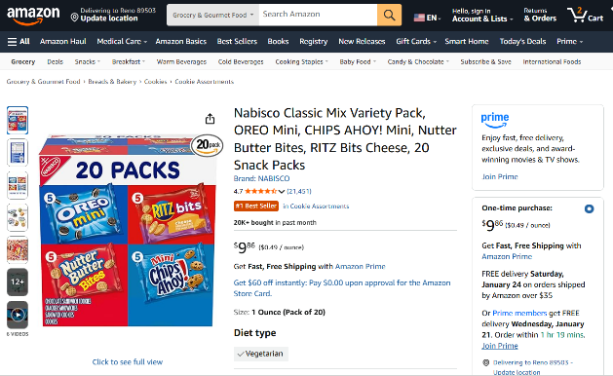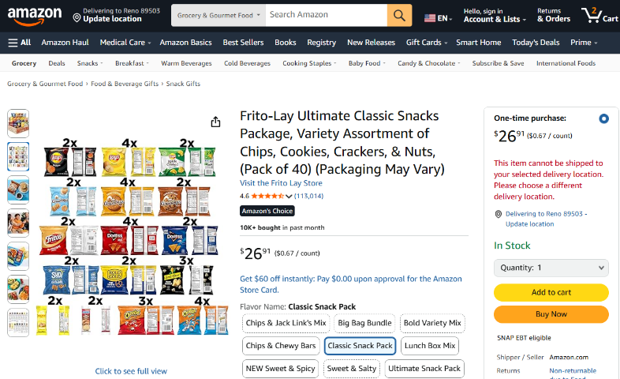
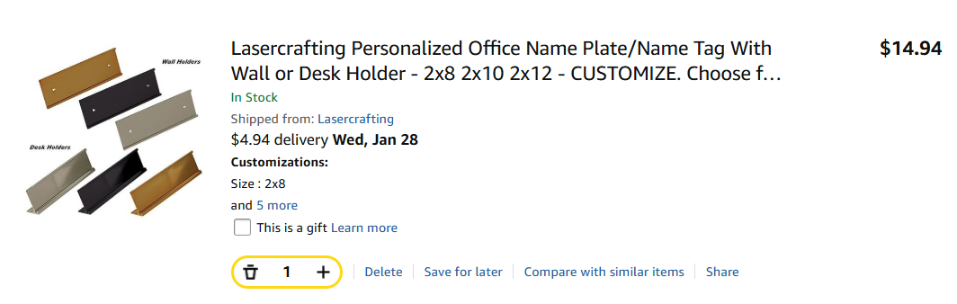

ASUN DEPARTMENT OF IDEA
EVENT & BUDGET PROPOSAL FORM

CONTACT INFORMATION:
Organizer(s)/ Intern(s): Zyna Navarte
E-mail(s): diversitydirector@asun.unr.edu or Znavarte@unr.edu
Learning Outcomes:
- Participants will gain a deeper understanding of Black history and culture through interactive performances, educational resources, and community engagement.
- Participants will recognize the impact of Black culture on social, artistic, and political movements and reflect on its continued influence today.
- Participants will build intercultural awareness and allyship skills by engaging in inclusive dialogue that promotes equity and respect.
EVENT INFORMATION:
Event Name: | Black Culture Event | Date: | March 06, 2026
Event Location: | JCSU Ballroom | Time: | 5:30pm to 8:00pm
Expected  Attendance: | 100+ | Cost Per  Student: | N/A

BUDGET INFORMATION: Please itemize your ENTIRE event budget below:
DESCRIPTION: | AMOUNT: | VENDOR:
- Black Cultural Festival (Action Needed) 419 - Milt Glick Ballroom Exclusive | $630.00 | JCSU
TOTAL EVENT BUDGET: | $630.00
TOTAL ASUN BUDGET: | $630.00
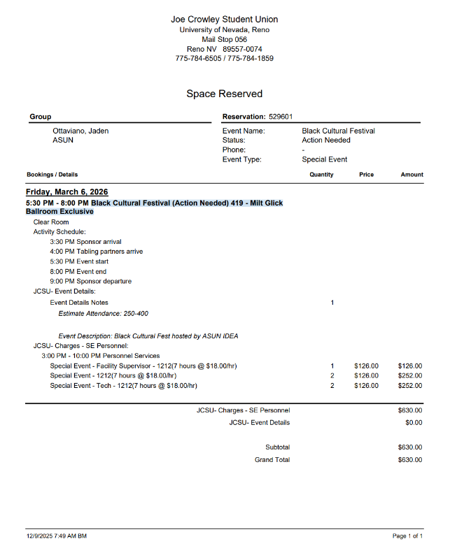

ASUN DEPARTMENT OF IDEA
EVENT & BUDGET PROPOSAL FORM

CONTACT INFORMATION:
Organizer(s)/ Intern(s): Zyna Navarte
E-mail(s): diversitydirector@asun.unr.edu or Znavarte@unr.edu
Learning Outcomes:
- Participants will learn about the cultural significance and traditions of Lunar New Year across different Asian cultures through performances, food, and educational activities.
- Participants will increase cultural awareness and appreciation by engaging with the history, values, and symbolism associated with Lunar New Year celebrations.
EVENT INFORMATION:
Event Name: | Lunar New Year | Date: | February 21, 2026
Event Location: | JCSU Ballroom | Time: | 2:00 PM – 6:00 PM
Expected  Attendance: | 100+ | Cost Per  Student: | N/A

BUDGET INFORMATION: Please itemize your ENTIRE event budget below:
DESCRIPTION: | AMOUNT: | VENDOR:
- Black Cultural Festival (Action Needed) 419 - Milt Glick Ballroom Exclusive | $1,500 | The Multicultural Center
TOTAL EVENT BUDGET: | $1,500
TOTAL ASUN BUDGET: | $1,500

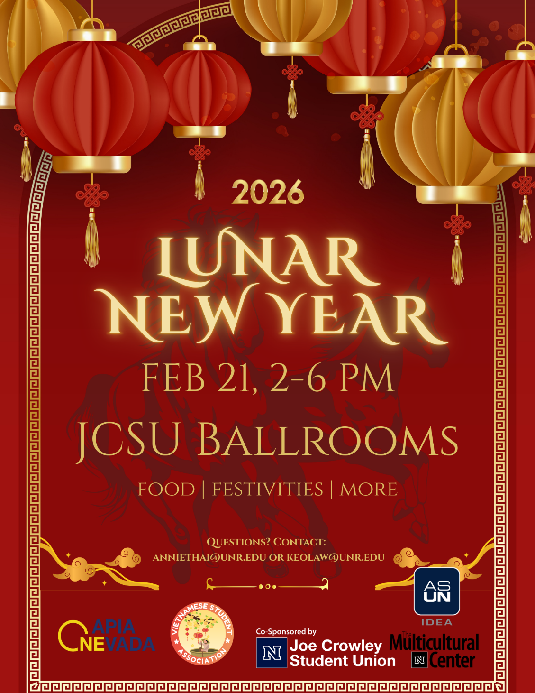

DRAFT Flyer

ASUN DEPARTMENT OF IDEA
EVENT & BUDGET PROPOSAL FORM

CONTACT INFORMATION:
Organizer(s)/ Intern(s): Zyna Navarte
E-mail(s): diversitydirector@asun.unr.edu or Znavarte@unr.edu
Learning Outcomes:
- Participants will learn about the cultural significance of Black hair and self-expression through hands-on activities, hair care kits, and community conversation.
- Participants will build community and cultural appreciation by engaging in interactive games, shared food, and celebratory spaces that affirm Black identity and joy.
EVENT INFORMATION:
Event Name: | Share the Crown | Date: | February 11, 2026
Event Location: | Graduate Student Lounge | Time: | 4:00 PM – 6:00 PM
Expected  Attendance: | 80+ | Cost Per  Student: | N/A

BUDGET INFORMATION: Please itemize your ENTIRE event budget below:
DESCRIPTION: | AMOUNT: | VENDOR:
- 100PCS 1OZ/30ML Travel Bottles with 150pcs Labels, Mini Empty Hand Sanitizer Bottle, Clear Plastic Portable . . . | $19.99 (2) | Amazon
- BEISHIDA Black Purple Star Halloween Hanging Swirl Decorations, Halloween Party Supplies for Horror Party . . . | $7.99 | Amazon
- NICROLANDEE Black Gold Party Decorations, 15 PCS Tissue Paper Pom Poms Kit for 2026 New Year Party . | $14.99 | Amazon
- 84 Pack Hand cream Gifts Set for Women, Stocking Stuffers for Women Teengirls, Christmas Gift, etc. | $22.49 | Amazon
- Bokon 100 Pcs Small Toiletry Bags Bulk, 5.12 x 8.11 Inches Clear Cosmetic Makeup Bags with Zipper Travel Pouches . | $26.99 | Amazon
- Large Hot Chick-n-Strips Tray | $107.00 (2) | Chick-Fil-A
- Large Garden Salad Tray | $36.00 (2) | Chick-Fil-A
- Assorted Cookie Tray, 84 ct. | $19.93 | Sams Club
- Member’s Mark Fresh Fruit Tray, priced per pound | $14.92 (4) | Sams Club
- Capri Sun Variety 6 Pack fl. Oz. pouches, 40k | $10.48 (2) | Sams Club
- TRESemmé Ultimate Moisture Shampoo & Conditioner 39 fl. Oz., 2 pk. TRESemmé Ultimate Moisture Shampoo & Conditioner 39 fl. Oz., 2 pk. | $11.98 (5) | Sams Club
TOTAL EVENT BUDGET: | $555.89
TOTAL ASUN BUDGET: | $555.89

ITEM SCREENSHOTS
AMAZON CART LINK
