Department of IDEA
Minutes for Monday, January 26, 2026 at 7:00 PM
In Person- JSCU 332 Frankie Sue Del Papa Presidents Conference Room
Joe Crowley Student Union 4th Floor
1664 N. Virginia Street
Reno, Nevada 89557
Virtual Zoom ID: 339 969 0437 Passcode: IDEA25
Zoom: LINK

- CALL MEETING TO ORDER

- Director Navarte called the Department of IDEA Meeting to order on Monday, January 26th at 7:00 pm in the Frankie Sue Del Papa Conference Room on the 3rd floor of the Joe Crowley Student Union on Zoom. Presiding Secretary, Doga Akyurek

- COMPLIANCE WITH NEVADA OPEN MEETING LAW

  - Was the agenda posted three full working days by 9 am, not including the meeting date?

- Yes.

  - Is the meeting taking place on the day of the week, month, day, year, at the time and location listed on the agenda?

- Yes.

  - Is the Zoom link working and available to the public?

- Yes.

  - If the answer to any of these questions is no, this meeting must be ENDED IMMEDIATELY unless NOML covers a legitimate correction.

- LAND ACKNOWLEDGEMENT
We recognize that the University of Nevada, Reno, sits on the traditional homelands of the Numu (Northern Paiute), Wašiw (Washoe), Newe (Western Shoshone), Nuwu (Southern Paiute) peoples. These lands continue to be a gathering place for Indigenous peoples and we recognize the deep connections to these places. We extend our appreciation for the opportunity to live and learn on their territory.

- ROLL CALL
Present: Director Navarte, Commissioner Campbell, Commissioner Ottaviano, Commissioner Mummalaneni

No-absence found.

A quorum was present.

- PUBLIC COMMENT

- Justin Berger, Assistant Director of Programs and Services with Center for Student Engagement, offered public comment to introduce himself, congratulate and thank members he has met, and share that he will be temporarily advising the group this semester (and possibly beyond). He invited members to stop by his office (JCCC 334) within the next one to two weeks, emphasized his availability for advising, support, and listening, and expressed appreciation for everyone’s time.

- ADOPTION OF MINUTES

- There are no minutes to be approved at this time.

- AUDIO MINUTES MISSING FOR PREVIOUS MEETINGS OF THIS BODY THAT DO NOT MEET 30 DAY POSTING OF NEVADA OPEN MEETING LAW FOR CORRECTIVE ACTION

- There are no Possible Corrective Action at this time.

- REPORTS
- Director, Zyna Navarte
- Meeting with everyone in the department: mentors and asun officers and interns for individual events.
- Attended the president cabinet to tell them about upcoming events.
- Department of orgs told them they would assist in contacting.
- Thanks to everyone coming from MLK Gala; experience was phenomenal.
- First meeting with new advisors: Justin Berger.
- Meeting with media who will publish IDEA for the Black Cultural Fest and Fusion.

- Commissioner of Event Planning, Bea Campbell
- Share the Crown correspondence with Black Wall Street donation.
- Communication with staff about relocating the event to the Food Court to maintain cleaning.
- Sent marketing/promotion drafts to Officer Ottaviano and Inkblot for Share the Crown.
- Requested tabling reservation in the KC Breezeway for upcoming events.
- Assisted Officer Mummalaneni and her intern expand on Women’s History Month tabling
- Setting up meetings with interns to check on their event progress and status in the internship

- Commissioner for Marketing and Outreach, Jaden Ottaviano
- Met with Director Navarte and intern about details: Black Cultural Event, planning food and who to invite
- Logistics for venue set up
- Plan to meet with intern to expand on details
- Submitted marketing for Black Cultural and Share the Crown
- Inkblot meeting with gabby about social media request for love in the pack event
- Planning another 1:1 formal meeting to discuss details about departments marketing and specifications about work orders already submitted.

Commissioner of Social Justice and Reform, Manvi Mummalaneni
- Met with Director Navarte about intern event and Commissioner Campbell to expand ideas for event
- Budget proposal remains the same
- Working on new social justice packet; requested to add a date about know your rights training.

- OLD BUSINESS

- No old business at this time.

- NEW BUSINESS
  - Department Professionalism and Inclusion

- Director Navarte mentioned that she purchased presents for the records of professionalism and Department’s interns. Presents includes such as snacks and etc.
- Director Navarte seeks a motion for budget for Packs and Snacks.
- Seconded by Commisioner Campbell.
- No abstention found.
- The motion passed.

  - Black Culture Event Space
- Director Navarte seeks a motion to approve the budget for Black Culture Event
- Seconded by Commisioner Ottaviano.
- No abstention was found.
- The motion passed.
  - Lunar New Year Sponsorship and Tabling
- Director Navarte seeks motion to approve the budget for Lunar New Year Sponsorship and Tabling
- Seconded by Commissioner Ottaviano.
- No abstention was found.
- The motion passed.
  - Share the Crown Items
- Director Navarte seeks motion to approve the budget for Share The
-Seconded by Commisioner Campbell.

- PUBLIC COMMENT

-No public comment at this time.

- ADJOURNMENT

- Director Navarte adjourned the meeting at 7:18 pm on Monday, January 26th , 2026 in the Frankie Sue Del Papa Conference Room.

ASUN DEPARTMENT OF IDEA
EVENT & BUDGET PROPOSAL FORM

CONTACT INFORMATION:
Organizer(s)/ Intern(s): Zyna Navarte
E-mail(s): diversitydirector@asun.unr.edu or Znavarte@unr.edu
Learning Outcomes:
- Strengthened Department Identity and Professionalism: Purchasing name plaques helps establish a clear and consistent departmental presence, reinforcing professionalism, recognition of roles, and a sense of belonging among officers, interns, and collaborators.
- Improved Engagement and Morale: Providing snacks during meetings and events supports attendee comfort and focus, creating a more welcoming environment that encourages participation, collaboration, and sustained engagement.
- Enhanced Accessibility and Inclusivity: Offering light refreshments and clearly labeled name plaques helps reduce barriers to participation by supporting basic needs and ensuring individuals feel recognized, respected, and included within department spaces.
EVENT INFORMATION:
Event Name: | N/a | Date: | January 30, 2026
Event Location: | N/A | Time: | n/a
Expected  Attendance: | 8 | Cost Per  Student: | $19.54

BUDGET INFORMATION: Please itemize your ENTIRE event budget below:
DESCRIPTION: | AMOUNT: | VENDOR:
- Frito-Lay Ultimate Classic Snacks Package, Variety Assortment of Chips, Cookies, Crackers, & Nuts, (Pack of 40) | $26.91 | Amazon
- Nabisco Classic Mix Variety Pack, OREO Mini, CHIPS AHOY! Mini, Nutter Butter Bites, RITZ Bits Cheese, 20 Snack Packs | $9.86 | Amazon
- Lasercrafting Personalized Office Name Plate/Name Tag With Wall or Desk Holder - 2x8 2x10 2x12 - CUSTOMIZE. Choose from a variety of colors and fonts to match your style. Great Christmas gift idea. | $14.94 (9) | Amazon
TOTAL EVENT BUDGET: | $171.23
TOTAL ASUN BUDGET: | $171.23

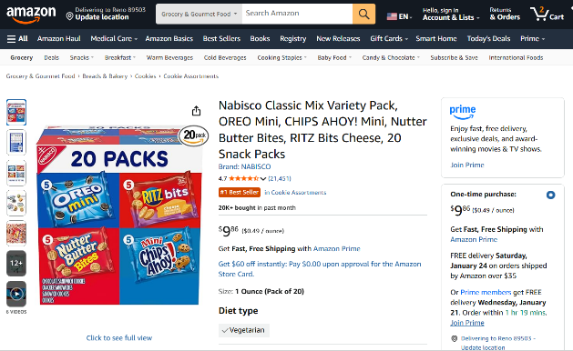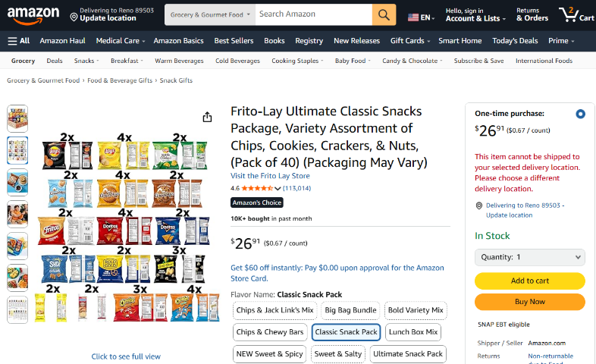
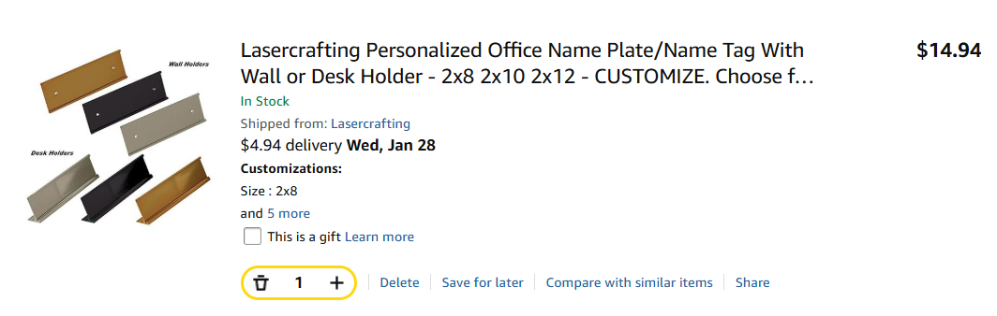

ASUN DEPARTMENT OF IDEA
EVENT & BUDGET PROPOSAL FORM

CONTACT INFORMATION:
Organizer(s)/ Intern(s): Zyna Navarte
E-mail(s): diversitydirector@asun.unr.edu or Znavarte@unr.edu
Learning Outcomes:
- Participants will gain a deeper understanding of Black history and culture through interactive performances, educational resources, and community engagement.
- Participants will recognize the impact of Black culture on social, artistic, and political movements and reflect on its continued influence today.
- Participants will build intercultural awareness and allyship skills by engaging in inclusive dialogue that promotes equity and respect.
EVENT INFORMATION:
Event Name: | Black Culture Event | Date: | March 06, 2026
Event Location: | JCSU Ballroom | Time: | 5:30pm to 8:00pm
Expected  Attendance: | 100+ | Cost Per  Student: | N/A

BUDGET INFORMATION: Please itemize your ENTIRE event budget below:
DESCRIPTION: | AMOUNT: | VENDOR:
- Black Cultural Festival (Action Needed) 419 - Milt Glick Ballroom Exclusive | $630.00 | JCSU
TOTAL EVENT BUDGET: | $630.00
TOTAL ASUN BUDGET: | $630.00
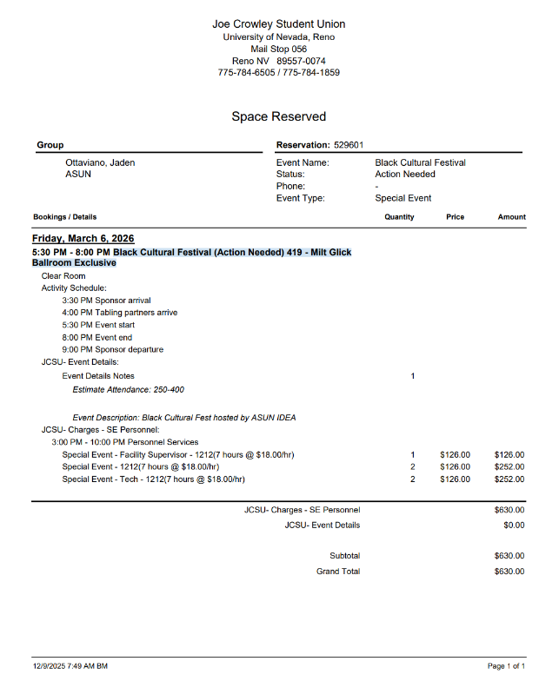

ASUN DEPARTMENT OF IDEA
EVENT & BUDGET PROPOSAL FORM

CONTACT INFORMATION:
Organizer(s)/ Intern(s): Zyna Navarte
E-mail(s): diversitydirector@asun.unr.edu or Znavarte@unr.edu
Learning Outcomes:
- Participants will learn about the cultural significance and traditions of Lunar New Year across different Asian cultures through performances, food, and educational activities.
- Participants will increase cultural awareness and appreciation by engaging with the history, values, and symbolism associated with Lunar New Year celebrations.
EVENT INFORMATION:
Event Name: | Lunar New Year | Date: | February 21, 2026
Event Location: | JCSU Ballroom | Time: | 2:00 PM – 6:00 PM
Expected  Attendance: | 100+ | Cost Per  Student: | N/A

BUDGET INFORMATION: Please itemize your ENTIRE event budget below:
DESCRIPTION: | AMOUNT: | VENDOR:
- Black Cultural Festival (Action Needed) 419 - Milt Glick Ballroom Exclusive | $1,500 | The Multicultural Center
TOTAL EVENT BUDGET: | $1,500
TOTAL ASUN BUDGET: | $1,500

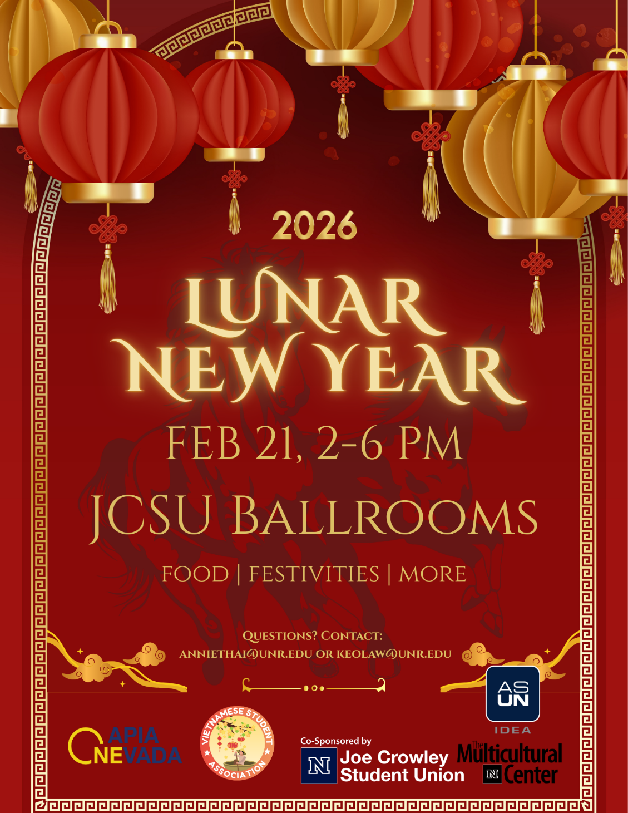

DRAFT Flyer

ASUN DEPARTMENT OF IDEA
EVENT & BUDGET PROPOSAL FORM

CONTACT INFORMATION:
Organizer(s)/ Intern(s): Zyna Navarte
E-mail(s): diversitydirector@asun.unr.edu or Znavarte@unr.edu
Learning Outcomes:
- Participants will learn about the cultural significance of Black hair and self-expression through hands-on activities, hair care kits, and community conversation.
- Participants will build community and cultural appreciation by engaging in interactive games, shared food, and celebratory spaces that affirm Black identity and joy.
EVENT INFORMATION:
Event Name: | Share the Crown | Date: | February 11, 2026
Event Location: | Graduate Student Lounge | Time: | 4:00 PM – 6:00 PM
Expected  Attendance: | 80+ | Cost Per  Student: | N/A

BUDGET INFORMATION: Please itemize your ENTIRE event budget below:
DESCRIPTION: | AMOUNT: | VENDOR:
- 100PCS 1OZ/30ML Travel Bottles with 150pcs Labels, Mini Empty Hand Sanitizer Bottle, Clear Plastic Portable . . . | $19.99 (2) | Amazon
- BEISHIDA Black Purple Star Halloween Hanging Swirl Decorations, Halloween Party Supplies for Horror Party . . . | $7.99 | Amazon
- NICROLANDEE Black Gold Party Decorations, 15 PCS Tissue Paper Pom Poms Kit for 2026 New Year Party . | $14.99 | Amazon
- 84 Pack Hand cream Gifts Set for Women, Stocking Stuffers for Women Teengirls, Christmas Gift, etc. | $22.49 | Amazon
- Bokon 100 Pcs Small Toiletry Bags Bulk, 5.12 x 8.11 Inches Clear Cosmetic Makeup Bags with Zipper Travel Pouches . | $26.99 | Amazon
- Large Hot Chick-n-Strips Tray | $107.00 (2) | Chick-Fil-A
- Large Garden Salad Tray | $36.00 (2) | Chick-Fil-A
- Assorted Cookie Tray, 84 ct. | $19.93 | Sams Club
- Member’s Mark Fresh Fruit Tray, priced per pound | $14.92 (4) | Sams Club
- Capri Sun Variety 6 Pack fl. Oz. pouches, 40k | $10.48 (2) | Sams Club
- TRESemmé Ultimate Moisture Shampoo & Conditioner 39 fl. Oz., 2 pk. TRESemmé Ultimate Moisture Shampoo & Conditioner 39 fl. Oz., 2 pk. | $11.98 (5) | Sams Club
TOTAL EVENT BUDGET: | $555.89
TOTAL ASUN BUDGET: | $555.89

ITEM SCREENSHOTS
AMAZON CART LINK
