Department of IDEA
Agenda for Friday, November 21st, 2025 at 1:30 PM
In Person- JSCU 406 Conference Room
Joe Crowley Student Union 4th Floor
1664 N. Virginia Street
Reno, Nevada 89557
Virtual Zoom ID: 339 969 0437 Passcode: IDEA25
Zoom: LINK

- CALL MEETING TO ORDER

- COMPLIANCE WITH NEVADA OPEN MEETING LAW
  - Was the agenda posted three full working days by 9 am, not including the meeting date? [Bring up the ASUN website and show the public]
  - Is the meeting taking place on the day of the week, month, day, year, at the time and location listed on the agenda?
  - Is the Zoom link working and available to the public?
  - If the answer to any of these questions is no, this meeting must be ENDED IMMEDIATELY unless NOML covers a legitimate correction.

- LAND ACKNOWLEDGEMENT
We recognize that the University of Nevada, Reno, sits on the traditional homelands of the Numu (Northern Paiute), Wašiw (Washoe), Newe (Western Shoshone), Nuwu (Southern Paiute) peoples. These lands continue to be a gathering place for Indigenous peoples and we recognize the deep connections to these places. We extend our appreciation for the opportunity to live and learn on their territory.

- ROLL CALL
The Secretary must list roll call.
- Director, Zyna Navarte
- Assistant Director, Kaitlyn Rock
- Commissioner of Event Planning, Bea Campbell
- Commissioner for Marketing and Outreach, Jaden Ottaviano
- Commissioner of Social Justice and Reform, Manvi Mummalaneni

- PUBLIC COMMENT (INFORMATION ONLY)
Items heard under public comment may be for items either on or off the agenda. Action may not be taken on items raised under public comment. The Chair may elect to take public comment on actions on this agenda. The Chair may impose reasonable limits on the length of time members of the public may speak.

- ADOPTION OF MINUTES (FOR POSSIBLE ACTION)
There are no minutes to be approved at this time.

- REPORTS (INFORMATION ONLY)
- Director, Zyna Navarte
- Assistant Director, Kaitlyn Rock
- Commissioner of Event Planning, Bea Campbell
- Commissioner for Marketing and Outreach, Jaden Ottaviano
- Commissioner of Social Justice and Reform, Manvi Mummalaneni

- OLD BUSINESS (INFORMATION ONLY/FOR POSSIBLE ACTION)
  - Discussions of I Stand with Immigrants event logistics and schedules (Information Only)

- NEW BUSINESS (INFORMATION ONLY/FOR POSSIBLE ACTION
  - Reapproval of API Night Market (For Possible Corrective Action)
  - Reapproval of World Tourism Day (For Possible Corrective Action)
  - Reapproval of Filipino Festival (For Possible Corrective Action)
  - Reapproval of Diversity Calendar (For Possible Corrective Action)
  - Reapproval of Diversity Calendar events and adjustment of Black Cultural event (For Possible Corrective Action)
  - Reapproval of Intern Presentation (For Possible Corrective Action)
  - Discussions on I Stand with Immigrants event name change to Pack Without Borders (Information Only)
  - Discussions on Intern and Mentor Pantry/Food Bank Volunteering Requirement (Information Only)
  - Discussions on Distribution of Pack Without Borders Event Flyers (Information Only)
  - Discussion on Department’s Outgoing Emails (Information Only)
  - Discussion on IDEA Grant (Information Only)

- PUBLIC COMMENT (INFORMATION ONLY)
Items heard under public comment may be for items either on or off the agenda. Action may not be taken on items raised under public comment. The Chair may elect to take public comment on action items on this agenda. The Chair may impose reasonable limits on the length of time members of the public may speak.

- ADJOURNMENT
NOTES:
Agenda items may be considered out of order at the discretion of the Chair. The committee may combine two or more agenda items for consideration. The Committee may remove an item from the agenda or delay discussion of an item at any time.

ASUN DEPARTMENT OF IDEA
EVENT & BUDGET PROPOSAL FORM

CONTACT INFORMATION:
Organizer(s)/ Intern(s): Zyna Navarte
E-mail(s): diversitydirector@asun.unr.edu or Znavarte@unr.edu
Learning Outcomes:
- Students will be able to recognize and appreciate diverse global cultures by engaging with international foods, games, and traditions.
- Students will practice inclusive and respectful communication by interacting with peers and tabling hosts about the cultural significance of the foods and games presented.
- Students will reflect on how global tourism connects communities and fosters mutual understanding, leaving the event with a greater sense of their role in promoting cultural exchange and diversity

EVENT INFORMATION:
Event Name: | World Tourism Day | Date: | September 26, 2025
Event Location: | KC Breezeway Tables | Time: | 2pm-5pm
Expected  Attendance: | 70+ | Cost Per  Student: | NONE

BUDGET INFORMATION: Please itemize your ENTIRE event budget below:
DESCRIPTION: | AMOUNT: | QUANTITY | VENDOR:
- InnoAsian Mini Vegetable Spring Rolls | $4.56 | 8 | Walmart  Link
- Spam(Regular) | $3.88 | 8 | Walmart  LINK
- Rice (Jasmine Rice) | $6.88 | 2 | Walmart  LINK
PACK Kirkland Signature Organic Roasted Seaweed Snack | $21.95 | 2 | Walmart  LINK
Ricks Pizza (Wings) | $128 (total) | 8 order of 10 pieces of wings | Ricks Pizza  LINK
Whole Tiramisu | $69.99 | 2 | Olive Garden  Link
Tostitos Scoops! Party Size Tortilla Chips | $5.94 | 8 | Walmart  Link
Great Value Vegetable Oil | $3.97 | 1 | Walmart  Link
Freshness Guaranteed Mild Guacamole Mini Cups (6 Count) | $4.22 | 12 | Walmart  Link
DEIKAL Compostable Clamshell Food Containers (50 pack) | $18.88 | 2 | Walmart  Link
100 Pack 12 oz Disposable Cups | $13.79 | 1 | Walmart  Link
Ziploc Sandwich Bags (100 Count) | $3.98 | 1 | Walmart  Link
Bracelets 338 Pcs International Party Favors Around The World Map Stickers Country Flags Pens Wristbands Keychains Badge Pins for World Tourism Day History Geography Social Studies Classroom | $40.99 | 1 | Amazon  LINK
200pcs World Travel Stickers Pack | $9.99 | 1 | Amazon  Link
Sharpie Electro Pop Permanent Markers | $19.65 | 2 | Walmart  Link
Decorations  19 Pcs World Map Classroom Decorations Travel Themed Party Decor Globes Hanging Paper Lantern Fans Triangle Flags | $21.99 | 1 | Amazon  LINK
International Flags of The World 100 Countries Pennant Bunting World Flag Banner for Themed Parties, Grand Openings, Around the World Decorations​ | $12.99 | 1 | Amazon  LINK

TOTAL EVENT BUDGET: | $656.43
TOTAL ASUN BUDGET: | $656.43

ASUN DEPARTMENT OF IDEA
EVENT & BUDGET PROPOSAL FORM

CONTACT INFORMATION:
Organizer(s)/ Intern(s): Zyna Navarte
E-mail(s): diversitydirector@asun.unr.edu or Znavarte@unr.edu
Learning Outcomes:
- Students will be able to identify and appreciate the diversity of Asian and Pacific Islander traditions through exposure to foods, games, art, and performances at the night market.
- Students will engage with campus and community organizations at event tables, strengthening their awareness of available cultural, academic, and wellness resources.
- Students will reflect on the importance of representation and cultural celebration in building a more inclusive campus, demonstrating this by participating in at least one interactive activity or dialogue.

EVENT INFORMATION:
Event Name: | API Night Market | Date: | October 03, 2025
Event Location: | JCSU GATEWAY PLAZA | Time: | 5PM
Expected  Attendance: | 100+ | Cost Per  Student: | NONE

BUDGET INFORMATION: Please itemize your ENTIRE event budget below:
DESCRIPTION: | AMOUNT: | QUANTITY | VENDOR:
API NIGHT MARKET | $1,500 | 1 | SPONSORSHIP

TOTAL EVENT BUDGET: | $1,500
TOTAL ASUN BUDGET: | $1,500

ASUN DEPARTMENT OF IDEA
EVENT & BUDGET PROPOSAL FORM

CONTACT INFORMATION:
Organizer(s)/ Intern(s): Zyna Navarte
E-mail(s): diversitydirector@asun.unr.edu or Znavarte@unr.edu
Learning Outcomes:
- Students will be able to identify and appreciate the diversity of Asian and Pacific Islander traditions through exposure to foods, games, art, and performances at the night market.
- Students will engage with campus and community organizations at event tables, strengthening their awareness of available cultural, academic, and wellness resources.
- Students will reflect on the importance of representation and cultural celebration in building a more inclusive campus, demonstrating this by participating in at least one interactive activity or dialogue.

EVENT INFORMATION:
Event Name: | Filipino Festival | Date: | October 18, 2025
Event Location: | JCSU Ballroom | Time: | 3-6pm
Expected  Attendance: | 100+ | Cost Per  Student: | NONE

BUDGET INFORMATION: Please itemize your ENTIRE event budget below:
DESCRIPTION: | AMOUNT: | QUANTITY | VENDOR:
Artifical Banana Leaves | $13.99 | 5 | Amazon
Artifical Wisteria Flowers | $11.99 | 1 | Amazon
Artifical Tropical Flowers | $12.99 | 1 | Amazon
Brown Paper Lanterns | $18.99 | 2 | amazon
Acrylic Paint Bottle Set | $33.59 | 1 | amazon
Foam Paint Brushes | $7.99 | 1 | amazon
Paint Brush Set | $3.99 | 5 | amazon
Acrylic Paint Markers | $9.48 | 2 | amazon
Red Plastic Table Covers | $8.99 | 1 | amazon
Paper Hand Fan | $41.99 | 1 | amazon
Face/Body Paints | $19.99 | 2 | amazon
Plates | $5.99 | 5 | amazon
Gloves | $5.97 | 1 | amazon
Forks | $11.99 | 2 | amazon
Spoons | $11.99 | 2 | amazon
Name Tag Stickers | $5.98 | 1 | amazon

TOTAL EVENT BUDGET: | $394.22
TOTAL ASUN BUDGET: | $394.22

ASUN Department of IDEA
Diversity Calendar
Date | Location/Time | Theme
August  28, 2025 | Quad  4:00pm-7:00pm | Fall Club Fair  Collab: ASUN Clubs and Orgs Department
September 4, 2025 | GBH MPR  6pm | Pride Prep Party  Collab: DSJI
September 6, 2025 | Downtown and Midtown Reno  10:00 a.m.-6:00 p.m. | Northern Nevada Pride Event  Collab: ASUN Programming Department, DEI, ORVIS NURSING, QLAB, GSA
September 8, | JCSU Lawn  12:00pm-3:00pm | Suicidal Prevention Tabling  Collab: UNR Counseling Services
September 26, 2025 | KC Rotunda  2:00pm-5:00pm | World Tourism Day (w Activities)  Collab: USAC
October 03, 2025 | JCSU Ballrooms  5pm | API Night Market  Host/Collab: Multicultural Center
October 13, 2025  6-8pm | Great Basin Hall | Know Your Rights Presentation; Tabling  Residential Housing, Great Basin
October 15, 2025 | Nye Canada Plaza  5pm | Noche de Locura  Collab: DSJI
October 18, 2025 | Ballroom JCSU  3-6PM | Nevada Filipino Festival  Collab: Filipino Club
October 19, 2025 | 5-8pm | Homecoming Parade
October 20, 2025 | Great Basin Hall, Multipurpose Room; 6PM | SEXPO; Tabling
October 25, 2025 | JCSU Ballroom | African in Reno “The Wedding”; Tabling  Host/Collab: African Students Association Club
November  3, 2025 | JCSU Ballroom | Dia de los Muertos
November  20, 2025 | KC or outside of Joe | Informational social justice packets + Awareness month Distribution; Tabling
December  8, 2025 | Bulletin Boards | Informational social justice packets distribution
January 30, 2026 | PSAC/ Tabling | Informational social justice packets + Awareness month Distribution
February 4, 2026 | KC/ Tabling | EmployNV (External Organization)
February  11, 2026 | KC/ Tabling | Hair We Go! (Hair care kit giveaway) and advertising Black Cultural Festival Event  Collab: UNR Clubs
February 13, 2026 | KC/Tabling | Love in the Pack (Valentine’s Day)
February 21, 2026 | n/a | Lunar New Year Celebration Festival Event  Volunteer: Filipino Club  Host: API Multicultural Center
February  27, 2026 | JCSU Ballroom | Black Cultural Festival Event
March  12, 2026 | Rotunda and KC Breezeway | Fusion: A Celebration of Multiracial Identity  Volunteer: Filipino Club
March  23, 2026 | KC/ Tabling | Informational social justice packets + Awareness month Distribution
April  22, 2026 | JCSU Lawn | Keep it Green, Keep it Clean! (Earth Day Tabling w Activities)  Collab: ASUN Sustainability and Wellness
April 27, 2026 | Outside UNR | IDEA Wrap-Up Gathering
May | EMAILS | IDEA GRANT (DISTRIBUTION)

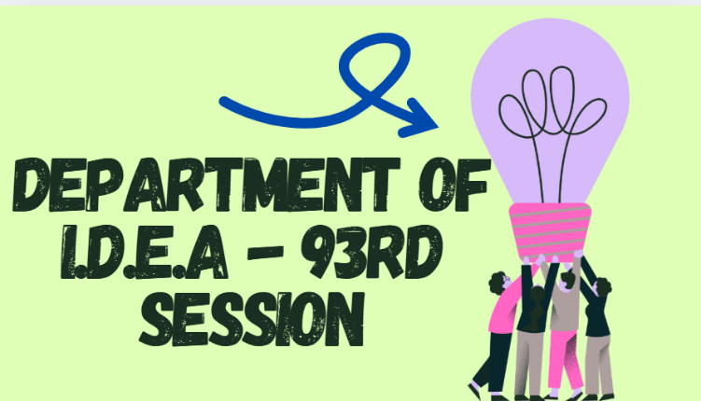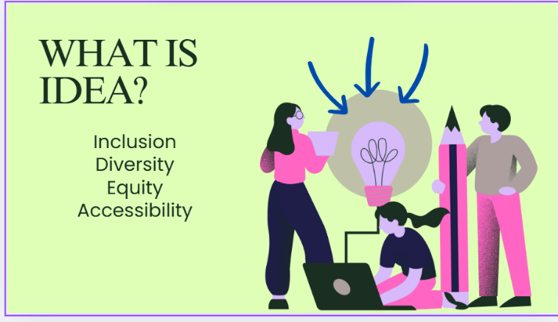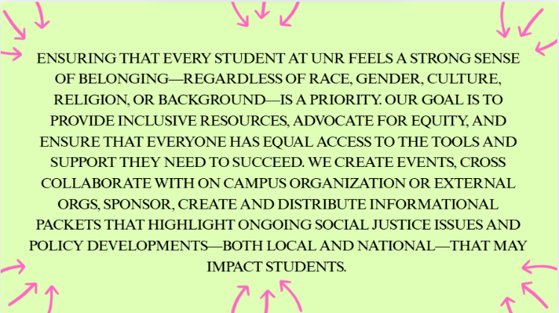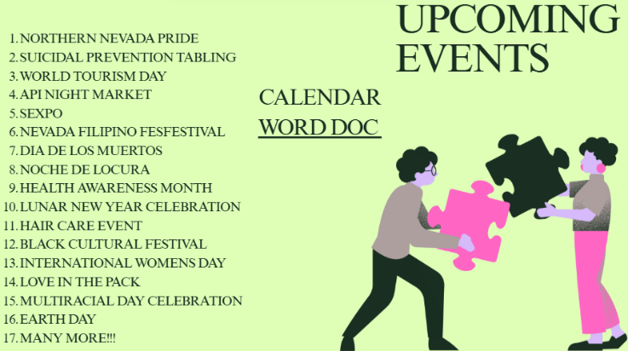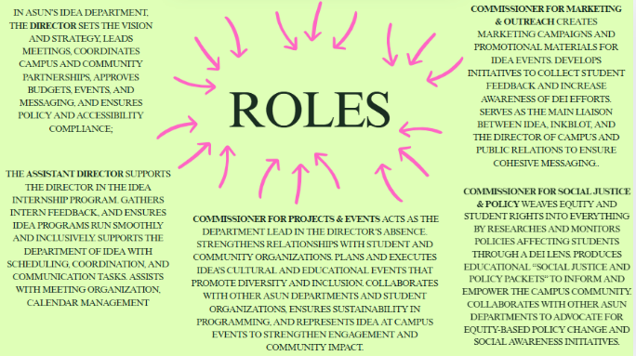
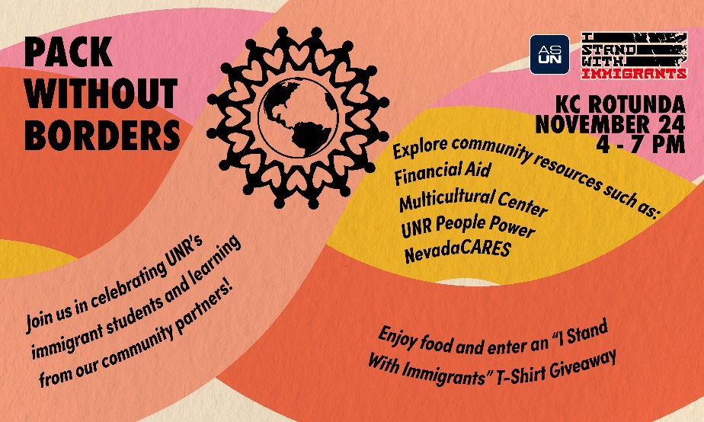

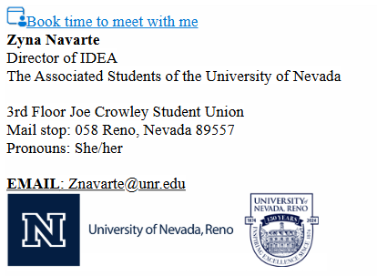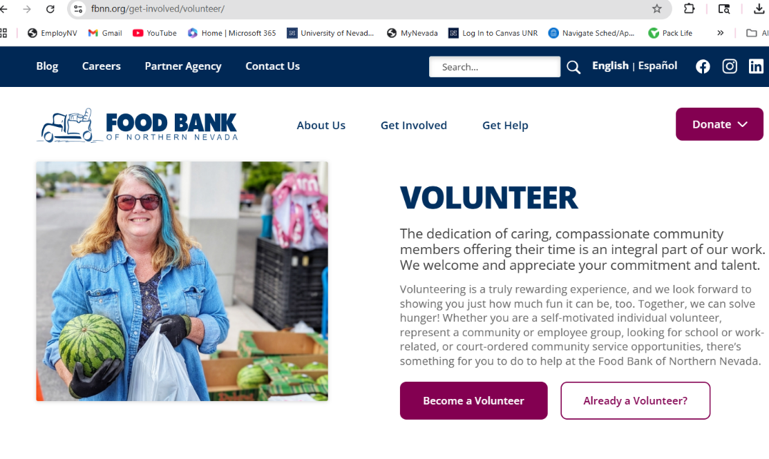
IDEA Grant Description
The IDEA Grant is a $1,500 funding opportunity, awarded equally to TWO students, organizations, clubs, who demonstrate a strong commitment to Inclusion, Diversity, Equity, and Access (IDEA) at the University of Nevada, Reno. This initiative, proudly presented by the Associated Students of the University of Nevada (ASUN) through the Department of IDEA, supports students who are passionate about creating a more inclusive campus environment.
This grant is specifically designed for students who submit a proposal for an event or initiative that promotes the values of IDEA on campus. Applicants are encouraged to creatively implement programs, events, or projects that foster cultural awareness, inclusivity, and equitable access for all students.
How to Participate:
- Application submission: submit an application detailing an event or initiative idea that aligns with IDEA’s core values by (DATE HERE) (application form link here)

QR CODE:
- Proposal format: Attach a Word document describing how your project or event will promote inclusion, diversity, equity, and access across the UNR community. (DRAFT WORD DOC INSERT HERE)
- Funding: Two selected applicants will each receive $750 in funding, distributed on (DATE HERE, prior to showcase fair event).
- Event timeline: Funded events or initiatives must be executed in February, March, or April with support from the Department of IDEA.
The IDEA Grant is not just a financial award—it’s a celebration of student leadership, dedication, peer support, and the ongoing effort to make our university a more inclusive, more connected community and equitable space for all.
Go Pack!
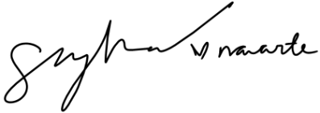
Zyna G Navarte
Director of IDEA

