Department of IDEA
Agenda for Friday, November 07, 2025 at 1:30 PM
In Person- JSCU 406 Conference Room
Joe Crowley Student Union 4th Floor
1664 N. Virginia Street
Reno, Nevada 89557
Virtual Zoom ID: 339 969 0437 Passcode: IDEA25
Zoom: LINK

- CALL MEETING TO ORDER
Director Zyna Navarte called the Department of IDEA meeting to order on Friday, November 7, 2025, at 1:30 PM in the Joe Crowley Student Union Room 406. The meeting was held in person and via Zoom.

- COMPLIANCE WITH NEVADA OPEN MEETING LAW
  - Director Navarte confirmed that the agenda was posted three full working days in advance on the ASUN website. The meeting occurred on the date, time, and location listed on the agenda, and the Zoom link was publicly accessible. All requirements under Nevada Open Meeting Law were met.
  - Was the agenda posted three full working days by 9 am, not including the meeting date? [Bring up the ASUN website and show the public]
  - Is the meeting taking place on the day of the week, month, day, year, at the time and location listed on the agenda?
  - Is the Zoom link working and available to the public?
  - If the answer to any of these questions is no, this meeting must be ENDED IMMEDIATELY unless NOML covers a legitimate correction.

- LAND ACKNOWLEDGEMENT
We recognize that the University of Nevada, Reno, sits on the traditional homelands of the Numu (Northern Paiute), Wašiw (Washoe), Newe (Western Shoshone), Nuwu (Southern Paiute) peoples. These lands continue to be a gathering place for Indigenous peoples and we recognize the deep connections to these places. We extend our appreciation for the opportunity to live and learn on their territory.

- ROLL CALL
The Secretary must list roll call.
- Director Zyna Navarte – Present
- Assistant Director Kaitlyn Rock – Present
- Commissioner of Event Planning Bea Campbell – Present
- Commissioner for Marketing and Outreach Jaden Ottaviano – Present
- Commissioner of Social Justice and Reform Manvi Mummalaneni – Present

- PUBLIC COMMENT (INFORMATION ONLY)
There was no public comment at this time.

- ADOPTION OF MINUTES (FOR POSSIBLE ACTION)
There are no minutes to be approved at this time.

- REPORTS (INFORMATION ONLY)
- Director Navarte reported collaborating with the UNR International Club to sponsor their event and noted that the week was hectic due to agenda adjustments. She confirmed a meeting initially planned for next Thursday would be canceled.
- Assistant Director Rock provided updates on outreach to departments and officers within ASUN. She noted communications with multiple departments and ongoing coordination with the Internship Coordinating Committee to ensure representation from various branches.
- Commissioner Campbell reported on the Pack Without Borders event, confirming the event name and date changes. She submitted PACLIFE forms, managed reservations, and coordinated credit card requests. She also planned to follow up with UNRPD and KC for confirmations.
- Commissioner Mummalaneni shared updates regarding coordination with Austin from ACLU to arrange a speaker for the Pack Without Borders event, confirming ongoing scheduling communication.
- Commissioner Ottaviano reported progress on marketing materials, including finalized stickers, social media graphics, and partnerships with community organizations such as Catholic Charities, the Multicultural Center, and Financial Aid. Six organizations had confirmed attendance, with two more being contacted.

- OLD BUSINESS (INFORMATION ONLY/FOR POSSIBLE ACTION)
  - The I Stand with Immigrants event was renamed 'Pack Without Borders' and rescheduled for Monday, November 24, 2025, from 4:00–7:00 PM at the Rotunda and Breezeway. Attendance is expected between 100–200 attendees. Logistics, setup, and organizational outreach were discussed. The next coordination meeting was scheduled for November 11 via Zoom. Director Navarte outlined logistics including check-in procedures, tabling tickets, and speaker introductions.

- NEW BUSINESS (INFORMATION ONLY/FOR POSSIBLE ACTION
  - Director Navarte introduced the budget proposal for the UNR International Club’s 'Night of All Nations' event. A motion to approve the $500.15 budget was moved by Commissioner Campbell and seconded. The motion passed unanimously. Funds will be allocated via Amazon purchases through the accounting office, with expected delivery before November 21, 2025
  - The IDEA Grant is a $1,500 funding opportunity awarded equally to two students, organizations, or clubs who demonstrate a strong commitment to Inclusion, Diversity, Equity, and Access (IDEA) at the University of Nevada, Reno. This initiative, led by the Department of IDEA through ASUN, supports projects that promote a more inclusive campus environment. Applications must outline an event or initiative aligning with IDEA’s core values. Two recipients will each receive $750 to implement their programs in Spring 2026 (February–April). Proposals should include measurable outcomes and plans for student engagement. The IDEA Grant celebrates student leadership, creativity, and advocacy toward fostering cultural awareness, inclusivity, and equitable access across the UNR community

- PUBLIC COMMENT (INFORMATION ONLY)
There was no public comment at this time.

- ADJOURNMENT
Director Navarte adjourned the meeting at 1:53 PM on Friday, November 7, 2025, in the Joe Crowley Student Union Room 406. The meeting concluded successfully.

Agenda items may be considered out of order at the discretion of the Chair. The committee may combine two or more agenda items for consideration. The Committee may remove an item from the agenda or delay discussion of an item at any time.

ASUN DEPARTMENT OF IDEA
EVENT & BUDGET PROPOSAL FORM

CONTACT INFORMATION:
Organizer(s)/ Intern(s): Zyna Navarte
E-mail(s): diversitydirector@asun.unr.edu or Znavarte@unr.edu
Learning Outcomes:
- Students will gain a deeper appreciation for the diverse cultures represented at UNR by engaging with international performances, traditions, and cuisine.
- Participants will develop cross-cultural communication skills and broaden their understanding of global perspectives through interaction with students from around the world.
- Attendees will strengthen their sense of belonging within the university’s multicultural community by celebrating diversity and fostering inclusivity through shared cultural experiences.
EVENT INFORMATION:
Event Name: | Night of All Nation | Date: | November 21st 2025
Event Location: | JCSU Ballroom | Time: | 5pm
Expected  Attendance: | 100+ | Cost Per  Student: | N/A

BUDGET INFORMATION: Please itemize your ENTIRE event budget below:
DESCRIPTION: | AMOUNT: | VENDOR:
- Snack Box | $47.98 | Amazon
- Elotitos | $12.84 | Amazon
- Diana | $12 | Amazon
- Pelon Pelo | $8.22 | Amazon
- Duvalin | $14.99 | Amazon
- Tao Kae Noi | $49.95 | Amazon
- Taro | $49.95 | Amazon
- Lux chips cheese | $14.99 | Amazon
- Lux chips sour cream | $14.99 | Amazon
- Korivka Roshen 3 pack | $30.08 | Amazon
- Roshen Strila candy | $29.98 | Amazon
- Roshen chocolateria box | $19.99 | Amazon
- Turkish delight candy | $26.98 | Amazon
- Turkish delight with pomegranate | $12.99 | Amazon
- Bulghur | $12.22 | Amazon
- Turkish coffee | $43.98 | Amazon
- Coconut candy | $15.2 | Amazon
- Chinese snacks | $23.99 | Amazon
- Chinese couplets | $14.86 | Amazon
- Classic guava hard candy | $13.98 | Amazon
- Chinese mooncakes | $29.99 | Amazon
TOTAL EVENT BUDGET: | $500.15
TOTAL ASUN BUDGET: | $500.15

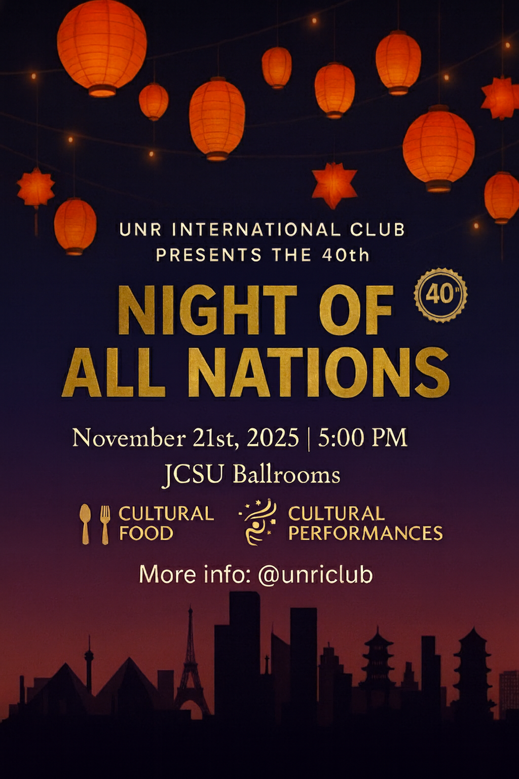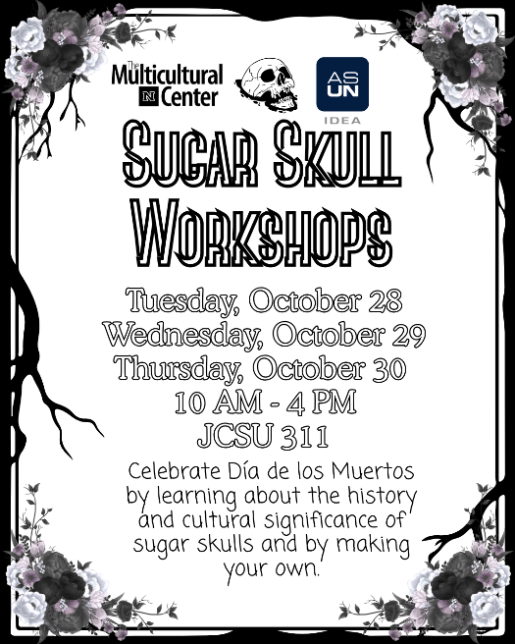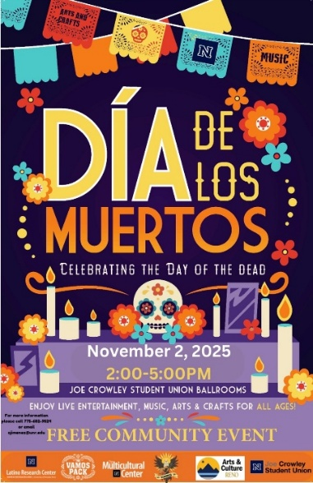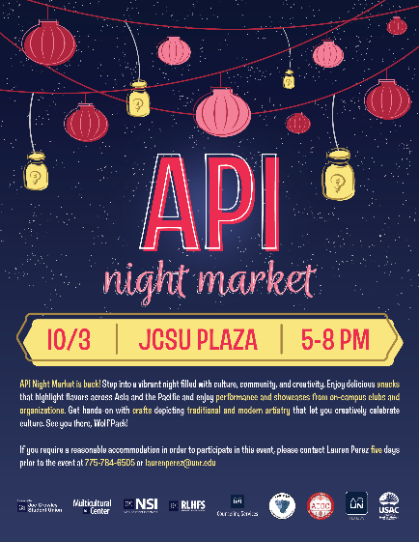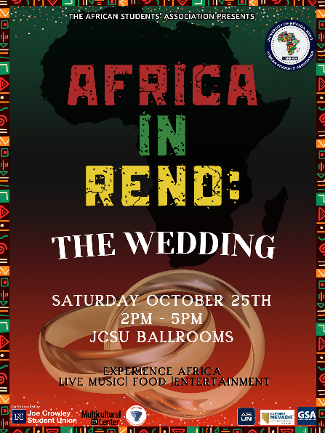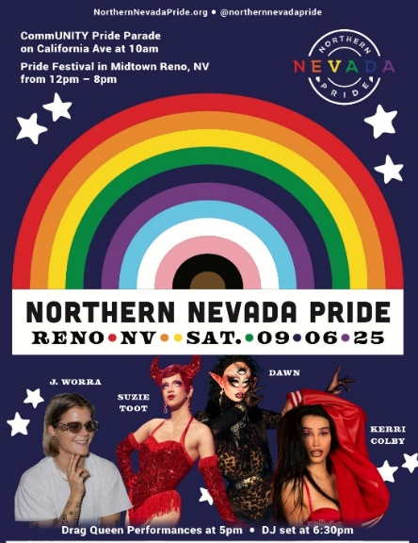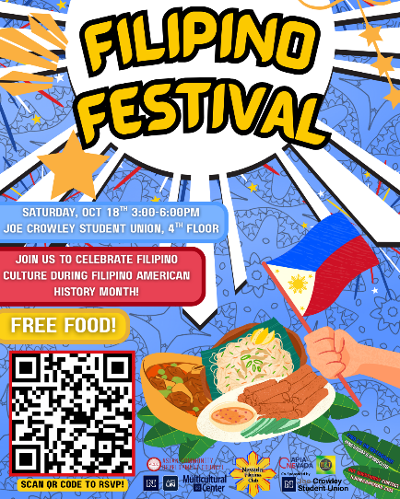

IDEA Grant Description DRAFT
The IDEA Grant is a $1,500 funding opportunity, awarded equally to TWO students, organizations, clubs, who demonstrate a strong commitment to Inclusion, Diversity, Equity, and Access (IDEA) at the University of Nevada, Reno. This initiative, proudly presented by the Associated Students of the University of Nevada (ASUN) through the Department of IDEA, supports students who are passionate about creating a more inclusive campus environment.
This grant is specifically designed for students who submit a proposal for an event or initiative that promotes the values of IDEA on campus. Applicants are encouraged to creatively implement programs, events, or projects that foster cultural awareness, inclusivity, and equitable access for all students.
How to Participate:
- Application submission: submit an application detailing an event or initiative idea that aligns with IDEA’s core values by (DATE HERE) (application form link here)

QR CODE:
- Proposal format: Attach a Word document describing how your project or event will promote inclusion, diversity, equity, and access across the UNR community. (DRAFT WORD DOC INSERT HERE)
- Funding: Two selected applicants will each receive $750 in funding, distributed on (DATE HERE, prior to showcase fair event).
- Event timeline: Funded events or initiatives must be executed in February, March, or April with support from the Department of IDEA.
The IDEA Grant is not just a financial award—it’s a celebration of student leadership, dedication, peer support, and the ongoing effort to make our university a more inclusive, more connected community and equitable space for all.
Go Pack!
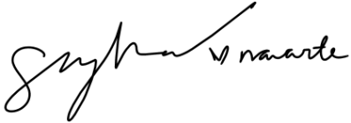
Zyna G Navarte
Director of IDEA

