Department of ASUN IDEA
Agenda for Friday, October 24th, 2025 at 1:30 PM
In Person- JSCU 406 Conference Room
Joe Crowley Student Union 4th Floor
1664 N. Virginia Street
Reno, Nevada 89557
Virtual Zoom ID: 339 969 0437 Passcode: IDEA25
Zoom: LINK

- CALL MEETING TO ORDER

- COMPLIANCE WITH NEVADA OPEN MEETING LAW
  - Was the agenda posted three full working days by 9 am, not including the meeting date? [https://nevadaasun.com/meetings/]
  - Is the meeting taking place on the day of the week, month, day, year, at the time and location listed on the agenda?
  - Is the Zoom link working and available to the public?
  - If the answer to any of these questions is no, this meeting must be ENDED IMMEDIATELY unless NOML covers a legitimate correction.

- LAND ACKNOWLEDGEMENT
We recognize that the University of Nevada, Reno, sits on the traditional homelands of the Numu (Northern Paiute), Wašiw (Washoe), Newe (Western Shoshone), Nuwu (Southern Paiute) peoples. These lands continue to be a gathering place for Indigenous peoples and we recognize the deep connections to these places. We extend our appreciation for the opportunity to live and learn on their territory.

- ROLL CALL
The Secretary must list roll call.
- Director, Zyna Navarte
- Assistant Director, Kaitlyn Rock
- Commissioner of Social Justice and Reform, Manvi Mummalaneni
- Commissioner of Event Planning, Bea Campbell
- Commissioner for Marketing and Outreach, Jaden Ottaviano

- PUBLIC COMMENT (INFORMATION ONLY)
Items heard under public comment may be for items either on or off the agenda. Action may not be taken on items raised under public comment. The Chair may elect to take public comment on actions on this agenda. The Chair may impose reasonable limits on the length of time members of the public may speak.

- ADOPTION OF MINUTES (FOR POSSIBLE ACTION)
There are no minutes to be approved at this time.

- AUDIO MINUTES MISSING FOR PREVIOUS MEETINGS OF THIS BODY THAT DO NOT MEET 30 DAY POSTING OF NEVADA OPEN MEETING LAW FOR CORRECTIVE ACTION
For Possible Corrective Action:
08/11/2025 – (For Possible Corrective Action)

- REPORTS (INFORMATION ONLY)
- Director, Zyna Navarte
- Assistant Director, Kaitlyn Rock
- Commissioner of Social Justice and Reform, Manvi Mummalaneni
- Commissioner of Event Planning, Bea Campbell
- Commissioner for Marketing and Outreach, Jaden Ottaviano

- OLD BUSINESS (INFORMATION ONLY/FOR POSSIBLE ACTION)
  - Filipino Festival Event (Information Only)
  - African Students Association “The Wedding” Event (Information Only)

- NEW BUSINESS (INFORMATION ONLY/FOR POSSIBLE ACTION
There is no new business to be discussed.
  - Budget for I Stand with Immigrants (Possible Action)
  - Brainstorm ideas for the November Calendar & Events (Information Only)
  - IDEA Interns Introduction (Information Only)

- PUBLIC COMMENT (INFORMATION ONLY)
Items heard under public comment may be for items either on or off the agenda. Action may not be taken on items raised under public comment. The Chair may elect to take public comment on action items on this agenda. The Chair may impose reasonable limits on the length of time members of the public may speak.

- ADJOURNMENT
NOTES:
Agenda items may be considered out of order at the discretion of the Chair. The committee may combine two or more agenda items for consideration. The Committee may remove an item from the agenda or delay discussion of an item at any time.

ASUN DEPARTMENT OF IDEA
EVENT & BUDGET PROPOSAL FORM

CONTACT INFORMATION:
Organizer(s)/ Intern(s): Zyna Navarte
E-mail(s): diversitydirector@asun.unr.edu or Znavarte@unr.edu
Learning Outcomes:
- Participants will be able to identify and explain the diverse experiences, challenges, and contributions of immigrant communities within Nevada and the United States
- Participants will develop a deeper understanding of immigrant identity and resilience, fostering empathy and cultural humility through personal stories, dialogue, and reflection activities
- Participants will gain knowledge of campus and community resources that support immigrants and will be empowered to advocate for inclusion, accessibility, and equitable opportunities for all students
EVENT INFORMATION:
Event Name: | I Stand with Immigrants | Date: | 11/21/2025
Event Location: | Rotunda | Time: | 4pm – 7pm
Expected  Attendance: | 100+ | Cost Per  Student: | none

BUDGET INFORMATION: Please itemize your ENTIRE event budget below:
DESCRIPTION: | AMOUNT: | VENDOR:
- Caprisun 30 cts | $25.56 | Amazon
- Water bottle 40 counts | $21.88 | Walmart
- Coca cola 24 counts | $41.94 | Walmart
- Pepsi wild cherry 12 counts | $46.08 | Walmart
- Spaghetti with Meat Sauce and Meatballs | $294.95 (5 of $58.99) | Olive Garden
- Jumbo Salad | $99.16 (4 of $24.79) | Olive Garden
- Fettuccine Alfredo | $254.95 (5 of $50.99) | Olive Garden
- 12 Breadsticks Baked | $52.43 (7 of $7.49) | Olive Garden
- 12 Breadsticks unbaked | $52.43 (7 of $7.49) | Olive Garden
- Variety of Cheesecakes 8 slices | $103.74 (13 order of $7.98) | Walmart
- 10 I Stand with Immigrants Shirts | $137.50 | I Am An Immigrant
- Red 100pcs Gift bags | $17.98 | Amazon
- Stand with Immigrant | $16.35 | Amazon
- Social Justice stickers | $15.98 | Amazon
- Beautiful Thank You card | $8.99 | Amazon
- Red 16 Pack 54 x 108 Inch Plastic Tablecloths | $29.98 | Amazon
- Indiana Ticket RED | $11.54 | Amazon
- Gloves 1200 counts (1 quantities) | $18.99 | Amazon
- Jolly Clamshell food container | $99.96 (4 of $24.99) | Amazon
- Heavy duty 360 silverware plastic | $23.98 | Amazon
- Indexcard 300 | $5.99 | Amazon
- 35 pcs fiesta paper | $17.99 | Amazon
- 48 pcs notepad, pens etc | $99.95 (5 orders of $19.99) | Amazon
- LCR PRINTING | $100 | LRC

TOTAL EVENT BUDGET: | $1,600
TOTAL ASUN BUDGET: | $1,600

Items link and screenshots:
https://store.iamanimmigrant.com/checkouts/cn/hWN450yiDfzrXDODn2cJbHtg/en-us?auto_redirect=false&edge_redirect=true&skip_shop_pay=true
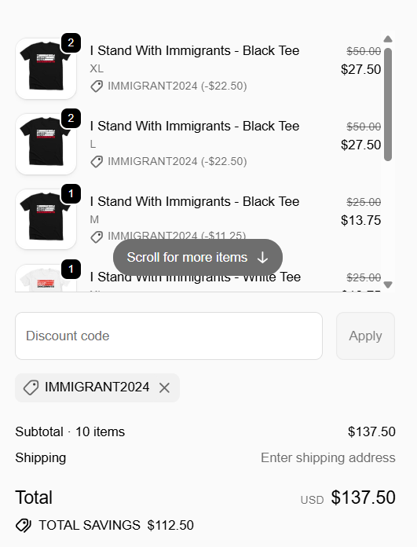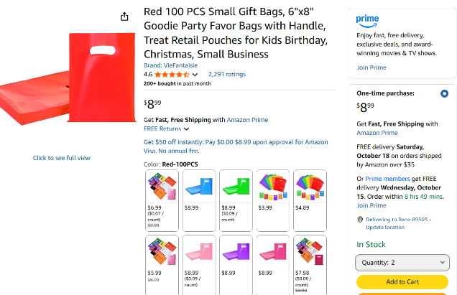
Red 100 Pcs small gift bags (2 quantity)
FLAG (1 quantity)
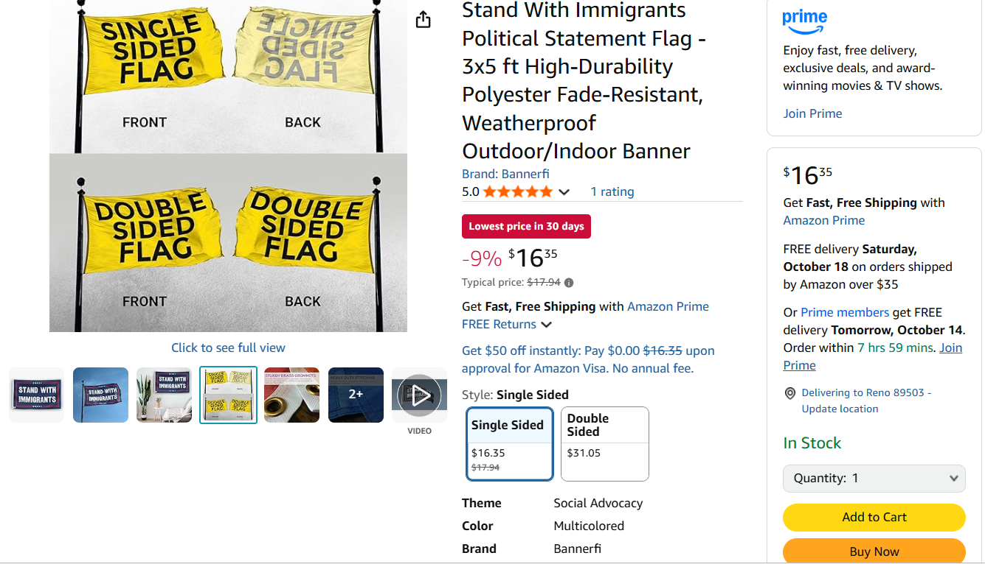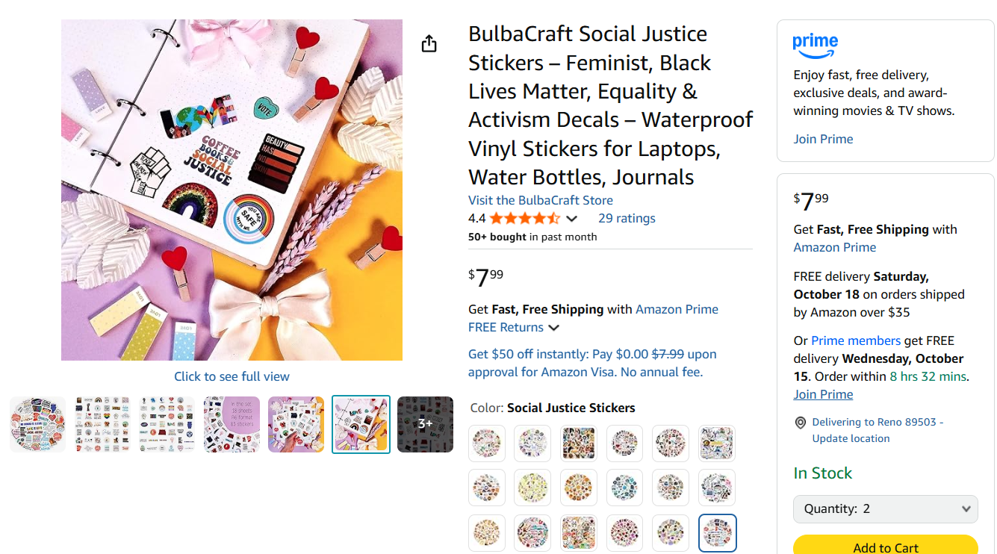
Social Justice Stickers (2 quantity)
Thank you card (1 quantity)
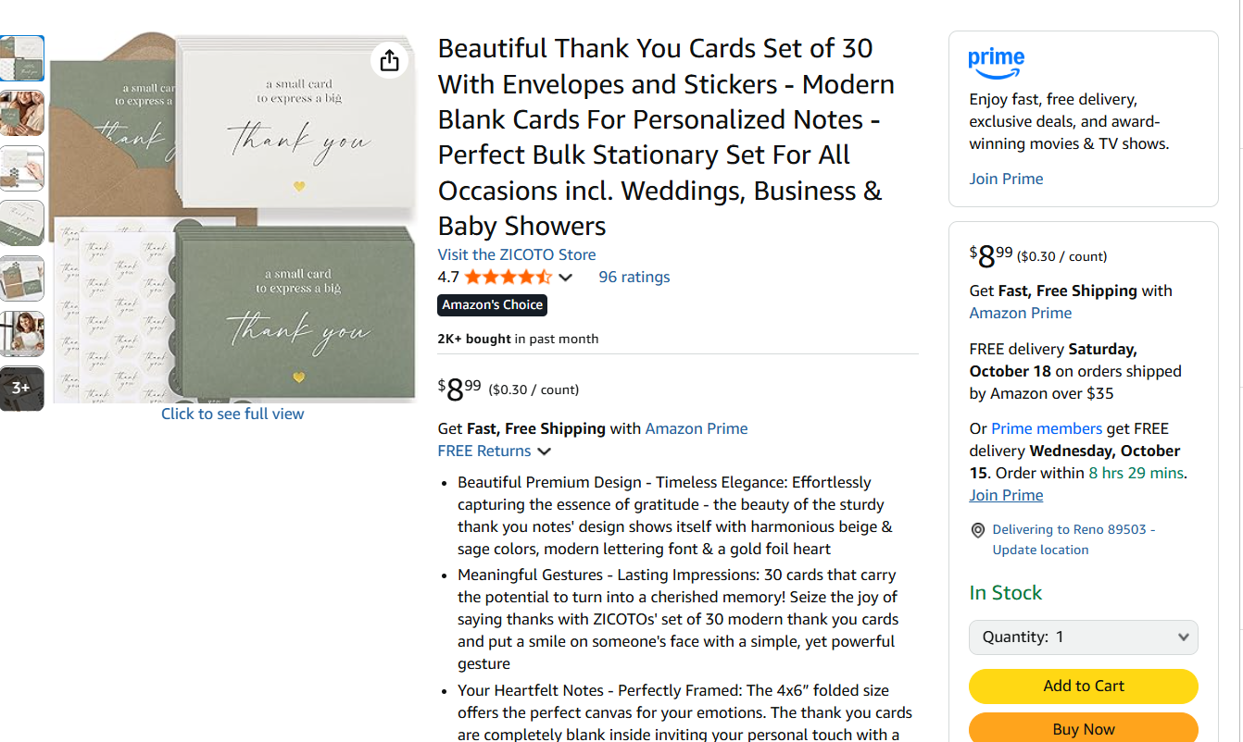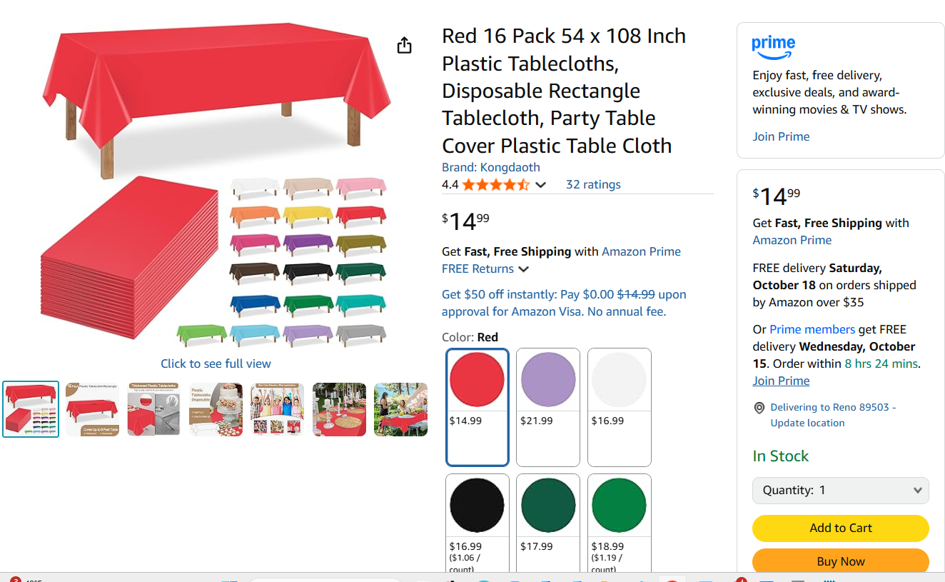
Tablecloths (1 quantity)

Caprisun
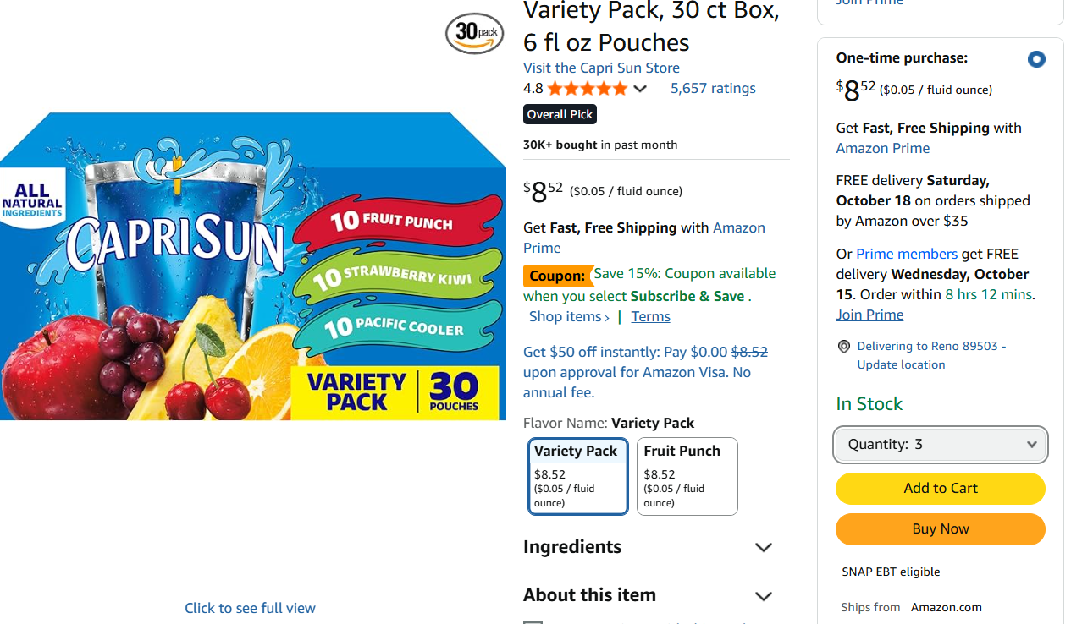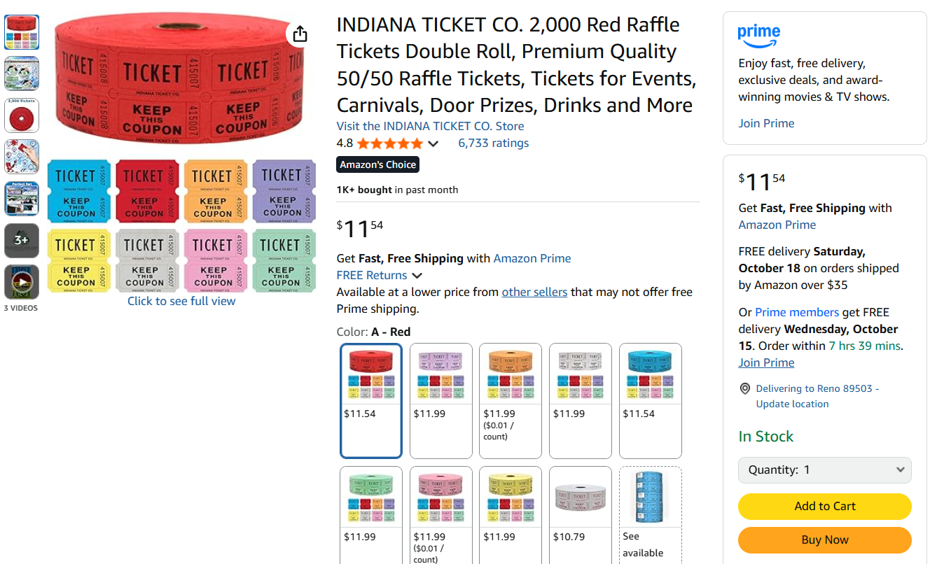
Indianna Ticker Red

Gloves 1200 counts (1 quantities)
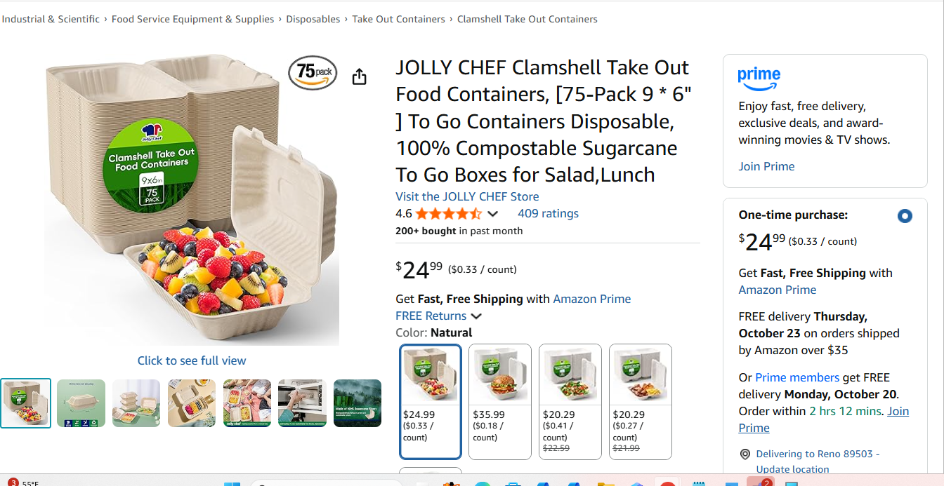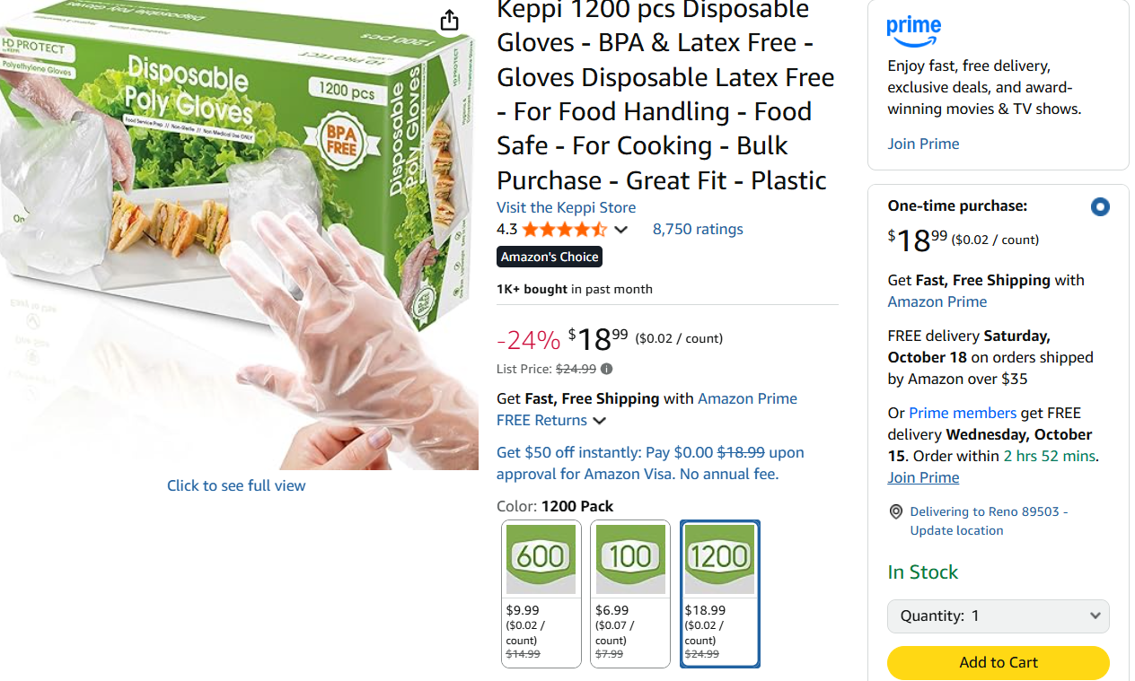
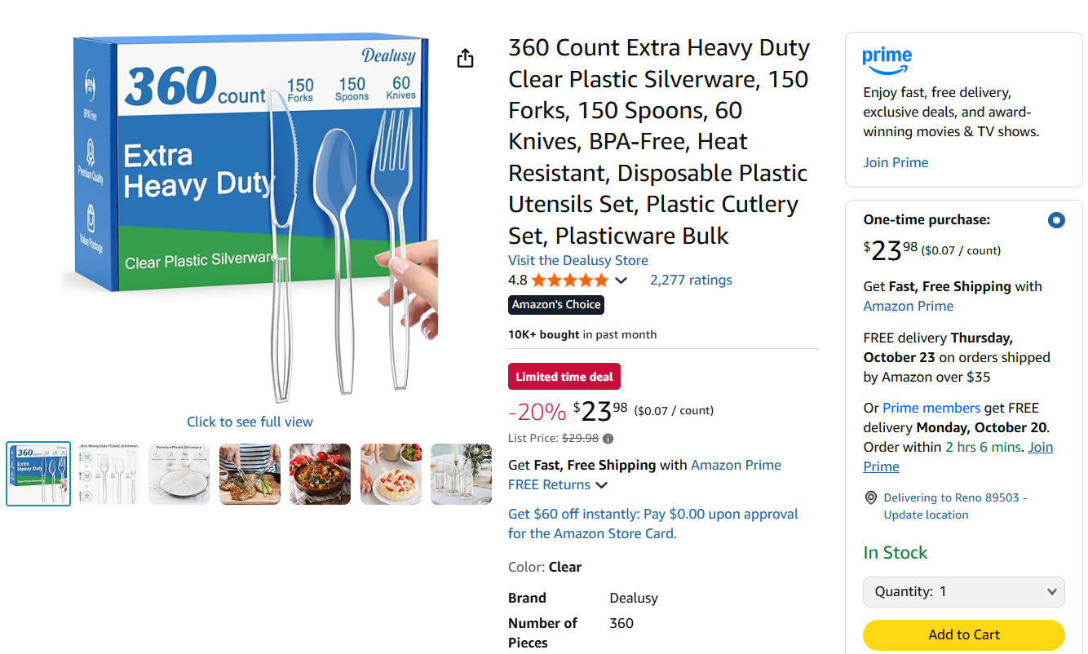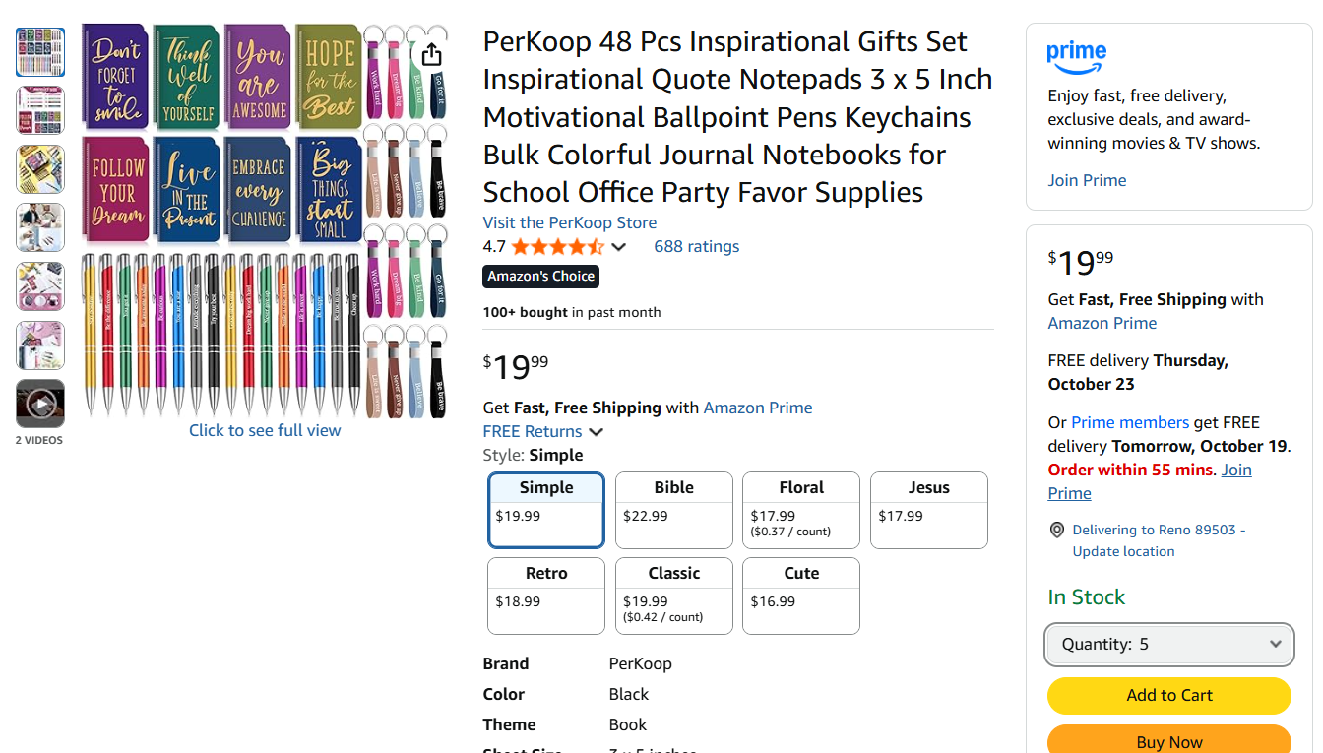
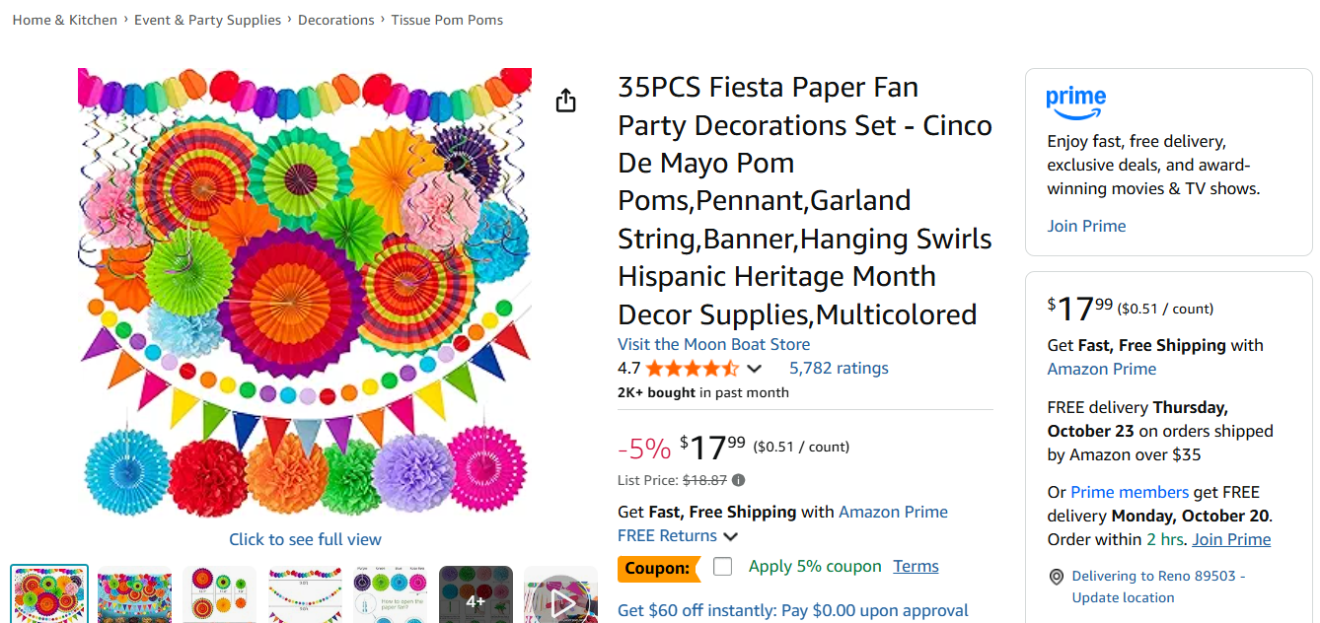 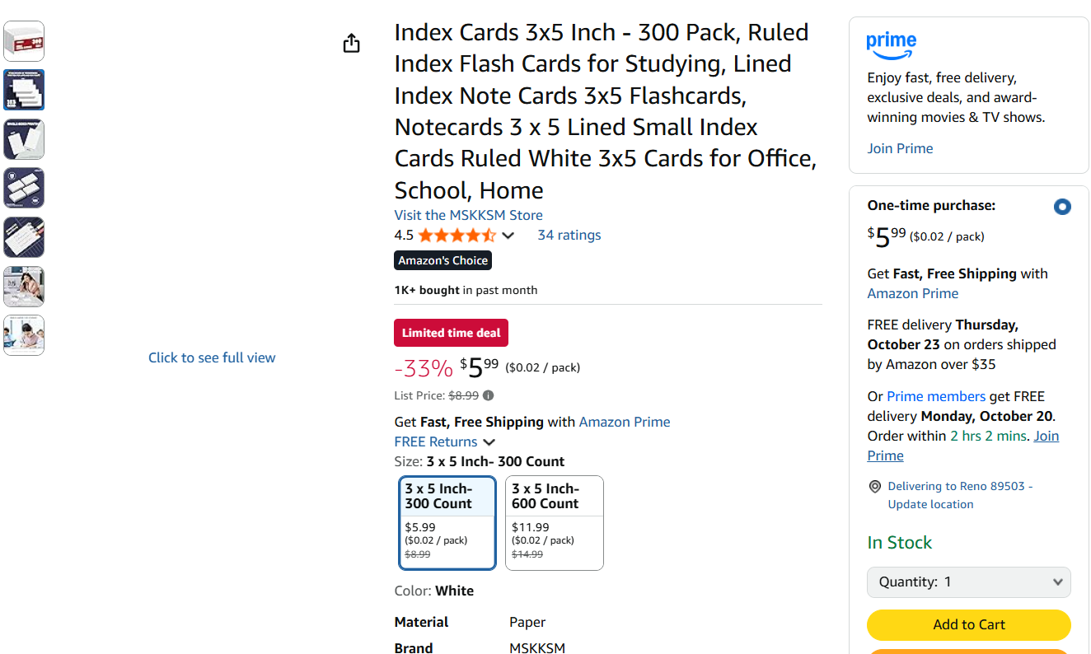 Walmart
Water 40 counts (4 quantity)
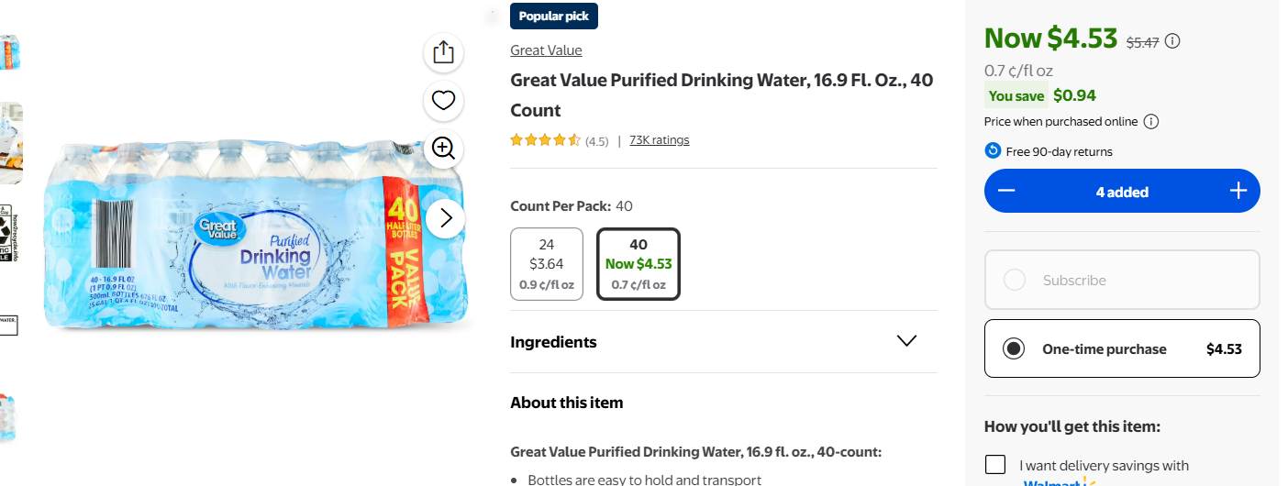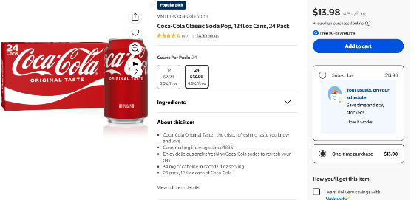 Cola 24 counts (4 quantity)

Cherry pepsi 12 counts (6 quantities)
