Department of IDEA

Senate of the Associated Students 93rd Session

Agenda for Friday, October 10, 2025, at 1:30PM

In Person- JCSU Room 406 Conference Room

Joe Crowley Student Union 4th Floor

1664 N. Virginia Street

Reno, Nevada 89557

Virtual Zoom ID: 339 969 0437 Passcode: IDEA25

Zoom: [LINK](https://us04web.zoom.us/j/3399690437?pwd=br6tQjaJIfK98nVb3LnTVrIW1y0GlL.1)

1. **CALL MEETING TO ORDER**
2. **COMPLIANCE WITH NEVADA OPEN MEETING LAW**
   1. Was the agenda posted three full working days by 9 am, not including the meeting date? [Bring up the ASUN website and show the public]
   2. Is the meeting taking place on the day of the week, month, day, year, at the time and location listed on the agenda?
   3. Is the Zoom link working and available to the public?
   4. If the answer to any of these questions is no, this meeting must be ENDED IMMEDIATELY unless NOML covers a legitimate correction.
3. **LAND ACKNOWLEDGEMENT**

We recognize that the University of Nevada, Reno, sits on the traditional homelands of the Numu (Northern Paiute), Wašiw (Washoe), Newe (Western Shoshone), Nuwu (Southern Paiute) peoples. These lands continue to be a gathering place for Indigenous peoples and we recognize the deep connections to these places. We extend our appreciation for the opportunity to live and learn on their territory.

1. **ROLL CALL**

The Secretary must list roll call.

1. Director, Zyna Navarte
2. Assistant Director, Kaitlyn Rock
3. Commissioner of Event Planning, Bea Campbell
4. Commissioner for Marketing and Outreach, Jaden Ottaviano
5. Commissioner of Social Justice and Reform, Manvi Mummalaneni
6. **PUBLIC COMMENT (INFORMATION ONLY)**

Items heard under public comment may be for items either on or off the agenda. Action may not be taken on items raised under public comment. The Chair may elect to take public comment on actions on this agenda. The Chair may impose reasonable limits on the length of time members of the public may speak.

1. **ADOPTION OF MINUTES (FOR POSSIBLE ACTION)**

There are no minutes to be approved at this time.

1. **AUDIO MINUTES MISSING FOR PREVIOUS MEETINGS OF THIS BODY THAT DO NOT MEET 30 DAY POSTING OF NEVADA OPEN MEETING LAW FOR CORRECTIVE ACTION**

For Possible Corrective Action:

1. **August 11, 2025**
2. **August 29, 2025**
3. **September 11, 2025**
4. **OLD BUSINESS (INFORMATION ONLY/FOR POSSIBLE ACTION)**

The department will discuss :

1. API Night Market Tabling Event (Information Only)
2. Filipino Festival (For Possible Action)
3. **NEW BUSINESS (INFORMATION ONLY/FOR POSSIBLE ACTION**

The department will discuss the following line items for information/possible corrective action

1. Budget for Noche de Locura for October 15, 2025 (Possible Corrective Action)
2. Budget for African Student Association collaboration on October 25, 2025 (Possible Corrective Action)
3. Budget for Sexpo collaboration on October 20th at 6pm (Possible Corrective Action)
4. Budget for IDEA poster/flyer/sticky notes Plastic Frame and Reusable Tote Bags (Possible Corrective Action)
5. Voices of the Land Event Cancellation (Possible Corrective Action)
6. Homecoming Parade (Possible Corrective Action)
7. Social Justice Pamphlets (Possible Corrective Action)
8. Internship by Assistant Director Kaitlyn Rock (Possible Corrective Action)
9. UNR International Club collaboration (Information Only)
10. Undocupack collaboration (Information Only)
11. **PUBLIC COMMENT (INFORMATION ONLY)**

Items heard under public comment may be for items either on or off the agenda. Action may not be taken on items raised under public comment. The Chair may elect to take public comment on action items on this agenda. The Chair may impose reasonable limits on the length of time members of the public may speak.

1. **ADJOURNMENT**

ASUN DEPARTMENT OF IDEA

EVENT & BUDGET PROPOSAL FORM

CONTACT INFORMATION:

Organizer(s)/ Intern(s): Zyna Navarte

E-mail(s): [diversitydirector@asun.unr.edu](mailto:diversitydirector@asun.unr.edu) or [Znavarte@unr.edu](mailto:Znavarte@unr.edu)

Learning Outcomes:

1. Students gained exposure to Latinx heritage through music, food, and performances, fostering cross-cultural understanding and inclusivity.
2. Students connected with peers, cultural clubs, and campus organizations, strengthening their sense of belonging and campus involvement.
3. The event provided a safe, festive space for students to relax, reduce stress, and build positive social networks outside of academics.

EVENT INFORMATION:

|  |  |  |  |
| --- | --- | --- | --- |
| **Event Name:** | **Noche de Locura** | **Date:** | **10/15/2025** |
| **Event Location:** | **Nye Canda Plaza** | **Time:** | **5pm** |
| **Expected**  **Attendance:** | **100+** | **Cost Per**  **Student:** | **none** |

BUDGET INFORMATION: *Please itemize your ENTIRE event budget below:*

|  |  |  |
| --- | --- | --- |
| **DESCRIPTION:** | **AMOUNT:** | **VENDOR:** |
| 1. Sponsorship | $1,000 | DSJI Noche de Locura |

|  |  |  |
| --- | --- | --- |
| **TOTAL EVENT BUDGET:** | **$1,000** |  |
| **TOTAL ASUN BUDGET:** | **$1,000** |  |

ASUN DEPARTMENT OF IDEA

EVENT & BUDGET PROPOSAL FORM

CONTACT INFORMATION:

Organizer(s)/ Intern(s): Zyna Navarte

E-mail(s): [diversitydirector@asun.unr.edu](mailto:diversitydirector@asun.unr.edu) or [Znavarte@unr.edu](mailto:Znavarte@unr.edu)

Learning Outcomes:

1. Students will be able to **define key concepts of sexual health** (such as consent, contraception, and STI prevention) and explain their importance in maintaining well-being.
2. Students will be able to **demonstrate increased awareness of safe and inclusive practices** that promote respect for diverse sexual orientations, gender identities, and relationship choices.
3. Students will be able to **identify at least two campus or community resources** that provide sexual health education, services, or support, and describe how to access them.

EVENT INFORMATION:

|  |  |  |  |
| --- | --- | --- | --- |
| **Event Name:** | **Sexpo** | **Date:** | **10/20/2025** |
| **Event Location:** | **Great Basin Hall Multipurpose Room** | **Time:** | **6pm** |
| **Expected**  **Attendance:** | **100+** | **Cost Per**  **Student:** | **none** |

BUDGET INFORMATION: *Please itemize your ENTIRE event budget below:*

|  |  |  |
| --- | --- | --- |
| **DESCRIPTION:** | **AMOUNT:** | **VENDOR:** |
| 1. Chips (Mixed Packs) | $39.96 | Walmart |

|  |  |  |
| --- | --- | --- |
| **TOTAL EVENT BUDGET:** | **$39.96** |  |
| **TOTAL ASUN BUDGET:** | **$39.96** |  |

ASUN DEPARTMENT OF IDEA

EVENT & BUDGET PROPOSAL FORM

CONTACT INFORMATION:

Organizer(s)/ Intern(s): Zyna Navarte

E-mail(s): [diversitydirector@asun.unr.edu](mailto:diversitydirector@asun.unr.edu) or [Znavarte@unr.edu](mailto:Znavarte@unr.edu)

Learning Outcomes:

1.Students will be able to **demonstrate the importance of visibility and representation** by displaying posters, flyers, and sticky notes from the Northern Nevada Pride Parade and Festival in the office, highlighting the impact of community engagement and inclusivity.

2.Students will be able to **recognize the Department of IDEA’s mission and resources** through distributed tote bags, which serve as a tool to increase visibility, promote engagement, and encourage participation in campus events.

EVENT INFORMATION:

|  |  |  |  |
| --- | --- | --- | --- |
| **Event Name:** | **NONE** | **Date:** | **n/a** |
| **Event Location:** | **n/a** | **Time:** | **n/a** |
| **Expected**  **Attendance:** | **n/a** | **Cost Per**  **Student:** | **none** |

BUDGET INFORMATION: *Please itemize your ENTIRE event budget below:*

|  |  |  |
| --- | --- | --- |
| **DESCRIPTION:** | **AMOUNT:** | **VENDOR:** |
| 2. 27x40 in Poster Frame Black 3 Pack, | $59.99 | Amazon |
| Reusable Tote Bags | $86.97 | Amazon |

|  |  |  |
| --- | --- | --- |
| **TOTAL EVENT BUDGET:** | **$146.46** |  |
| **TOTAL ASUN BUDGET:** | **$146.96** |  |

ASUN DEPARTMENT OF IDEA

EVENT & BUDGET PROPOSAL FORM

CONTACT INFORMATION:

Organizer(s)/ Intern(s): Zyna Navarte

E-mail(s): [diversitydirector@asun.unr.edu](mailto:diversitydirector@asun.unr.edu) or [Znavarte@unr.edu](mailto:Znavarte@unr.edu)

Learning Outcomes:

1. Students gained exposure to Latinx heritage through music, food, and performances, fostering cross-cultural understanding and inclusivity.
2. Students connected with peers, cultural clubs, and campus organizations, strengthening their sense of belonging and campus involvement.
3. The event provided a safe, festive space for students to relax, reduce stress, and build positive social networks outside of academics.

EVENT INFORMATION:

|  |  |  |  |
| --- | --- | --- | --- |
| **Event Name:** | **African in Reno “The Wedding”** | **Date:** | **10/25/2025** |
| **Event Location:** | **JCSU Ballroom** | **Time:** | **2-5pm** |
| **Expected**  **Attendance:** | **100+** | **Cost Per**  **Student:** | **none** |

BUDGET INFORMATION: *Please itemize your ENTIRE event budget below:*

|  |  |  |
| --- | --- | --- |
| **DESCRIPTION:** | **AMOUNT:** | **VENDOR:** |
| 1.Sponsorship | $460 | African Students Association Club |
| 2.LRC posters and Flyers | $40 | LRC |

|  |  |  |
| --- | --- | --- |
| **TOTAL EVENT BUDGET:** | **$500** |  |
| **TOTAL ASUN BUDGET:** | **$500** |  |

<https://www.walmart.com/cart> (2 orders of mix variety pack)

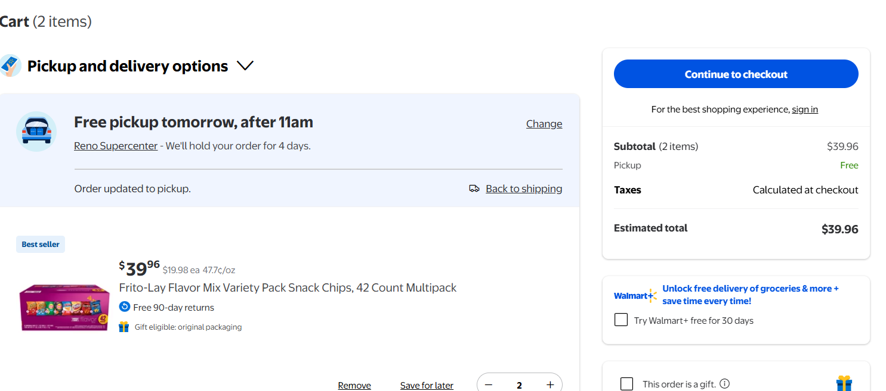

<https://www.amazon.com/gp/cart/view.html?ref_=nav_cart> (1 order of frame and 3 order of totes bag)

