Committee on Government Operations

Senate of the Associated Students 93rd Session

Agenda for The 1st of October 10/1/2025 at Time 4:30 pm

In-Person: Joe Crowley Student Union - PCR – Frankie Sue Del Papa President’s Conference Room

Virtual: Email: Senator Nick Bohlander for the Zoom link: senatorbohlander@unr.edu

1. **CALL MEETING TO ORDER**

Call Meeting to Order must be listed by Secretaries.

1. **LAND ACKNOWLEDGMENT**

We acknowledge that the University of Nevada, Reno is situated on the traditional homelands of

the Numu (Northern Paiute), Wašiw (Washoe), Newe (Western Shoshone), Nuwu (Southern

Paiute) people. These lands continue to be a gathering place for Indigenous peoples and we

recognize the deep connections to these places. We extend our appreciation for the

opportunity to live and learn on their territory

1. **ROLL CALL**

Roll Call must be listed by Secretaries.

1. **PUBLIC COMMENT (INFORMATION ONLY)**

Items heard under public comment may be for items either on or off the agenda. Action may not be taken on items raised under public comment. The Chair may elect to take public comment on action items on this agenda. The Chair may impose reasonable limits on the length members of the public may speak.

1. **ADOPTION OF MINUTES (FOR POSSIBLE ACTION)**

5/8, 9/12

1. **REPORTS (INFORMATION ONLY)**

The Committee will share progress on Committee-related activities that they have been working on.

1. **OLD BUSINESS (INFORMATION ONLY/FOR POSSIBLE ACTION)**

* SAS Audit Titles X-XVIII

1. **NEW BUSINESS (INFORMATION ONLY/FOR POSSIBLE ACTION)**

* S.B.R. 93 – a Binding Resolution to define the Duties and Liaison Positions of the Special Committee on Food Insecurity

1. **PUBLIC COMMENT (INFORMATION ONLY)**

Items heard under public comment may be for items either on or off the agenda. Action may not be taken on items raised under public comment. The Chair may elect to take public comment on action items on this agenda. The Chair may impose reasonable limits on the length members of the public may speak.

1. **ADJOURNMENT**

1. **NOTES.**

Agenda items may be considered out of order at the discretion of the Chair. The Committee may combine two or more agenda items for consideration. The Committee may remove an item from the agenda or delay discussion relating to an item on the agenda at any time.

The Associated Students supports providing equal access to all programs for people with disabilities. Reasonable efforts will be made to assist and accommodate physically handicapped persons desiring to attend the meeting. Please call the Speaker of the ASUN at (775) 784-6589 in advance so that arrangements may be conveniently made.

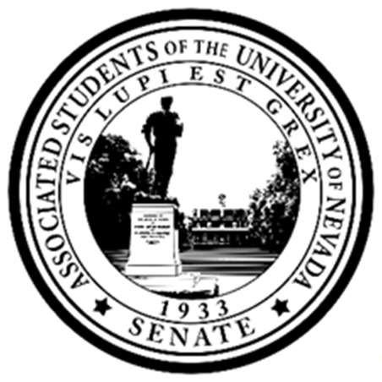Posted at the ASUN Offices in the Joe Crowley Student Union, Frandsen Humanities Building, the Penning Student Achievement Center, the Mathewson IGT Knowledge Center and online at [www.nevadaasun.com](http://www.nevadaasun.com/). Requests for supporting material for an agenda should be directed to the Archives of the Associated Students. All other inquiries should be directed to Senator Bohlander at senatorbohlander@unr.edu

Committee on Government Operations

The 1st of October 10/1/2025 at 4:30 pm

