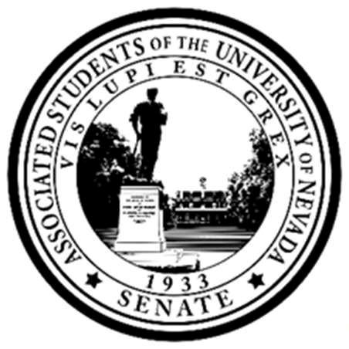
Committee on Safety, Sustainability,
and Wellness
Senate of the Associated Students 93rd Session Minutes for Tuesday, July 15th, at 1 p.m.
In Person- Frankie Sue Del Papa Presidents Conference Room

1. CALL MEETING TO ORDER
Chair Levy called the Committee on Safety, Sustainability and Wellness to order on Tuesday July 15th at 1:00 PM in the Frankie Sue Del Papa Presidents Conference room and on zoom. Presiding Secretary Johnson.

2. LAND ACKNOWLEDGEMENT
We acknowledge that the University of Nevada, Reno is situated on the traditional homelands of the Numu (Northern Paiute), Wašiw (Washoe), Newe (Western Shoshone), Nuwu (Southern Paiute) peoples. These lands continue to be a gathering place for Indigenous peoples and we recognize the deep connections to these places. We extend our appreciation for the opportunity to live and learn on their territory.

3. ROLL CALL
Roll Call must be listed by the Secretaries.
- Chair Levy- Present
- Senator Atkinson-Present
- Senator Barrus- Present
- Senator Evans-Present
- Senator Houghtelling-Absence Excused
- Senator Kitch-Present
- Senator Sapporito- Present
- Senator Terry-Present
- Senator Villa- Tardy Excused
-Quorum was present

4. PUBLIC COMMENT (INFORMATION ONLY)
-No Public comment at the time
5. ADOPTION OF MINUTES (FOR POSSIBLE ACTION)
There were no minutes to be approved at the time.

6. REPORTS (INFORMATION ONLY)
- Chair Levy:
Committee on Safety, Sustainability, and Wellness Minutes Tuesday, July 15th, 2025 at 1:00p.m.
Page 2

  - Liaison familiarity: Chair Levy reported on aiming for goals regarding liaison positions; Reported on availability for committee members to schedule a meeting with her and Vice Chair Barrus. They will be checking up on what the plans are in August.

  - Event planning and expected contribution for Safety Week (week of Sept. 14th).

-Wants to possibly host an event for Safety Week
-Senator Terry made a point of order regarding information only agenda items.

  - Brainstormed alongside Director Hohman and Lee, events that can be held. Brought up SSW liaisons that can collaborate/ what kind of events people would like to see during this week that highlight safety (ex: self-defense lessons with UNR PD, food safety with Campus Dining, etc...)
-Senator Villa entered the chambers at 1:09 PM
- Vice Chair Barrus- No Report at the time.
- Director of Sustainability - Sephora Lee- No Report at the time.
- Director of Wellness - Emily Hohman- Reported on meeting with the center for civil rights to discuss a book fair on the 17th and 18th where maybe local bookstores could come/other vendors for students to visit- Will be meeting with President Aglubat on July 17th to discuss funds and allocations per day.
- Assistant Director of Wellness -
- Assistant Director of Sustainability-

- Reviewing the Canva- Safety Week Event Planning Details

7. OLD BUSINESS (FOR POSSIBLE ACTION)
There was no old business to be discussed at the time.

8. NEW BUSINESS (FOR POSSIBLE ACTION)

a. Assignment of Liaison Positions: - No changes were made at the time
i. Facility Services - Senator Levy
ii. NevadaCARES - Senator Barrus
iii. University Police Services - Senator Sapporito iv. E.L. Wiegand Fitness Center - Senator Evans v. Counseling Services- Senator Terry vi. Title IX Office - Senator Kitch vii. Campus Dining - Senator Villa

Committee on Safety, Sustainability, and Wellness Tuesday, July 15th, 2025 at 1:00p.m.
Page 3

viii. The Student Health Center – VACCANT ix. University Housing - Senator Atickison

9. SENATOR REPORTS
-Senator Barrus reported on planning an event with several other senators and nutrition and SHC about food and nutritional safety on campus/would like to implement into Safety Week
-Director Lee mentioned partnering with the food accessibly coalition
-Senator Terry made a point of clarification regarding several events within Safety Week.
-Director Lee and and Hohman discussed 5k event and details thereof
-Senator Terry mentioned responsibility and expectations for the event the committee will be planning.
-Chair Levy opened the floor for opinions on dates for events
-Senator Terry suggested waiting to establish a date until vendors/tabling groups are contacted - seconded by Senator Kitch and Director Lee
-Director Hohman gave insight about Inkblot back up and timeline
-Director Lee gave insight about the UNR PD event and the scheduling thereof.
-Senator Kitch made a point off clarification regarding what events committee will be working on.
-Senator Saporito voiced wanting to hold an event with UNR PD
-Senator Kitch expressed wanting to work with Avery Vogul regarding Sexual Safety for Safety Week.
-Senator Terry mentioned possibly working on a larger tabling event and Senate outreach etc.
-Director Lee noted on previous years plans and event layout.
-Director Atkinson noted liking the idea of a Safety walk for students.
-Senator Terry noted on maybe bringing in RPD
-Senator Saporito responded to Senator Terry regarding jurisdiction information.
-Senator Kitch noted on S.N.A.P benefits and providing students with information and other options

10. PUBLIC COMMENT (INFORMATION ONLY)
-There was no public comment at the time

11. ADJOURNMENT
Chair Levy Adjourned the Committee of Safety Sustainability on Tuesday, July 15th, at 1:49 PM 2025, in the Frankie Sue Del Papa Presidents Conference room and on zoom.

