Committee on IDEA
Senate of the Associated Students 91th Session
Agenda for Wednesday May 10th, 2023, at 5:30 PM
In-Person: President’s Conference Room located in the ASUN Center for Student Engagement Virtual: Email Aween Ali for the Zoom link: aweena@unr.edu

- CALL MEETING TO ORDER
Call Meeting to Order must be listed by Secretaries.

- ROLL CALL
Roll Call must be listed by Secretaries.

- PUBLIC COMMENT (INFORMATION ONLY)
Items heard under public comment may be for items either on or off the agenda. Action may not be taken on items raised under public comment. The Chair may elect to take public comment on action items on this agenda. The Chair may impose reasonable limits on the length members of the public may speak.

- ADOPTION OF MINUTES (FOR POSSIBLE ACTION)
There are no minutes to be approved at this time.

- OLD BUSINESS (INFORMATION ONLY/FOR POSSIBLE ACTION)
There is no old business to consider at this time.

- NEW BUSINESS (INFORMATION ONLY/FOR POSSIBLE ACTION)
  - Senator Introductions
  - Election of a Vice Chair
  - Discussion of Committee Goals for Upcoming Session
  - Addressing of Liaison Positions

- PUBLIC COMMENT (INFORMATION ONLY)
Items heard under public comment may be for items either on or off the agenda. Action may not be taken on items raised under public comment. The Chair may elect to take public comment on action
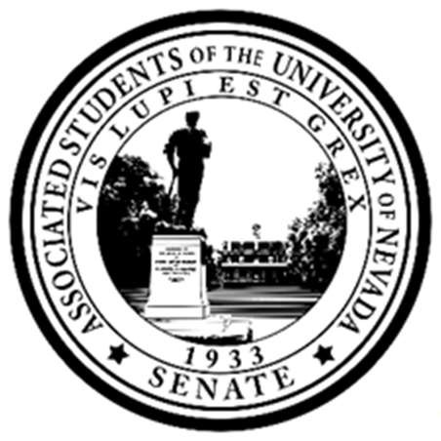Posted at the ASUN Offices in the Joe Crowley Student Union, Frandsen Humanities Building, the Penning Student Achievement Center, the Mathewson IGT Knowledge Center and online at www.nevadaasun.com. Requests for supporting material for an agenda should be directed to the Archives of the Associated Students. All other inquiries should be directed to Senator Ali at aweena@unr.edu.

Committee on IDEA
Wednesday May 10th, 2023, at 5:30 PM
Page 2

items on this agenda. The Chair may impose reasonable limits on the length members of the public may speak.

- ADJOURNMENT

- NOTES.
Agenda items may be considered out of order at the discretion of the Chair. The Committee may combine two or more agenda items for consideration. The Committee may remove an item from the agenda or delay discussion relating to an item on the agenda at any time.

The Associated Students supports providing equal access to all programs for people with disabilities. Reasonable efforts will be made to assist and accommodate physically handicapped persons desiring to attend the meeting. Please call the Speaker of the ASUN at (775) 784-6589 in advance so that arrangements may be conveniently made.

