Committee on Government Operations
Senate of the Associated Students of the University of Nevada 90th Session
Agenda for Wednesday, September 14, 2022 at 3:00 pm
President’s Conference Room, 3rd Floor of the Joe Crowley Student Union and on Zoom Email Senator Salah at senatorsalah@asun.unr.edu for more information

- CALL MEETING TO ORDER*

- ROLL CALL*
Roll Call must be listed by the Secretary.

3. PUBLIC COMMENT
Items heard under public comment may be for items either on or off the agenda. Action may not be taken on items raised under public comment. The Chair may elect to take public comment on action items on this agenda. The Chair may impose reasonable limits on the length members of the public may speak.

4. ADOPTION OF MINUTES
a. There are no minutes to be approved at this time.

5. OLD BUSINESS
- There is no new business at this time.

6. NEW BUSINESS (FOR POSSIBLE ACTION)
- Committee Goals and Expectations

7. COMMENTS AND ANNOUNCEMENTS
The Chair will recognize Committee members requesting the floor for a period not to exceed two minutes for the purpose of miscellaneous reports and requests.

8. PUBLIC COMMENT
Items heard under public comment may be for items either on or off the agenda. Action may not be taken on items raised under public comment. The Chair may elect to take public comment on action items on this agenda. The Chair may impose reasonable limits on the length members of the public may speak.

POSTED ON OR BEFORE 9:00 a.m. ON THE THIRD WORKING DAY BEFORE THE MEETING

Posted at the ASUN Offices in the Joe Crowley Student Union, Frandsen Humanities
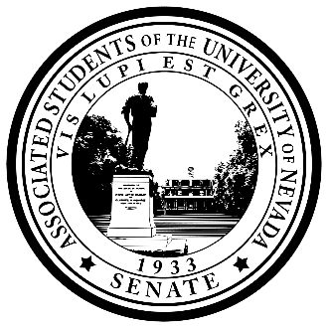
Building, the Pennington Student Achievement Center, the Mathewson IGT Knowledge Center and online at www.nevadaasun.com. Requests for supporting material for an agenda item should be directed to the Archives of the Associated Students.

If you would like a copy of any of the agenda items listed, please contact Chair Salah at senatorsalah@asun.unr.edu

Committee on Government Operations Agenda
Wednesday, September 14, 2022 at 3:00 pm
Page 2

9. ADJOURNMENT

10. NOTES
Unless otherwise marked by an asterisk, all items are action items upon which the Committee may take action. Agenda items may be considered out of order at the discretion of the Chair. The Committee may combine two or more agenda items for consideration. The Committee may remove an item from the agenda or delay discussion relating to an item on the agenda at any time.

The Associated Students supports providing equal access to all programs for people with disabilities. Reasonable efforts will be made to assist and accommodate physically handicapped persons desiring to attend the meeting. Please call ASUN at (775) 784-6589 or contact Chair Salah at senatorsalah@asun.unr.edu in advance so that arrangements may be conveniently made.

