Committee on Democratic Civic Engagement
Senate of the Associated Students 88th Session
Agenda for Tuesday September 8th 2020 at 5:30 p.m.
Via Zoom: Email Senatordoyle@asun.unr.edu for the link
- CALL MEETING TO ORDER*
Call Meeting to Order must be listed by Secretaries

- ROLL CALL*
Roll Call must be listed by Secretaries

- PUBLIC COMMENT*
Items heard under public comment may be for items either on or off the agenda. Action may not be taken on items raised under public comment. The Chair may elect to take public comment on action items on this agenda. The Chair may impose reasonable limits on the length members of the public may speak

- MINUTES
- There are no minutes to be considered at this time.

- OLD BUSINESS
There is no old business to discuss at this time.

- NEW BUSINESS
- Legislative Priorities – Final Conversation

The Committee will confirm the legislative priorities for the 88th Session that will be drafted into legislation
- When2Meet

The Committee will discuss the current meeting time

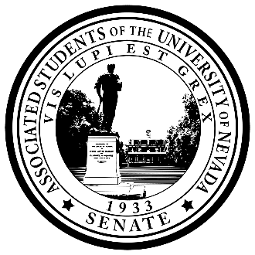Posted online at www.nevadaasun.com.

If you would like a copy of any of the agenda items listed, please contact
Senator Doyle at senatordoyle@asun.unr.edu.

- PUBLIC COMMENT*
Items heard under public comment may be for items either on or off the agenda. Action may not be taken on items raised under public comment. The Chair may elect to take public comment on action items on this agenda. The Chair may impose reasonable limits on the length members of the public may speak.

- ADJOURNMENT
- NOTES.
Unless otherwise marked by an asterisk, all items are action items upon which the Senate may take action. ASUN supports providing equal access to all programs for people with disabilities. Reasonable efforts will be made to assist and accommodate physically handicapped persons desiring to attend the meeting. Please call the Speaker of the ASUN at (775) 784-6589 in advance so that arrangements may be conveniently made.

