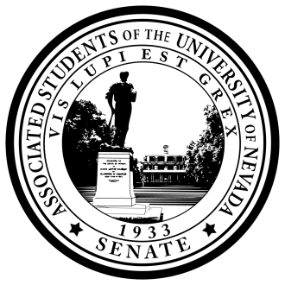
Senate of the Associated Students of the University of Nevada
87th Session, 2019-2020

A RESOLUTION IN RECOGNITION OF DR. CINDY MARCZYNSKI AND DR. JERRY MARCZYNSKI

Resolution Number: 57
Authored By: Speaker Hughes
Sponsored By: 2019-2020 Student Government Assembly

Whereas, Dr. Cindy and Dr. Jerry Marczynski have both exemplified outstanding commitment to the University of Nevada, Reno throughout their time here;
Whereas, Dr. J. Marczynski has served the University community as Associate Vice President of Student Life Services since 2006, totaling 13 years;
Whereas, Dr. C. Marczynski has served the University community since 2007 as the Director of Counseling Services, totaling 12 years;
Whereas, these individuals have gone above and beyond in their positions and, as they leave this University, it is essential that the Associated Students of the University of Nevada recognize their efforts;
Be it resolved that, the Associated Students of the University of Nevada requests that Director Sandra Rodriguez delegates the duty to create a formal recognition and plaque for both Dr. Cindy and Dr. Jerry Marczynski.

Adopted in Senate on May 15th, 2019

Attest:

__________________________________________
Frida Urena, Secretary of the Senate

__________________________________________
Savannah Hughes, Speaker of the Senate

