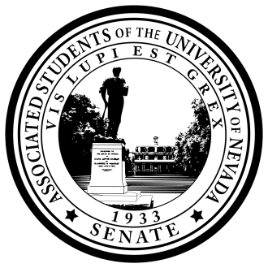
Senate of the Associated Students of the University of Nevada
84nd Session, 2016-2017
A RESOLUTION Adding Senator Taylor To the Committee on GOvernment Operations.

Resolution Number: 92
Authored By: 2016-2017 Student Government Assembly
Sponsored By: 2016-2017 Student Government Assembly

Be it resolved by the Senate of the Associated Students, that Senator Taylor is added to the Committee on Government Operations.

Adopted in Senate on November 2nd, 2016

Attest:

__________________________________________
Andrea Godoy, Secretary of the Senate

__________________________________________
Noah Teixeira, Speaker of the Senate

