Committee on Budget and Finance
Senate of the Associated Students 85th Session Minutes for Friday, February 9, 2018 at 1:00 p.m.
Joe Crowley Student Union – Presidents Conference Room

- CALL MEETING TO ORDER
Meeting was called to order at 1:00 pm in the President’s Conference Room, third floor of the JCSU. Presiding secretary was Secretary Cunneen.

- ROLL CALL
Senator Bussman was present
Senator Flangas was present
Senator Kuykendall was present
Senator Mall was present
Senator Martinez was absent excused
Senator Thummel was present
Senator Tralmer was present
Qourum was met

3. PUBLIC COMMENT
Rodriguez: don’t cover the capital account because we don’t have the right information

- MINUTES
There are no minutes to be heard at this time.

- OLD BUSINESS
There is no old business to be discussed at this time

6. NEW BUSINESS

a. Financial Reviews
The Committee will conduct a financial review of the following accounts: Executive Board (1702-105-0104), Capital (1702-105-0301), and ASUN Senate (1702-105-0103). The Committee will hear a presentation by the account managers and the will examine expenditures within each account to ensure full financial disclosure and transparency to the ASUN.
Noah: sent in a memo, everything we have paid since November, we have our regular and monthly expenses, past three months we have had an expenditure of student travel for San Antonio, October we switched to workday so you are just seeing these expenses now, there is a conference fee charge from September, intern socials is another expenditure, and ice cream social to debrief interns to see if they will run for senate, those are on the exec account. No other charges
Kuykendall: mall will be doing this financial review summary, memo is up in the box and it summaries the review.

ASUN Senate
Jackson: paid for posting board for the Pennington, we have been requested to designate a sign for the use of the board, that is being worked on at inkblot, for food they paid for a luncheon, fee came through in January, and they had an ice cream social for parliament.
Kuykendall: any questions? Sarwar was responsible for this review, but since she is no longer with us Senator Tralmer will take over this review summary.

Posted at the ASUN Offices in the Joe Crowley Student Union,
Frandsen
Humanities Building, the Ansari Business Building,

Mathewson
-

IGT Knowledge Center, and online at

www.nevadaasun.com.

If you would like a copy of any of the agenda items listed, please contact Senator Kuykendall at senatorkuykendall@asun.unr.edu.

Committee on Budget and Finance Agenda
Friday, February 9, 2018
Page 2

b. S.B.85 - An Act to Use Capital Funds to Fund the Construction of a Free Speech

Structure in Democracy Plaza
The Committee will read and debate the piece of legislation. The Committee may edit the piece of legislation as it sees fit. The Committee may decide to report favorably, unfavorably, take no action, or refer the legislation to another committee.

Kuykendall: we are skipping this review because it was not favorably referred, it will be discussed later

c. Approval of Financial Review Summaries
The Committee will discuss and vote on the approval of the following financial review summaries: Undergraduate Research Journal (1702-105-0137), Contingency Fund (1702105-0107), and Leadership Programs (1702-105-0119). If approved, the documents will be uploaded to the ASUN website for public viewership.

Kuykendall: was going to be a consent agenda item, they are pieces of legislation that are randomly approved, this doesn’t fall under a consent agenda item, a lot of them are being processed and there is no formal process on how we send them to senate. Seeks a motion to approve the financial review summaries for the undergraduate research journal. Flangas moves, Thummel seconded.
Mall: there were only two financial reviews attached
Kuykendall: we won’t be approving the in search document. The motion passes
Thummel: moves to approve financial review summary for leadership, it passes

7. PUBLIC COMMENT*
Flangas: we are going to submit a resolution to the committee on civic engagement on how we want the construction of the bill to look like, they will go to senate and there will be two separate bills.

8. ADJOURNMENT
Meeting adjourned at 1:12 pm
9. NOTES.
Unless otherwise marked by an asterisk, all items are action items upon which the Senate may take action. ASUN supports providing equal access to all programs for people with disabilities. Reasonable efforts will be made to assist and accommodate physically handicapped persons desiring to attend the meeting. Please call the Speaker of the ASUN at (775) 784-6589 in advance so that arrangements may be conveniently made.

[DISCUSSION DRAFT]

85_{th} SESSION 2017-2018

S. B. 85-

AN ACT TO USE CAPITAL FUNDS TO FUND THE CONSTRUCTION OF A FREE SPEECH
STRUCTURE IN DEMOCRACY PLAZA
_______________________________

IN THE SENATE OF THE ASSOCIATED STUDENTS

_______________________________

FEBRUARY 5TH, 2018

SUBMITTED BY SENATOR FLANGAS TO THE COMMITTEE ON CIVIC AND ENGAGEMENT AND THE COMMITTEE BUDGET AND FINANCE

A BILL

An Act to Use Capital Funds to Fund the Construction of a Free Speech Structure in Democracy Plaza
- Whereas, an appropriation from the Capital Fund has been
- requested;
- Whereas, the funds are needed to pay for the construction of a
- free speech structure in Democracy Plaza;
- Whereas, the resolution of the 83rd session of Senate which
- named the area in front of the Mathewson-IGT Knowledge

7 Center ‘Democracy Plaza’, did so with the intent to: “connect 8 the university’s foundational value of learning with the 9 democratic process”;

- Whereas, the Center for Student Engagement has created the
- iLead initiative to create a campus culture of democratic civic 3 engagement opportunities;
- Whereas, this structure would provide a platform, both physically
- with a microphone and granite structure and metaphorically, for
- students to exercise their first amendment right to free speech
- and assembly, essentially fulfilling the commitment to involving
- students in the democratic process and allowing for democratic
- civic engagement whenever students deem necessary;
- Whereas, this University has always created an environment for
- raising challenging questions and the discussion of significant
- issues, and this platform would allow for students to do just that;
- Whereas, this structure would further allow for students to
- specifically speak out about any issue, person, decision, policy
- which they deem important, and we, as the Associated Students
- of the University of Nevada, will pledge to listen to the students
- who use this platform and, to our best ability, write bills and
- resolutions which reflect these sentiments;
- Whereas, this structure will also provide students a platform to
- speak directly to the administration and community and will
- further promote the ideals of No Walls 2025, where the students
- are: “actively involved in the system of shared governance at the

23 University of Nevada,” and students “are holding their
- representatives and administrators accountable for their
- decision-making, whether it’s at the system, city, state or national
- level[, and the students] are framers of the… experience of the
- university”;
- Whereas, the benefit of this instillation, Democracy Plaza, will last 29 for as long as the structure stands and is maintained on campus; 1 Whereas, because this structure will be paid for by the Associated
- Students, the ASUN logo will forever be engraved on the
- aforementioned structure in Democracy Plaza;
- Whereas, the granite, the engraving of the quotes, and the
- microphone/speaker system will, in total, cost $15,000;
- Whereas, the Statutes of the Associated Students requires an
- additional 10% contingency of $1,500 be applied;
- Be it enacted by the Senate of the Associated Students, the Capital Fund 9 be used to pay the $16,500 necessary to fund the construction of 10 the free speech structure in Democracy Plaza.

FROM: | Noah Teixeira, President of the Associated Students
TO: | Hannah Jackson, Speaker of the Senate
 | Nicole Flangas, Senator
 | Andrea Godoy, Secretary of the Senate
DATE: | February 5, 2018
RE: | Democracy Plaza Construction Capital Funds Expenditure Request

To the Senate of the Associated Students:

For the construction of democracy plaza (see attached documents) I am requesting a capital funds expenditure of $15,000. The breakdown of cost for this capital funds request is as follows:
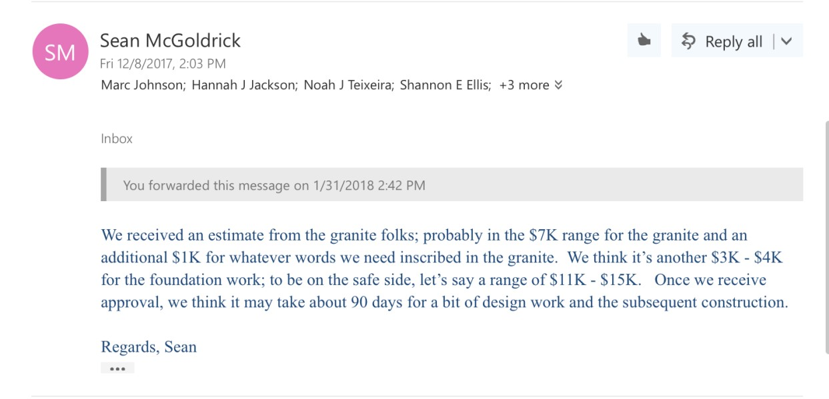

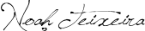
Noah Teixeira
President
Associated Students of the University of Nevada

Democracy Plaza
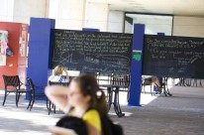
History
●
Democracy Plaza at Indiana University-Purdue
University Indianapolis (IUPUI)
○
one way to
make place(s) across our higher education
institutions intentional and meaningful for their
campus’
(
i.e., students, faculty, staff
)
political
engagement
●
83
rd Session Passes Resolution in favor of
Democracy Plaza
○
http://www.nevadaasun.com/wp-
content/uploads/2016/03/S.R.-83-A-
Resolution-in-support-of-naming-the-area-in-
front-of-the-KC-Democracy-Plaza.pdf
●
Student feedback/input
○
“Am I being heard?”
○
Wanting to create a culture of activism
Location
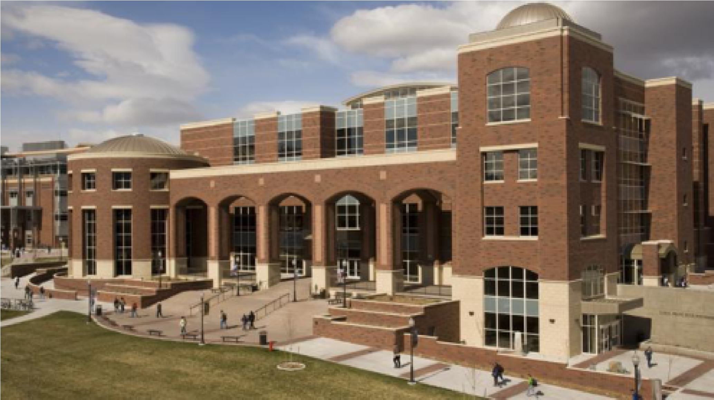
The Blueprints
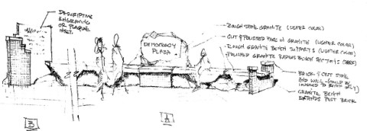
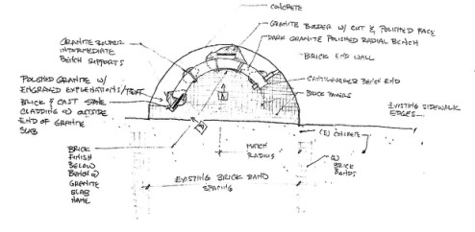
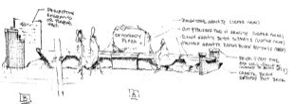
Materials
●
Rough natural stone/bolder granite
(
with some cut and polished
surfaces) for main name engraved
sign and bench supports -
both
rough and polished surfaces
●
Descriptive text of what the plaza
is based on can be put on polished
slab
●
Brick paver surface and vertical
elements, bringing in campus brick
finish appearance and KC
materials
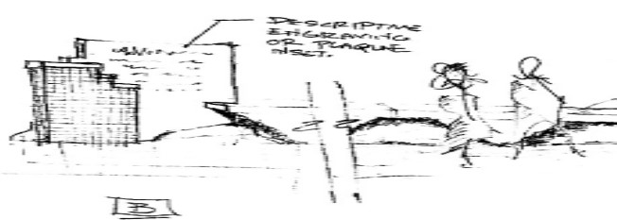
Plaque
●
Weaves building materials and
colors of the artwork into the
narrative on the plaque.
That much like mortar binds together the
multi-colored and textured materials to
create a strong foundation for this
artwork, it is the freedom of speech that
binds together a diverse society and is a
foundational element to our democracy.
●
We would be responsible for
proposing language/statements
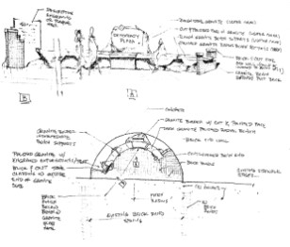
Engagement
●
Space is made for the purpose of
student civic and democratic
participation
●
Events that have been held in this
area (and potential for more)
○
Service Palooza
○
Speakers
○
Rallies/marches/student
organizing
○
philanthropy/volunteer
●
Potential to hold meetings,
diversity dialogues, other events
●
Students can stand, sit, engage
with the piece however they would
like

A monument
dedicated to the future.

Committee on Budget and Finance Financial Review
Submitted by Senator Flangas and Senator Martinez
Senate of the Associated Students 85th Session
Financial Review for Friday, February 2nd, 2018 at 1:00 p.m Joe Crowley Student Union – Presidents Conference Room

- Contingency Fund – 1702-105-0107

- Data/Numbers
a. Total Expenses up-to-date: Has not changed

b. Comparison to last year’s review
- No major changes as the contingency fund has not been utilized - Note: the fund is only used to keep ASUN afloat in times of dire need.

3. Account Manager(s)

a. Overview
We do not spend money out of the contingency fund. Chair Kuykendall said that we may expect to use it this semester since we have had some revenue lines which we may need to cover as enrollment did not grow at the rate in which we thought it would when we established the budget in April 2017.

b. Questions/Discussion from Committee
Senator Flangas asked what this account was for; Dr. Beattie gave an example. If the Wolf Shop is not making any money, we would use the contingency fund to ensure that ASUN can still function. In addition, the question was asked if the money in this account roles over because we put funds into the account. The answer was ‘yes’ that the money does roll over from fiscal year to the next year.

4. Conclusion
The contingency fund is not used often, unless it becomes pertinent in a case by case situation.

5. Supplemental Items
Any additional documents will be found on the ASUN Website under archives listed as the Budget and Finance meeting for February 2nd, 2018.
Committee on Budget and Finance Financial Review
Submitted by Senator Kuykendall
Senate of the Associated Students 85th Session
Financial Review for Friday, February 2nd, 2018 at 1:00 p.m Joe Crowley Student Union – Presidents Conference Room

- Leadership Programs - (1702-105-0119)

- Data/Numbers
a. Total Expenses up-to-date: None in Spring 2018/since the previous review

b. Total Revenues: None c. Comparison to last year’s review (that occurred around the same time/month): No major change d. Other: None

3. Account Manager(s)

a. Overview
President Teixeira presented as the account manager in meeting. During the presentation, he explained that no money had been spent out of it on leadership programs thus far in Spring 2018. He explained that money may be spent out of the account totaling $5,000 in the future. This amount would be for a diversity speaker for the diversity summit. $1,000 from each line item in the account would comprise the $5,000 anticipated for the speaker. The total for the speaker would be $20,000, of which the remaining $15,000 would be taken as such: $5,000 from the Director of Diversity and Inclusion’s budget and a $10,000 subsidy from Patricia Richards.

b. Questions/Discussion from Committee
The committee asked for clarification on where money would be taken from to fund the diversity summit speaker. Everything asked was answered and included in the overview section of this financial review summary.

4. Conclusion
The Committee found nothing wrong with the account during the financial review. Though unused so far in the semester, the account was planned to be utilized for the future diversity summit event. The Committee found nothing wrong with the planned expenditures.

5. Supplemental Items
To better understand the makeup of the Leadership Fund account, the entire ASUN Operating Budget FY18 can be found online on the ASUN website.

