COMMITTEE ON BUDGET AND FINANCE
Senate of the Associated Students
Agenda for Monday, February 27th, 2017 at 6:00 P.M.
PRESIDENT’S CONFERENCE ROOM, 3RD FLOOR OF THE JOE CROWLEY STUDENT UNION

1. CALL MEETING TO ORDER
Meeting called to order at 6:05 pm in the President’s Conference Room in the Joe Crowley Student Union. Presiding Secretary was Secretary Cunneen.
2. ROLL CALL
Qourum was met

3. PUBLIC COMMENT

4. MINUTES
- The Committee will consider the approval of the minutes from November 18th, 2016. The Committee will discuss the minutes of November 18th, 2016 and may choose to amend or edit the minutes. Upon conclusion of the discussion, the Committee may choose to approve the minutes.
- The Committee will consider the approval of the minutes from December 2nd, 2016. The Committee will discuss the minutes of December 2nd, 2016 and may choose to amend or edit the minutes. Upon conclusion of the discussion, the Committee may choose to approve the minutes.
- The Committee will consider the approval of the minutes from February 13th, 2017. The Committee will discuss the minutes of February 13th, 2017 and may choose to amend or edit the minutes. Upon conclusion of the discussion, the Committee may choose to approve the minutes.

5. OLD BUSINESS

6. NEW BUSINESS

a. Nevada Wolf Shop Initiatives
The Committee will discuss how they can support Director Dubey with ongoing projects at the Nevada Wolf Shop. The Committee will also receive an update on the Nevada Wolf Shop’s operations this past semester. b. Financial Reviews
The Committee will conduct Financial Reviews on the following ASUN accounts: Programming Board (1702-105-0111), Legislative Affairs (1702-105-0136), and Budget and Finance Committee (1702-105-0102).
Dr. Dubey- Increasing shift from students shopping online to student shopping in the store.
Spring rush numbers are down due to the semester being later. Revenue not expected to catch up in February. Not enough revenue in textbooks. Vacant position in shipping and receiving, hoping to hire a graduate student for the position to save expenses. Associate director has taken position as US Davis. Raised 1856 dollars for pack provisions. Students contributed change to pack provisions. Students seemed to know what Pack provision was. Collected more money than expected during the month, very successful. Plans on using the same format for other fundraising events. Launched Tech services to fix computer, first apple then pc. Will be able to fix damaged phone screens. Amazon pick up in the Save way on McCarran. US Davis has established on of these pick up locations. Amazon is interesting in coming to UNR. Amazon has had a challenge in hiring students and keeping them from leaving. We could have the only amazon run by students on campus. IN the area currently occupied on t eh second floor by the non-academic books and supplies. Amazon is waiting to see the space the wolf shop has. By the beginning of next school year, Dr. Dubey will have more information for the committee.
Dr. Dubey is looking to target niche markets. We are a growing Hispanic university. Contacted 2 Mexican pastry shops and one Asian. We are hoping to get Mexican pastries running by March.
Nevada legislation is considering increasing Nevada minimum wage by .25. IF the wolf shop also does this increase, it would cost the store $60,000. Considering not increasing the wage level for students who are already working. The $60,000 reflects a 3% increase for all wages of the wolf shop. The legislature is considering increasing the cost of living expense by 2%, a total of $16,000, and a 4% merit increase for hourly classified employees, a total of a $20,000 increase.
With less revenue and more expenses, something will have to be done.
South campus store expenditures, reduce union rent $60k = $120k. Consultant -$15k, equipment. Projected opening date Fall 2018. Thinking of hiring 3 full time staff. Full time marketing position. In the past, have hired junior and senior students to do marketing. Need a more consistent employee. Need to put more time into marketing. Will not be filling the shipping and receiving full time position to compensation for the addition of the marketing position. Also need to improve textbook sales as they are the bedrock of the Wolf shop. Largest problem has been that professors have not been turning in textbook lists in on time, thus orders have had to be rushed and costs are increased for students. Planning on expanding the graduation locations on campus. As 30 to finish and the graduated class is growing bigger, there should be more graduation materials sales. Instead of two, UNR is planning on increasing to three.
Whole foods has made their reputation on organic foods, however has had an identity issue because Costco has taken over the organic food market. We have the same problem. How do we continue to stay relevant? Consumer tastes are changing. It is the challenge of the wolf shop that the consumer base changes every 2 to 4 years. The wolf shop needs our help (As students) to stay relevant. This is why a young full time worker must be hired. Nevada Fit and dorm refrigerators help show the students that the wolf shop is relevant, not just t shirts. Looking forward, the south campus store and the Amazon partnership.
Buy back RFP. The contract for the third party will buy back company is renegotiating their contract at the same time as the opening of the south campus.
The wolf shop is behind in technology. Website is clunky and sales could be more automated.

Senator Feng- Allowing students to purchase textbooks through My Nevada and allowing student to use financial aid.
Sr. Dubois- Direct access is the program that allows students to buy online access textbooks through My Nevada. Trial on 2 classes was successful and will roll out again in the summer. Only 3, (20% of total), opted not to use the direct access for a variety of reasons.

Senator Barragan. The lack of a full time position, and professors not putting in textbook orders on time, which was a bigger cause of lack of sales. Connected but not related to each other. Wolf shop orders 3 months out, before revenue comes in. Figuring out which textbooks will sell out is based largely on major. Science had engineering rely on their textbooks, whereas liberal arts are able to find cheaper versions of common literature.

Senator Bradley- First right of refusal proposed bill. All clubs and orgs would have to go through the wolf shop first before ordering at a 3rd party location. Philosophically, does not maintain relevance because they are forced into relevance. Practically, would benefit the store and increase awareness of the store and its products.
Bradley- by writing it into the SAS and manual it will encourage the awareness and knowledge of the wolf shops services. Eventually it will become a tradition and not be forced onto the students.

Sandy- Students used to be exempt from using silver and blue catering. How ever there was an issue that 3rd party services used plastic and Styrofoam utensils, which was not sustainable. Now students do use silver and blue.
Sandy asked how to professors submit textbooks?

Dr. Dubey- simple online order

Sandy- can we use web campus

Dr. Dubey- what percentage is adjunct, because they do not know what there text book is until the class begins. 60% of faculty turn their book in right before classes start. Textbooks are one of the last thing professor’s think of. The wolf shop and this committee have to be more proactive in getting textbooks in faster. Then we won’t be waiting into the last minutes and quantity appropriate.

Sen Bradley- Wondering if we could have a program or campaign in reducing plastic bags used at the wolf shop or reducing the thickness of the plastics. Perhaps incentivizing students who chose not to use a plastic bags

The wooden nickel program. If a student decided not to use a plastic bag, give them a wooden nickel that gets put into a jar as a contribution to a local charity. We do need to have plastic bags in case there are high school programs that need to have bags to stuff swag items into.

Sen Boone- implementing cloth Wolf Shop branded bags instead of plastics.

Dr. Dubois would the students purchase the cloth bag? NO, students usually have a back pack. Which would also reduce plastic bags. We have had a cloth bag before, and even given them away. Nevada is lagging behind in plastic bag recycling.

Sandy- suggests charging for plastic bags

Dr. Dubois students already dislike paying high prices for textbooks and cloths. They would also hate the extra expense.

Sen Barragan- at grocery stores if you don't have a reusable bag, .10 cents is added on for every bag automatically. Create an incentive program, by ‘reducing the cost’ if they bring in their wolf shop bag

Dr. D agrees that an incentive program would be better.

Sen Bradley suggest to have a specific meeting for this not in committee

6b- Financial review Programing.

Working on getting a good speaker for unity week

Sen Feng- how come we didn’t use the ASUN grill for an event

Decided to use Camalot because the grill was not working the previous night. Supplies were wasted in trying to getting it to turn on, deciding not to waste further materials on a grill that might not work, order 3rd party grill

Sen Bradley- why was attendance so low during at pack movie night.

Moana was playing at the Joe that night. Lack of advertising.

Sen Feng- what are you planning on spending money on during Mackey week

Mackey and cheese, and a coffee crawl, between these events the costs is

Sandy—why not invite kids to the movie theatre rental? Make it a community event

Sen. Bradley—accounts aren’t set up for a donation. Not benefiting the ASUN.

Sandy- unless there was a second educational step bringing it back to the students.
Yes, ASUN is not allowed to give cash as a donation.

Financial review- budget and finance account.

Sandy- there has been little activity in the account since October. Until the transfer of 2 awards. Activity is if we decide to allocate funds from reserve. We still have the end of the year banquet.

Bradley- how much do we typically spend on the end of the year banquet.

Sen Feng- it is a line item in last year’s budget

Sandy- how is the legislation the committee is working on

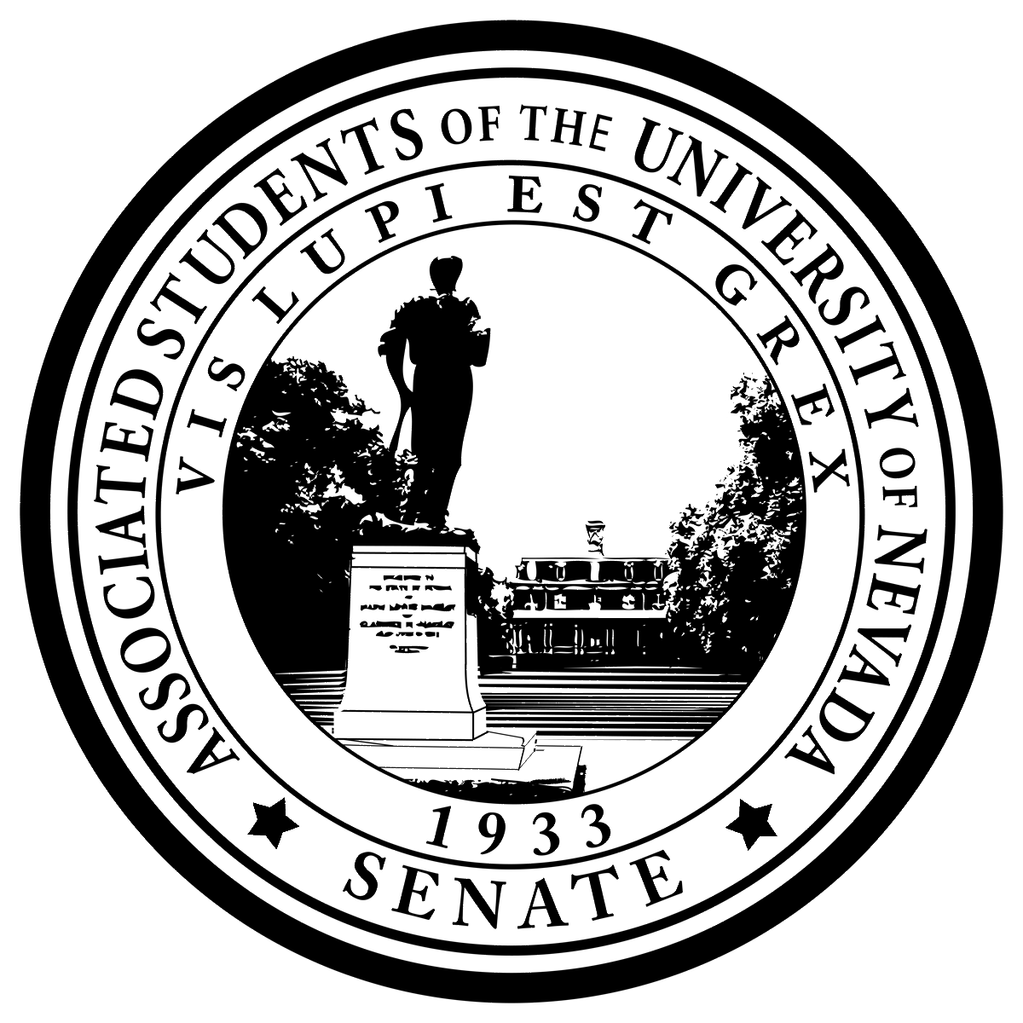
Posted
1664
N. Virginia St. Reno, NV 89557
at the ASUN Offices in the Joe Crowley Student Union,

Frandsen Humanities Building, the Ansari Business Building, Mathewson
-

IGT Knowledge Center,

and online at www.
nevadaasun.com
.

If you would like a copy of any of the agenda items listed, please contact

Senator

Feng at senatorfeng
@asun.unr.edu
.

Committee on Budget and Finance
February 27th, 2017 Page 2

7. PUBLIC COMMENT

There was no public comment at the time

8. ADJOURNMENT
Adjourned at 6:52 pm

NOTES:
Unless otherwise marked by an asterisk, all items are action items upon which the Senate may take action. ASUN supports providing equal access to all programs for people with disabilities. Reasonable efforts will be made to assist and accommodate physically handicapped persons desiring to attend the meeting. Please call the Speaker of the ASUN at (775) 784-6589 in advance so that arrangements may be conveniently made.

