Committee on Civic Engagement
Senate of the Associated Students 84th Session
Agenda for Thursday December 8th, 2016 at 9:00 a.m.
1664 N. Virginia St. Reno, NV 89503, President’s Conference Room in the
Center for Student Engagement, 3rd Floor of the Joe Crowley Student Union

- CALL MEETING TO ORDER*

- ROLL CALL*

3. PUBLIC COMMENT*
Items heard under public comment may be for items either on or off the agenda. Action may not be taken on items raised under public comment. The Chair may elect to take public comment on action items on this agenda. The Chair may impose reasonable limits on the length members of the public may speak
- MINUTES
  - Minutes of 11/10/16
  - Minutes of 11/18/16
- OLD BUSINESS
  - Charity Spotlight
  - Wolf Pack Reading Week

6. NEW BUSINESS

a. MLK Week of Service: Unity Project

b. Know Your Rights Week

7. PUBLIC COMMENT*
Items heard under public comment may be for items either on or off the agenda. Action may not be taken on items raised under public comment. The Chair may elect to take public comment on action items on this agenda. The Chair may impose reasonable limits on the length members of the public may speak.

8. ADJOURNMENT
NOTES.
Unless otherwise marked by an asterisk, all items are action items upon which the Senate may take action. ASUN supports providing equal access to all programs for people with disabilities. Reasonable efforts will be made to assist and accommodate physically handicapped persons desiring to attend the meeting. Please call the Speaker of the ASUN at (775) 784-6589 in advance so that arrangements may be conveniently made.
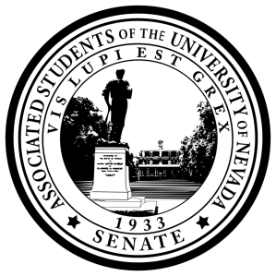
Posted at the ASUN Offices in the Joe Crowley Student Union,

Frandsen Humanities Building, the Ansari Business Building,

Mathewson
-

IGT Knowledge Center, and online at

www.nevadaasun.com.

If you would like a copy of any of the agenda items listed, please contact

Senator
Green

at senatordennisgreen@asun.unr.edu

